Wagoner's Song
Subtitle: Land of the Sacramento
Words: Randy Sparks
Music and Arrangements: Ralph Grasso & Art Podell
Key of G. 3/4 Time. "With A Steady Beat."
Ukulele.
Wagoner's Song
Subtitle: Land of the Sacramento
Words: Randy Sparks
Music and Arrangements: Ralph Grasso & Art Podell
Original Key of G (1 Sharp). 3/4 Time. "With A Steady Beat." Ukulele.

GCEA  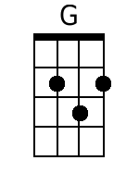  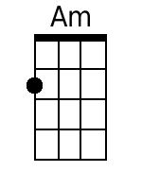  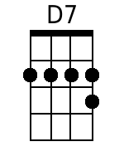  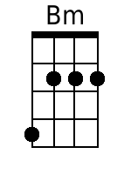  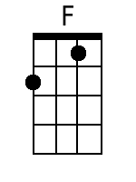  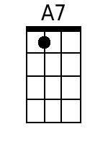  Bari  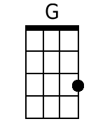  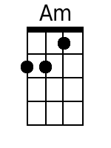  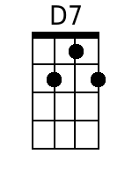  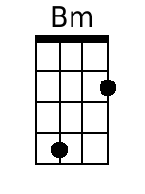  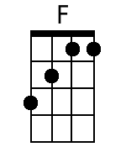  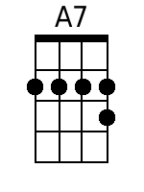 | Four measure introduction.  [No chords indicated … G Am G Am would fit]  G Am G Am  1. Far a-cross the wild country a-way,  G Am G Am  Come a-long.  D7 G Bm  Hi up! Oh, Su-san-nah,  F A7 D7  We're leavin' to-day  Bm  We'll cross the wide prairie,  F A7 D7  Through the mountains we'll go;  G Am G Am G Am  And we're bound for the land of the Sacramento.  G Am G Am  2. There's a new land of treasures un-told,  G Am G Am  Come a-long;  D7 G Bm  I've seen her green valleys,  F A7 D7  Her rivers of gold.  Bm  The wagons are ready,  F A7 D7  We're anxious to go;  G Am G Am G Am  And we're bound for the land of the Sacramento.  G Am G Am  3. Oo (instrumental first line - 3 2/3 measures)  G Am G Am  Come a-long;  D7 G Bm  Oo (instrumental third line - 3 2/3 measures)  F A7 D7  Oo (instrumental fourth line - 3 2/3 measures)  Bm  We'll cross the wide prai-rie,  F A7 D7  Through the mountains we'll go;  G Am G Am G Am  Yes, we're bound for the land of the Sacramento.  Instrumental Exit:  G . . . Am . . . G . . . Am . . .  [Four measure instrumental]  G . . . Am . . . G . . . Am . . .  [Four measure instrumental]  G . . . Am . . . G . . . Am . . .  [Four measure instrumental]  G . . . Am . . . G . . . Am . . .  [Four measure instrumental]  [Fade out on repeat]

