**Waikiki (Andy Cummings)**

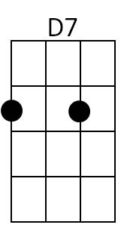**F E7**

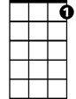

C7

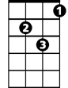

Gm

E7

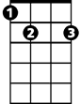

F



There's a feeling deep in my heart

**F D7**

Stabbing at me just like a dart

**Gm C7 F C7**

It's a feeling heavenly

**F E7**



Bb

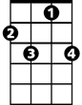

F7

I see memories out of the past

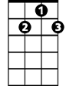

G7

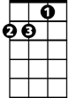

Dm

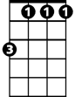

Bb m

**F D7**

Me mories that always will last

**G7 C7**

Of a place beside the sea

**F F7**

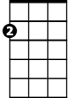

Am

Ahhhhhhhh Waikîkî

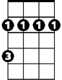

Bm

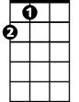

A

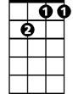

Gm7

**Bb Bbm**

At night when the shadows are falling

**F Dm G7**

I hear the rolling surf calling

**Gm7 C7 F**

Calling and calling to me

**F F7**

Waikîkî

**Bb Bbm**

**BARITONE**

Tis for you that my heart is yearning

**F Dm G7**

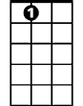

E7

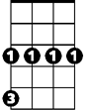

Gm



F



D7

My thoughts are always returning

**Gm7 C7 F E7**

Out there to you across the sea

**A Bm E7**

Your tropic nights and your wonderful charms

**A Bm E7**



C7

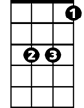

Bb

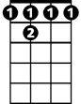

F 7



Dm

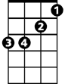

Bb m

Are ever in my memory

**A Bm E7**

And I recall when I held in my arms

**Am Gm7 C7**

An angel sweet and heavenly

**F F7**

Waikîkî



Am

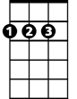

A

Bm

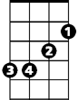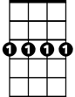

Gm7



G7

**Bb Bbm**

My whole life is empty without you

**F Dm G7**

I miss that magic about you

**Gm7 C7 F D7**

Magic beside the sea

**Gm C7 Gm C F**

Magic of Waikî - Magic of Waikiki