**Wake Me Up When September Ends Key C**

**(Michael Pritchard / Frank E. / Iii Wright / Billie Joe Armstrong)**

**C Cmaj7**

Summer has come and passed

**Am G**

The innocent can never last

**F Fm C**

Wake me up when September ends

**C Cmaj7**

Like my father's come to pass

**Am G**

Seven years has gone so fast

**F Fm C**

Wake me up when September ends

**Chorus:**

**Am Em**

Here comes the rain again

**F C**

Falling from the stars

**Am Em**

Drenched in my pain again



C

**F G**

Becoming who we are

**C Cmaj7**

As my memory rests

**Am G**

But never forgets what I lost

F



**F Fm C**

Wake me up when September ends

**BARITONE**

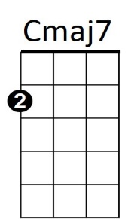

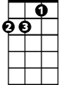

Am



G

C



**C Cmaj7**

Summer has come and passed

**Am G**

The innocent can never last

**F Fm C**

Wake me up when September ends

**C Cmaj7**

Ring out the bells again

**Am G**

Like we did when spring began

**F Fm C**

Wake me up when September ends

**(Chorus)**

**(First Verse)**

**F Fm C (3X)**

Wake me up when September ends

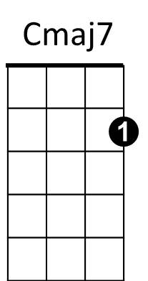



G

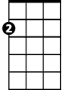

Am

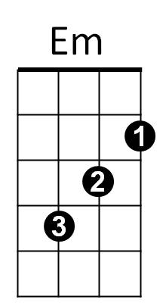

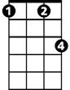

Fm



Em

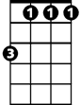

Fm



F

**Wake Me Up When September Ends Key G**

**(Michael Pritchard / Frank E. / Iii Wright / Billie Joe Armstrong)**

**G Gmaj7**

Summer has come and passed

**Em D**

The innocent can never last

**C Cm G**

Wake me up when September ends

**G Gmaj7**

Like my father's come to pass

**Em D**

Seven years has gone so fast

**C Cm G**

Wake me up when September ends

**Chorus:**

**Em Bm**

Here comes the rain again

**C G**

Falling from the stars

**Em Bm**

Drenched in my pain again

**C D**

Becoming who we are

**G Gmaj7**

As my memory rests

**Em D**



C

But never forgets what I lost

**C Cm G**

Wake me up when September ends

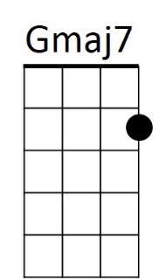

Bm

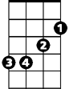

Cm

C



Em



G



D

**G Gmaj7**

Summer has come and passed

**Em D**

The innocent can never last

**C Cm G**

Wake me up when September ends

**G Gmaj7**

Ring out the bells again

**Em D**

Like we did when spring began

**C Cm G**

Wake me up when September ends

**(Chorus)**

**(First Verse)**

**C Cm G (3X)**

Wake me up when September ends

****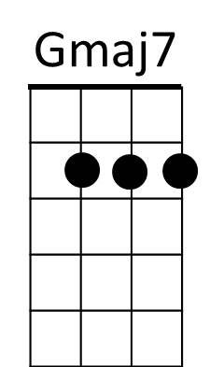

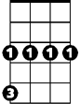

Cm



G

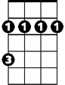

Bm

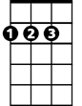

D

**BARITONE**