Walking To New Orleans (C)
Bobby Charles [Robert Charles Guidry], Antione "Fats" Domino, Jr., & Dave Bartholomew, 1960

Strum in on C  C F  This time I'm walkin' to New Orleans, I'm walkin' to New Orleans.  G7  I'm going to need two pair of shoes,  F  When I get through walkin' these blues,  C  When I get back to New Orleans  C F  I've got my suitcase in my hand, now, ain't that a shame.  G7 F  I'm leavin' here today, yes, I'm goin' back home to stay.  C  Yes, I'm walkin' to New Orleans.  C F  You use to be my honey, till you spent all my money.  G7 F  No use for you to cry, I'll see you bye and bye,  C  ‘Cause I'm walkin' to New Orleans.  C F  I've got no time for talkin', I've got to keep on walkin'  G7 F  New Orleans is my home, That's the reason why I'm goin'  C  Yes, I'm walkin' to New Orleans  Outro  C  I'm walkin' to New Orleans (3x) | 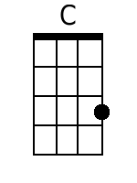
 | 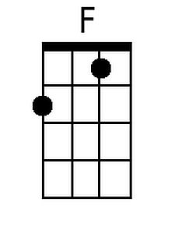
 | 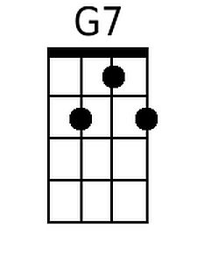
 | Bari
 | 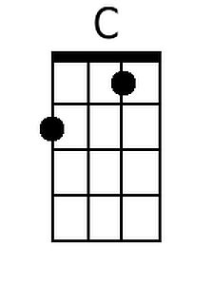
 | 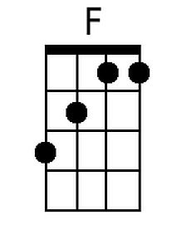
 | 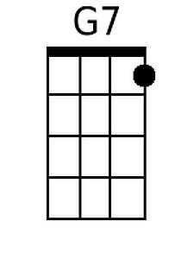

Walking To New Orleans (G)
Bobby Charles [Robert Charles Guidry], Antione "Fats" Domino, Jr., & Dave Bartholomew, 1960

Strum in on G  G C  This time I'm walkin' to New Orleans, I'm walkin' to New Orleans.  D7  I'm going to need two pair of shoes,  C  When I get through walkin' these blues,  G  When I get back to New Orleans  G C  I've got my suitcase in my hand, now, ain't that a shame.  D7 C  I'm leavin' here today, yes, I'm goin' back home to stay.  G  Yes, I'm walkin' to New Orleans.  G C  You use to be my honey, till you spent all my money.  D7 C  No use for you to cry, I'll see you bye and bye,  G  'Cause I'm walkin' to New Orleans.  G C  I've got no time for talkin', I've got to keep on walkin'  D7 C  New Orleans is my home, That's the reason why I'm goin'  G  Yes, I'm walkin' to New Orleans  Outro  G  I'm walkin' to New Orleans (3x) | 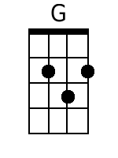
 | 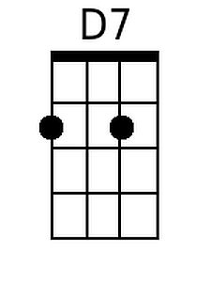
 | Bari
 | 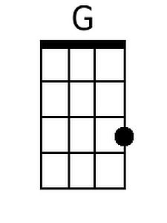
 | 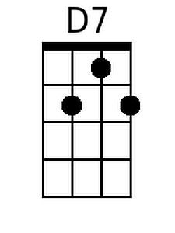

Walking To New Orleans (NN)
Bobby Charles [Robert Charles Guidry], Antione "Fats" Domino, Jr., & Dave Bartholomew, 1960

1 | 4 | 5(7)
A | D | E7
C | F | G7
D | G | A7
F | Bb | C7
G | C | D7

Intro: Strum in on 1

1 4
This time I'm walkin' to New Orleans, I'm walkin' to New Orleans.
5(7) 4
I'm going to need two pair of shoes, when I get through walkin' these blues,
1
When I get back to New Orleans

1 4
I've got my suitcase in my hand, now, ain't that a shame.
5(7) 4
I'm leavin' here today, yes, I'm goin' back home to stay.
1
Yes, I'm walkin' to New Orleans.

1 4
You use to be my honey, till you spent all my money.
5(7) 4
No use for you to cry, I'll see you bye and bye,
1
'Cause I'm walkin' to New Orleans.

1 4
I've got no time for talkin', I've got to keep on walkin'
5(7) 4
New Orleans is my home, That's the reason why I'm goin'
1
Yes, I'm walkin' to New Orleans

Outro
1
I'm walkin' to New Orleans (3x)

