Way Down Yonder In New Orleans (C)
(John Turner Layton, Jr. & Henry Creamer, 1922)

Intro: | C | Am | C | A7 | C | G7 | C |  G7 C  Way down yonder in New Orleans, In the land of the dreamy scenes.  G7 G7 C  There's a Garden of E - den, __ you know what I mean.  G7 C  Creole babies with flashin' eyes, __ Softly whisper with tender sighs.  C7 F  Stop! Oh, won't you give your lady fair, a little smile.  D7 G7  Stop! You bet your life you'll linger there, a little while.  | 1st Ending:  C Am  There is Heaven right here on Earth,  C Ab7  With those beautiful queens.  C G7 C  Way down yonder in New Or..leans.  Repeat From Top  | 2nd Ending:  C Am C Ab7  They’ve got angels right here on earth, Wearing little blue jeans.  C G7 C  Way down yonder in New Or..leans |  |  |  |  |  |  | 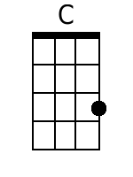 |  | 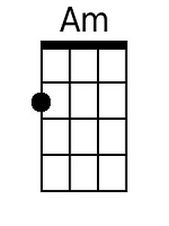
 |  |  |  |  |  |  | 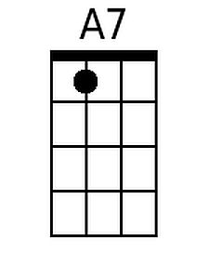 |  |  | 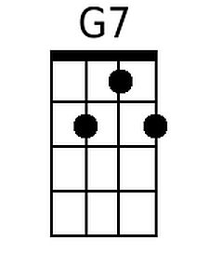
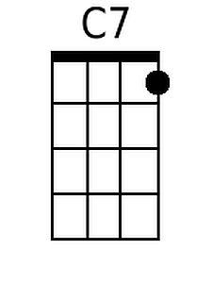
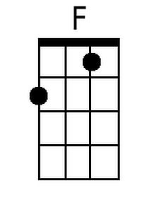
 |  |  |  |  |  |  | 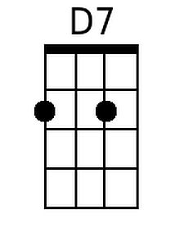 |  |  | 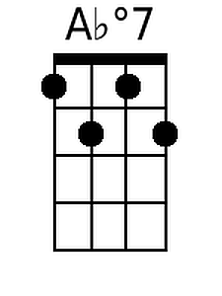
Baritone
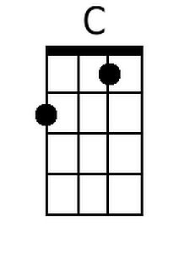 | 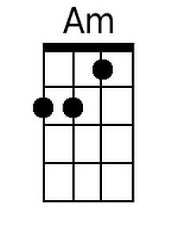 | 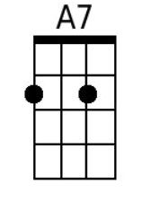 | 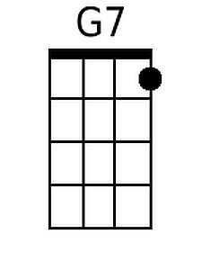 | 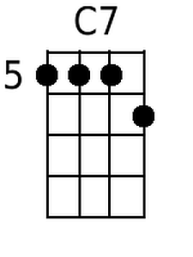 | 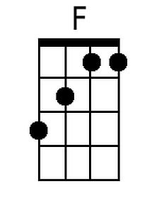 | 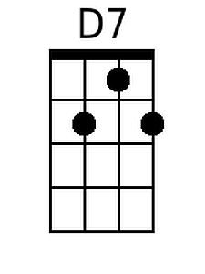 |  | 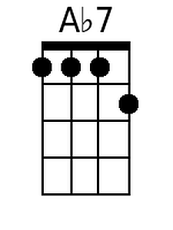

Way Down Yonder In New Orleans (G)
(John Turner Layton, Jr. & Henry Creamer, 1922)

Intro: | G | Em | G | E7 | G | D7 | G |  D7  Well, way down yonder in New Orleans,  G  In the land of the dreamy scenes.  D7 D7 G  There's a Garden of E - den, __ you know what I mean.  D7  Yeah, Creole babies with flashin' eyes,  G  __ Softly whisper with tender sighs.  G7 C  Stop! Oh, won't you give your lady fair, a little smile.  A7 D7  Stop! You bet your life you'll linger there, a little while.  D7  You bet your life you'll linger there, a little while.  | 1st Ending:  G Em  Yeah, there is Heaven right here on Earth,  G Eb7  With those beautiful queens.  G D7 G  Yeah, way down yonder in New Or..leans.  Repeat From Top  | 2nd Ending:  G Em  They've got angels right here on earth,  G D#7  Wearing little blue jeans.  G D7 G  Yeah, way down yonder in New Or..leans |  |  |  |  |  |  | 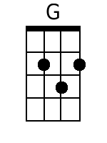 | 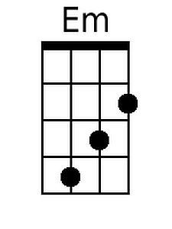
 |  |  |  |  |  |  | 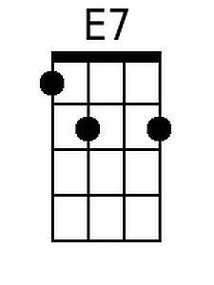
 |  |  |  |  |  |  |  | C
 |  |  |  |  |  |  |  | 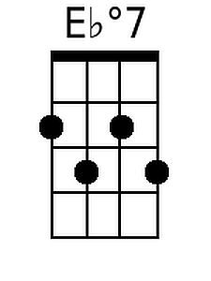
Baritone
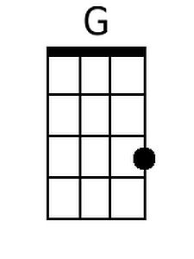 | 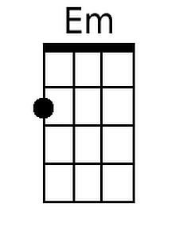 | 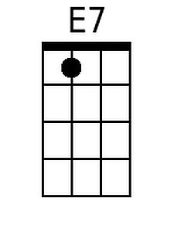 |  |  |  |  | 