We Three Kings Of Covid Are (John H. Hopkins, Jr., R.G. Huff) (C)

Intro: C C-C C-F F-C/  Am E7 Am E7 Am  We three kings are six feet a-part, we’ll Purell be-fore we de-part.  Am G C Dm Am E7 Am  We’ve been tested, as suggested, careful are we, and smart.  Chorus  G7 C F C  O-oh, Do our masks go with our gowns,  F C  Do these face shields hide our crowns?  Am G C F C G C  We’ve had plen-ty, twen-ty - twen-ty,  F C  Wash your hands and spray them down.  Am E7 Am E7 Am  Mel-chi-or is now quaran-tined, stuck in Persia, so-o it seems.  Am G C Dm Am E7 Am  No more travel on a camel, till there’s a good vac-cine. Chorus  Am E7 Am E7 Am  Bal-tha-sar has lo-ost his taste, eating food is such a waste  Am G C Dm Am E7 Am  How dis-quieting, now he’s dieting, life now is slow-er paced. Chorus  Am E7 Am E7 Am  Cas-par left the caravan, he postponed his stargazing plan  Am G C Dm Am E7 Am  No more roaming, Caspar’s homing, scrubbing his red - dened hands. Chorus |  |  |  |  |  |  | 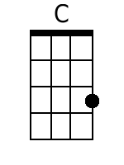
 |  |  |  |  |  |  | 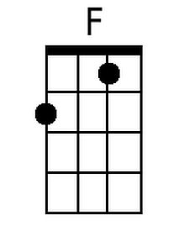
 |  |  |  |  |  |  | 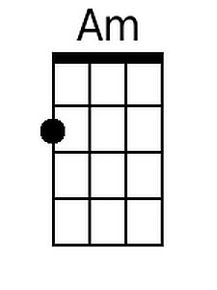
 |  |  |  |  |  |  | 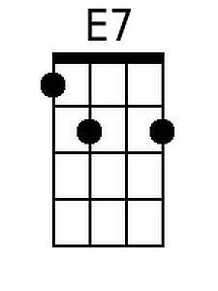
 |  |  |  |  |  |  | 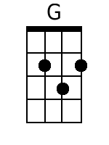
 |  |  |  |  |  |  | 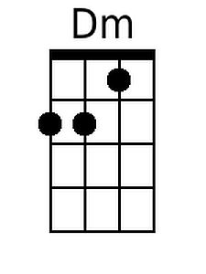
 |  |  |  |  |  |  | 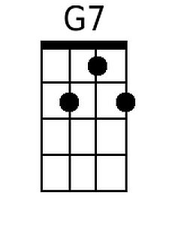
Baritone
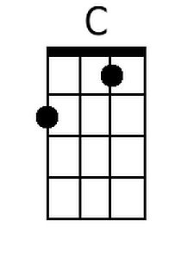 | 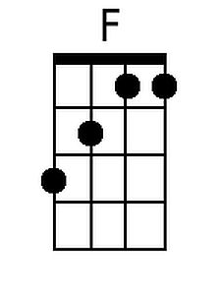 | 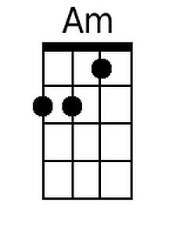 | 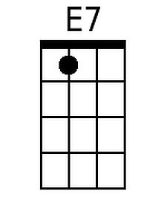 | 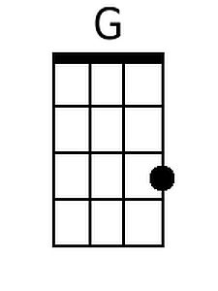 | 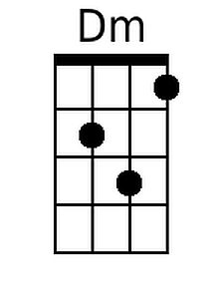 | 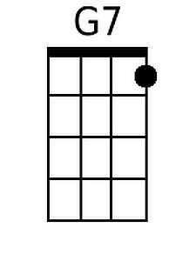

We Three Kings Of Covid Are (John H. Hopkins, Jr., R.G. Huff) (G)

Intro: G G-G G-C C-G/

Em B7 Em B7 Em
We three kings are six feet a-part, we'll Purell be-fore we de-part.
Em D G Am Em B7 Em
We've been tested, as suggested, careful are we, and smart.

Chorus
D7 G C G
O-oh, Do our masks go with our gowns,
C G
Do these face shields hide our crowns?
Em D G C G D G
We've had plen-ty, twen-ty - twen-ty,
C G
Wash your hands and spray them down.

Em B7 Em B7 Em
Mel-chi-or is now quaran-tined, stuck in Persia, so-o it seems.
Em D G Am Em B7 Em
No more travel on a camel, till there's a good vac-cine. Chorus

Em B7 Em B7 Em
Bal-tha-sar has lo-ost his taste, eating food is such a waste
Em D G Am Em B7 Em
How dis-quieting, now he's dieting, life now is slow-er paced. Chorus

Em B7 Em B7 Em
Cas-par left the caravan, he postponed his stargazing plan
Em D G Am Em B7 Em
No more roaming, Caspar's homing, scrubbing his red - dened hands. Chorus

 |  |  |  |  |  |  | 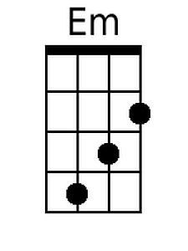
 |  |  |  |  |  |  | 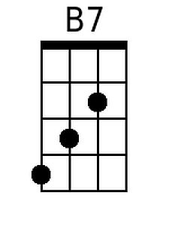
 |  |  |  |  |  |  | 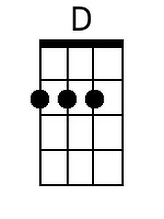
 |  |  |  |  |  |  | 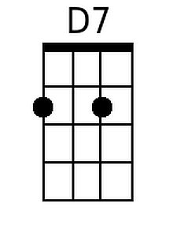
Baritone
 |  | 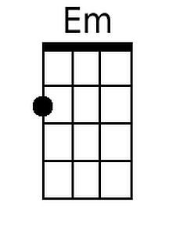 | 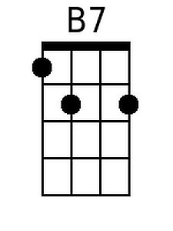 | 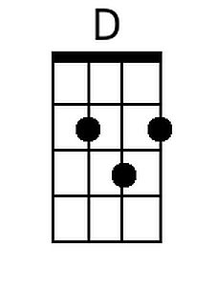 |  | 