We Wish You A Merry Christmas
(Why Can't We Have Christmas The Whole Year Around?)
We Wish You a Merry Christmas by The Kingston Trio from their LP "The Last Month of the Year."
Key of C - 3/4 Time – Version 1 - Briskly

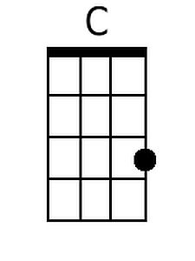 | 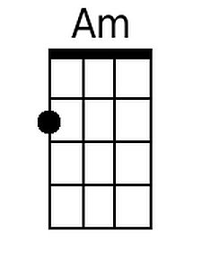 | 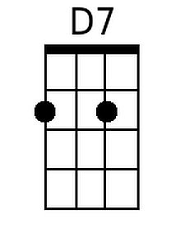 | 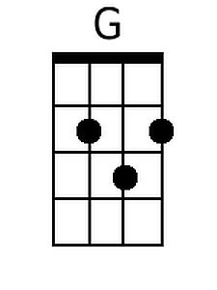 | 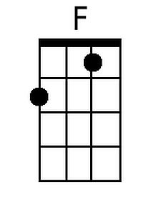 | 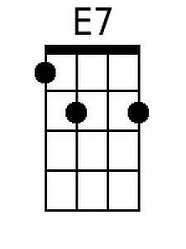 | 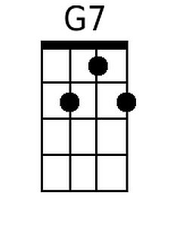 | 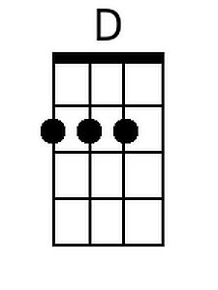

[Intro] | C | Am | D7 | G |

[Preface]
|C |Am |D7 |G
Once in a year it's not far a-miss,
|C |F |D7 |G7
To visit our neighbours and sing out like this:

[Chorus]
|C |F |D7 |G
We wish you a merry Christmas, We wish you a merry Christmas
|E7 |Am |F G7 |C
We wish you a merry Christmas, And a happy New Year.

|C |F |D7 |G
We want some figgy pudding, We want some figgy pudding
|E7 |Am |F G7 |C
We want some figgy pudding, And a cup of good cheer

|C |F |D7 |G
We won't go until we get some, We won't go until we get some
|E7 |Am |F G |C
We won't go until we get some, So bring it out here.

Bari
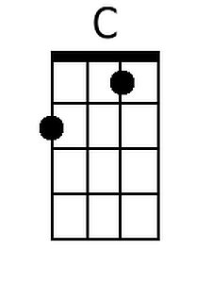 | 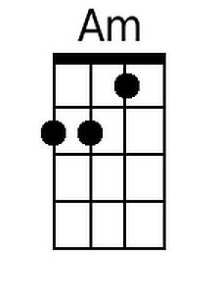 | 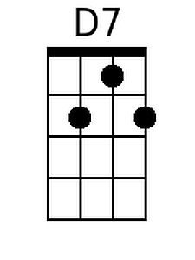 | 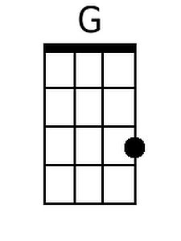 | 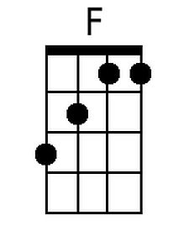 | 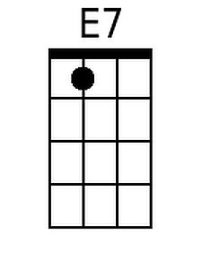 | 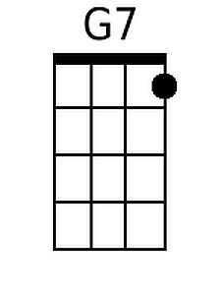 | 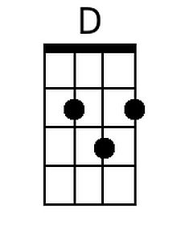

[Bridge]
|C |Am |D |G
Our friendship and love, good neighbors, a-bound
|C |F |D |G
And peace and good-will the whole year a-round
|C |F |C
Why can't we have Christmas the whole year a-round?
|Am |F |C
Why can't we have Christmas the whole year a-round? [Repeat Chorus Twice]

