
We Wish You A Merry Christmas
C81 C
(Why Can't We Have Christmas The Whole Year Around?)
We Wish You A Merry Christmas by The Weavers and "Paul Campbell"
Key of C - 3/4 Time – Briskly Except As Noted

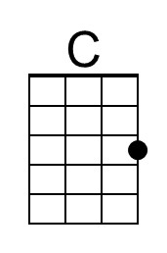 | 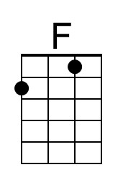 | 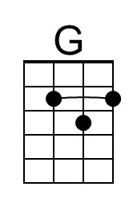 | 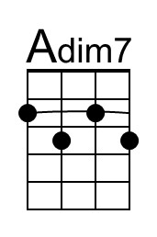 | 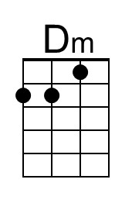 | 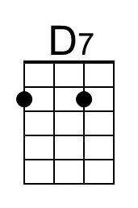 | 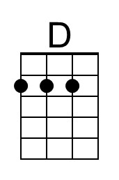 | 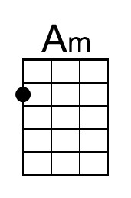 | 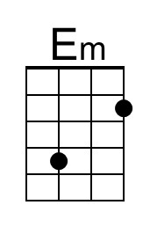

Intro | C . . | F . . | C . G | C .

Chorus
C F D G
We wish you a merry Christmas, We wish you a merry Christmas,
C F C G C | C .
We wish you a merry Christmas, And a happy New Year.

Instrumental Chorus

Preface
C Adim7 Dm G
Once in a year, it is not thought a - miss
C F D7 G
To visit our neighbors and sing out like this.

Chorus
C F D G
We wish you a merry Christmas, We wish you a merry Christmas,
C F C G C C .
We wish you a merry Christmas, And a happy New Year.

C F D7 G
1. We want some figgy pudding, We want some figgy pudding
C F C G C
We want some figgy pudding, And a cup of good cheer.

Baritone
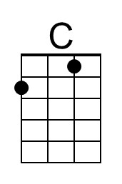 | 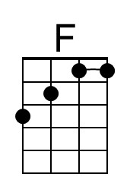 | 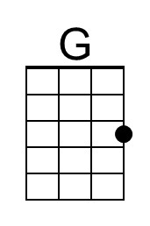 | 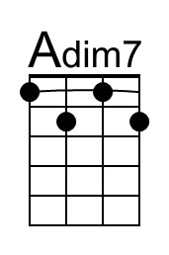 | 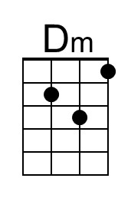 | 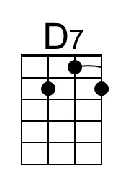 | 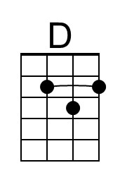 | 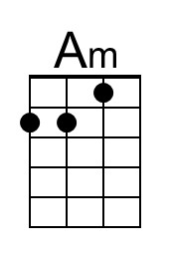 | 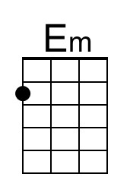

We Wish You A Merry Christmas (Why Can’t We Have Christmas The Whole Year Around) (C)
Page 2

C F D7 G
2. We won't go until we get some, We won't go until we get some,
C F C G C
We won't go until we get some, So bring it out here.

Chorus
C F D G
We wish you a merry Christmas, We wish you a merry Christmas,
C F C G C | C .
We wish you a merry Christmas, And a happy New Year.

Instrumental Chorus

Interlude
C Adim7 Dm G
Once in a year, it is not thought a-miss
C F D7 G
To visit our neighbors and sing out like this.
C Am D7 G
Of friendship and love, good neighbors a-bound
C F G F
And peace and good-will the whole year a-round.
Spoken
C F D G
(Pace!) (Shanti!) (Salud!) (Shalom!)
Resume Singing
C Adim7 Dm G
The words mean the same, what-ever your home.
C F G C
Why can't we have Christmas the whole year a-round?
Em F G C
Why can't we have Christmas the whole year a-round?

Chorus (Slower)
C F D G
We wish you a merry Christmas, We wish you a merry Christmas,
C F
We wish you a merry Christmas,
C . . C . . G . . C . . | C (Ring)
And a hap – py New Year.

Note: “Pace!” is pronounced “Pah-Chay.”
We Wish You A Merry Christmas
C81 G
(Why Can't We Have Christmas The Whole Year Around?)
We Wish You A Merry Christmas by The Weavers and "Paul Campbell"
Key of C - 3/4 Time – Briskly Except As Noted

 |  |  | 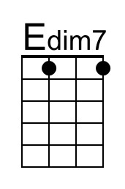 |  | 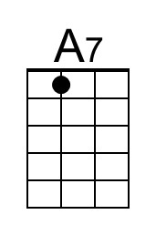 | 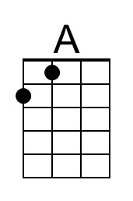 |  | 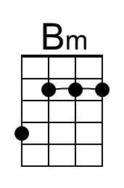

Intro | G . . | C . . | G . D | G .

Chorus
G C A D
We wish you a merry Christmas, We wish you a merry Christmas,
G C G D G | G .
We wish you a merry Christmas, And a happy New Year.

Instrumental Chorus

Preface
G Edim7 Am D
Once in a year, it is not thought a – miss
G C A7 D
To visit our neighbors and sing out like this.

Chorus
G C A D
We wish you a merry Christmas, We wish you a merry Christmas,
G C G D G | G .
We wish you a merry Christmas, And a happy New Year.

G C A7 D
1. We want some figgy pudding, We want some figgy pudding
G C G D G
We want some figgy pudding, And a cup of good cheer.

Bari
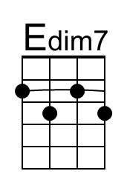

We Wish You A Merry Christmas (Why Can’t We Have Christmas The Whole Year Around) (G)
Page 2

G C A7 D
2. We won't go until we get some, We won't go until we get some,
G C G D G
We won't go until we get some, So bring it out here.

Chorus
G C A D
We wish you a merry Christmas, We wish you a merry Christmas,
G C G D G | G .
We wish you a merry Christmas, And a happy New Year.

Instrumental Chorus

Interlude
G Edim7 Am D
Once in a year, it is not thought a-miss
G C A7 D
To visit our neighbors and sing out like this.
G Em A7 D
Of friendship and love, good neighbors a-bound
G C D C
And peace and good-will the whole year a-round.
Spoken
G C A D
(Pace!) (Shanti!) (Salud!) (Shalom!)
Resume Singing
G Edim7 Am D
The words mean the same, what-ever your home.
G C D G
Why can't we have Christmas the whole year a-round?
Bm C D G
Why can't we have Christmas the whole year a-round?

Chorus (Slower)
G C A D
We wish you a merry Christmas, We wish you a merry Christmas
G C
We wish you a merry Christmas,
G . . G . . D . . G . . G Ring
And a hap – py New Year.

Note: “Pace!” is pronounced “Pah-Chay.”

