We Wish You A Merry Christmas
(Why Can't We Have Christmas The Whole Year Around?)
We Wish You A Merry Christmas by The Weavers and "Paul Campbell"
Key of C - 3/4 Time – Briskly Except As Noted

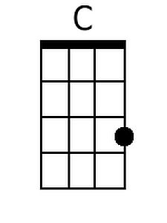 | 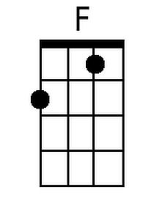 | 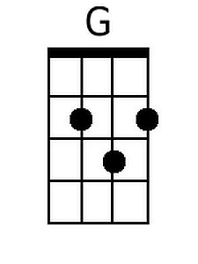 | 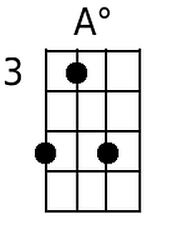 | 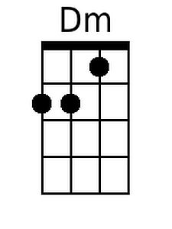 | 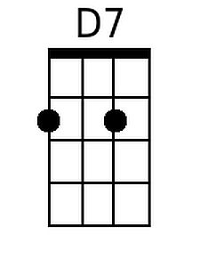 | 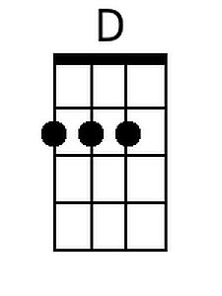 | 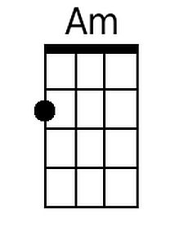 | 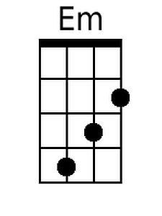

[Intro]: |C . . |F . . |C . G |C .

[Chorus]
|C |F |D |G
We wish you a merry Christmas, We wish you a merry Christmas
|C |F |C G |C | C .
We wish you a merry Christmas, And a happy New Year.

[Instrumental Chorus]

[Preface]
|C |A° |Dm |G
Once in a year, it is not thought a - miss
|C |F |D7 |G
To visit our neighbors and sing out like this.

[Chorus]
|C |F |D |G
We wish you a merry Christmas, We wish you a merry Christmas
|C |F |C G |C | C .
We wish you a merry Christmas, And a happy New Year.

|C |F |D7 |G
1. We want some figgy pudding, We want some figgy pudding
|C |F |C G |C
We want some figgy pudding, And a cup of good cheer.

Bari
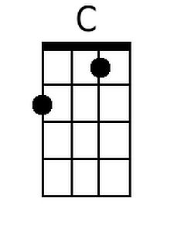 | 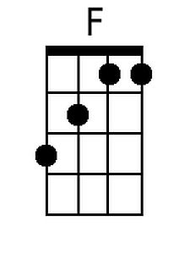 | 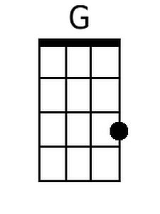 | 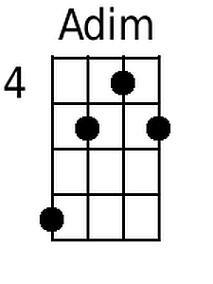 | 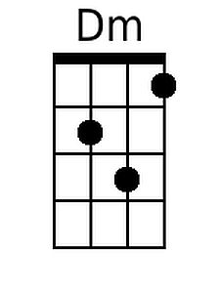 | 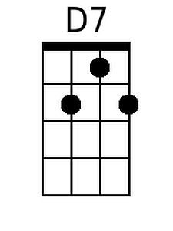 | 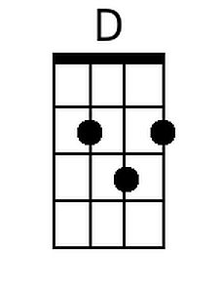 | 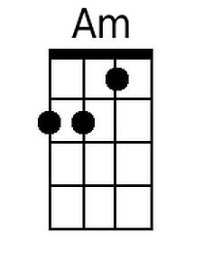 | 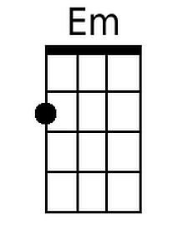

|C |F |D7 |G
2. We won't go until we get some, We won't go until we get some,
|C |F |C G |C
We won't go until we get some, So bring it out here.

[Chorus]
|C |F |D |G
We wish you a merry Christmas, We wish you a merry Christmas
|C |F |C G |C | C .
We wish you a merry Christmas, And a happy New Year.

[Instrumental Chorus]

[Interlude:]
|C |A° |Dm |G |
Once in a year, it is not thought a-miss
|C |F |D7 |G |
To visit our neighbors and sing out like this.
|C |Am |D7 |G |
Of friendship and love, good neighbors a-bound
|C |F |G |F |
And peace and good-will the whole year a-round.
[Spoken]
|C |F |D |G
(Pace!) (Shanti!) (Salud!) (Shalom!)
[Resume Singing]
|C |A° |Dm |G
The words mean the same, what-ever your home.
|C |F |G |C
Why can't we have Christmas the whole year a-round?
|Em |F |G |C
Why can't we have Christmas the whole year a-round?

[Slower]
[Chorus]
|C |F |D |G
We wish you a merry Christmas, We wish you a merry Christmas
|C |F
We wish you a merry Christmas,
|C . . |C . . |G . . |C . . |C [Ring]
And a hap – py New Year.

Note: “Pace!” is pronounced “Pah-Chay,”

