**We Wish You a Merry Christmas (Traditional)**

C20

**C F**

We wish you a Merry Christmas

**D7 G**



C

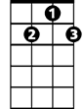

G7

F



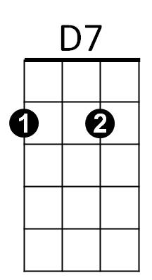We wish you a Merry Christmas

**C F**

We wish you a Merry Christmas

**D7 G7 C**

And a Happy New Year

**Chorus:**

**C G7**



G

Good tidings we bring

**D7 G**

To you and your kin,

**C G**

We wish you a Merry Christmas

**F G7 C**

And a Happy New Year

**C F**

Now bring us some figgy pudding

**D7 G**

Now bring us some figgy pudding

**C F**

**BARITONE**

Now bring us some figgy pudding



D7



F

C



**D7 G7 C**

And a cup of good cheer

**(Chorus)**

**C F**

We won’t go until we get some

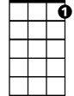

G7



G

**D7 G**

We won’t go until we get some

**C F**

We won’t go until we get some

**D7 G7 C**

So bring some right here

**Repeat first verse; last line slowly.**