We'll Meet Again (Ross Parker & Hughie Charles, 1939)
We'll Meet Again by Vera Lynn (Sept. 28, 1939)

C E7 A6 Bb7  We'll meet again don't know where, don't know when,  D7 Am Dm G7  But I know we'll meet a-gain some sunny day.  C E7 A6 Bb7  Keep smilin' through just like you always do  D7 Dm7 C6 Bb7  Till the blue skies drive the dark clouds far a-way.  Bridge  (Tacet) C C7#5  So will you please say hello to the folks that I know.  Fmaj7 F6 - Fmaj7  Tell them I won't be long  D7 D7#5  They'll be happy to know that as you saw me go  G7 Dm7 G7  I was singing this song.  C E7 A6  We'll meet again don't know where, don't know when,  D7 Am Dm G7  But I know we'll meet a-gain some sunny day.  Repeat from top.  Outro (retard last line)  C E7 A6 Bb7  We'll meet again don't know where, don't know when,  D7 Am Dm G7  But I know we'll meet a-gain some sunny day. |  |  |  |  |  | 
 |  |  |  |  | 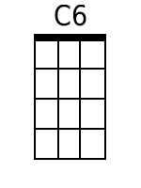 | Bb7
 |  |  |  |  |  | 
 |  |  |  |  |  | 
 |  |  |  |  | C7aug | Fmaj7
 |  |  |  |  | F6 | D7aug
 |  |  |  |  | Dm7
Bari
 |  | 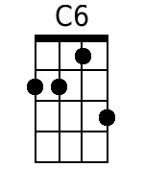 | 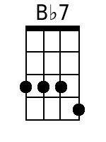 |  |  | 
 | 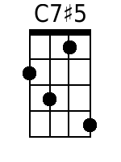 | 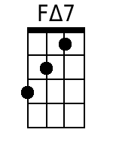 | 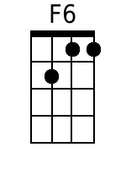 | 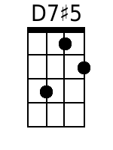 | 

We'll Meet Again (Ross Parker & Hughie Charles, 1939)
We'll Meet Again by Vera Lynn (Sept. 28, 1939)

G B7 E6 F7
We'll meet a-gain don't know where, don't know when,
A7 Em Am D7
But I know we'll meet a-gain some sunny day.
G B7 E6 F7
Keep smilin' through just like you always do
A7 Am7 G6 F7
Till the blue skies drive the dark clouds far a-way.

Bridge
(Tacet) G G7#5
So will you please say hello to the folks that I know.
Cmaj7 C6 - Cmaj7
Tell them I won't be long
A7 A7#5
They'll be happy to know that as you saw me go
D7 Am7 D7(b9)
I was singing this song

G B7 E6 F7
We'll meet a-gain don't know where, don't know when,
A7 Em Am D7
But I know we'll meet a-gain some sunny day.

Repeat from top.

Outro (retard last line)
G B7 E6 F7
We'll meet a-gain don't know where, don't know when,
A7 Em Am D7
But I know we'll meet a-gain some sunny day.
Bari
 | 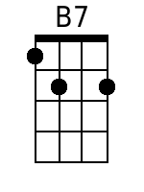 | 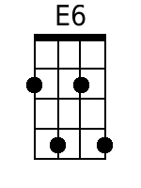 | 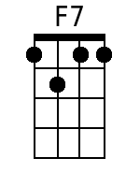 |  | 
 | 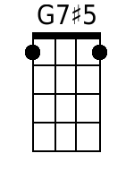 | 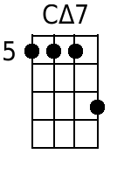 |  | 

