Weekend in New England (Randy Edelman, 1975)
In ¾ Time – Weekend in New England by Barry Manilow – Key of C

Intro: C | F | F | C | Em | Am | Dm7 | F F G |  C Em F G  Last night I said good-bye, __ now it seems years  C Em F G  I'm back in the city where nothing is clear  F C Dm7 G7  But thoughts of me holding you, bringing us near, and tell me...  Chorus  C F G C F G  When will our eyes meet? __ When can I touch you?  C F E7 Am D7sus D7  When will this strong yearning end?  Dm7 G7 C  And when will I hold you a-gain?  F | F | C | C  C Em F G  Time in New England __ took me a-way  C Em F G  to long rocky beaches and you by the bay.  F C Dm7 G7  We started a story whose end must now wait,  And tell me... Chorus  C F C F  I feel the change comin', _ I feel the wind blow  C F Bb C Dm7  __ I feel brave and daring, I feel my blood flow!  C7 F C Dm7 C Dm7  With you, I could bring out all the love that I have  C7 F C D7 G7 | G7 | G7 |  With you, there's a heaven, so earth ain't so bad,  G  And tell me  D G D G  When will our eyes meet? __ When can I touch you?  D G F# Bm E7  __ When will this strong yearn-ing end?  Em A7 A7 | A7 | A7 |  And when will I hold you  D | G | A7 | Bm | E7 |  a-gain?  Em G D | D | D | D  When will I hold you a-gain? | GCEA
 | 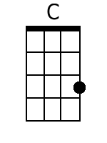 | 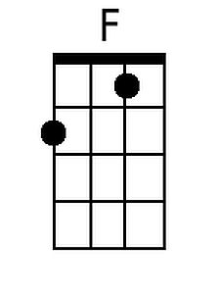 | 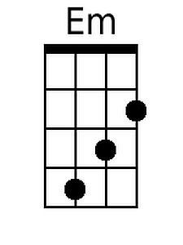
 | 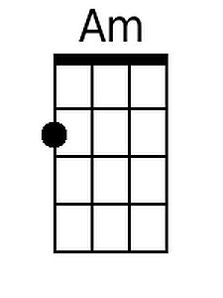 | 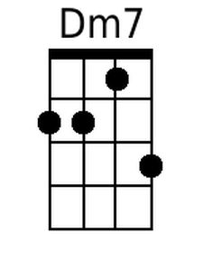 | 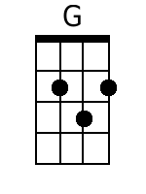
 | 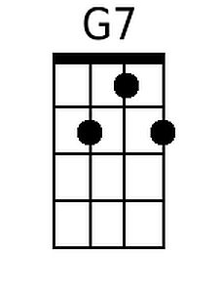 | 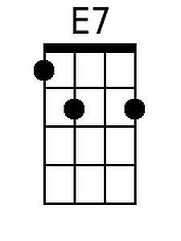 | 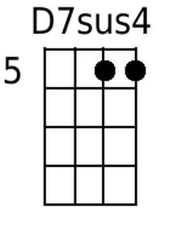
 | 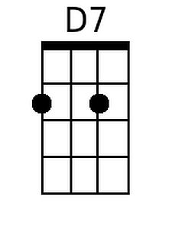 | 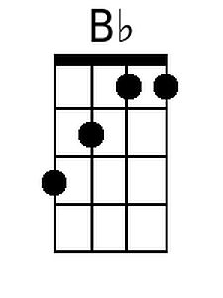 | 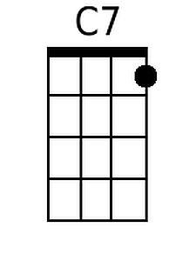
 | 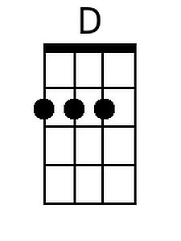 | 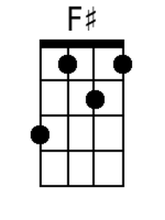 | 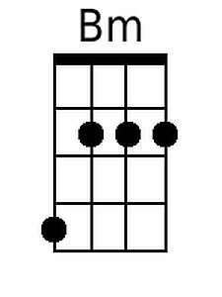
 | 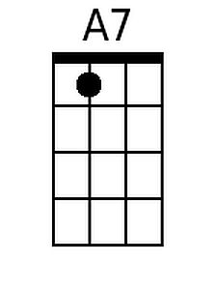

Weekend in New England (Randy Edelman, 1975)
In ¾ Time – Weekend in New England by Barry Manilow – Key of C

Intro: C | F | F | C | Em | Am | Dm7 | F F G |  C Em F G  Last night I said good-bye, __ now it seems years  C Em F G  I'm back in the city where nothing is clear  F C Dm7 G7  But thoughts of me holding you, bringing us near, and tell me...  Chorus  C F G C F G  When will our eyes meet? __ When can I touch you?  C F E7 Am D7sus D7  When will this strong yearning end?  Dm7 G7 C  And when will I hold you a-gain?  F | F | C | C  C Em F G  Time in New England __ took me a-way  C Em F G  to long rocky beaches and you by the bay.  F C Dm7 G7  We started a story whose end must now wait,  And tell me... Chorus  C F C F  I feel the change comin', _ I feel the wind blow  C F Bb C Dm7  __ I feel brave and daring, I feel my blood flow!  C7 F C Dm7 C Dm7  With you, I could bring out all the love that I have  C7 F C D7 G7 | G7 | G7 |  With you, there's a heaven, so earth ain't so bad,  G  And tell me  D G D G  When will our eyes meet? __ When can I touch you?  D G F# Bm E7  __ When will this strong yearn-ing end?  Em A7 A7 | A7 | A7 |  And when will I hold you  D | G | A7 | Bm | E7 |  a-gain?  Em G D | D | D | D  When will I hold you a-gain? | DGBE
 | 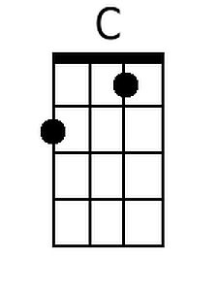 | 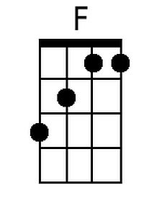 | 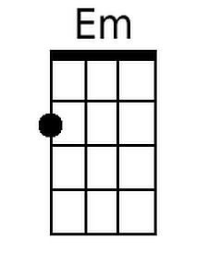
 | 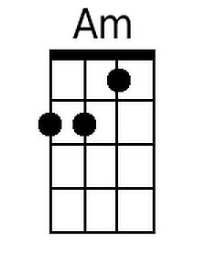 | 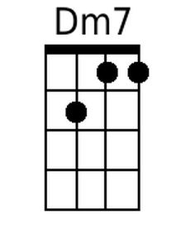 | 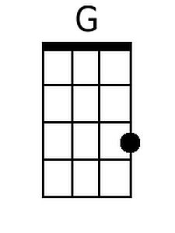
 | 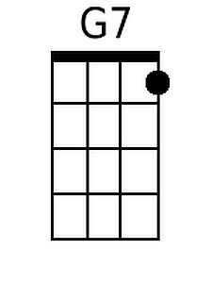 | 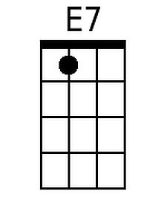 | 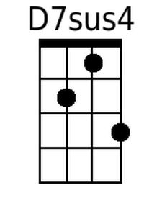
 | 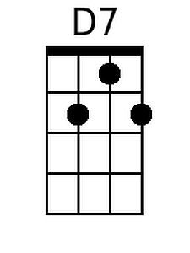 | 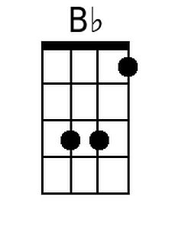 | 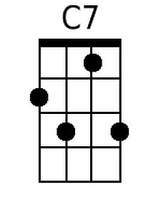
 | 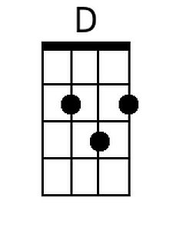 | 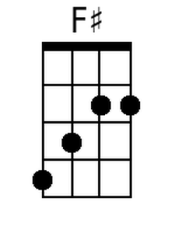 | 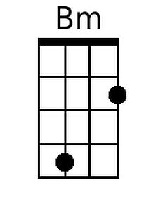
 | 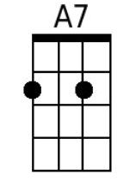

Weekend in New England (Randy Edelman, 1975)
In ¾ Time – Weekend in New England by Barry Manilow – Key of G

Intro: | G | C | C | G | Bm | Em | Am7 | C C D|  G Bm C D  Last night I said good-bye, __ now it seems years  G Bm C D  I'm back in the city where nothing is clear  C G Am7 D7  But thoughts of me holding you, bringing us near, and tell me...  Chorus  G C D |  When will our eyes meet?  G C D |  __ When can I touch you?  G C B7 Em | A7sus A7  When will this strong yearning end?  Am7 D7 G  And when will I hold you a-gain?  C | C | G | G |  G Bm C D  Time in New England __ took me a-way  G Bm C D  to long rocky beaches and you by the bay.  C G Am7 D7  We started a story whose end must now wait,  And tell me... Chorus  G C G C  I feel the change comin', _ I feel the wind blow  G C F G Am7  __ I feel brave and daring, I feel my blood flow!  G7 C G Am7 G Am7  With you, I could bring out all the love that I have  G7 C G A7 D7 | D7 | D7 |  With you, there's a heaven, so earth ain't so bad,  D  And tell me…  A D A D  When will our eyes meet? __ When can I touch you?  A D C# F#m – B7  __ When will this strong yearn-ing end?  Bm E7 | E7 | E7 | E7 |  And when will I hold you…  A | D | E7 | F#m | B7 |  a-gain?  Bm D A | A | A | A |  When will I hold you a-gain? | GCEA
 |  | 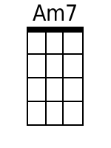
 |  | 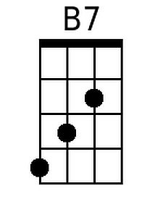 | 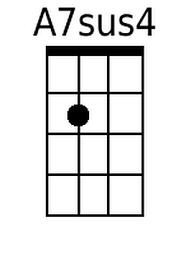
 | 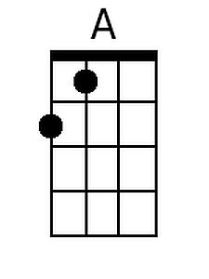 | 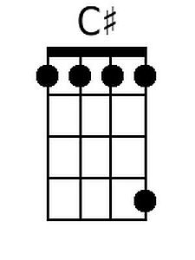 | 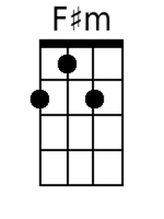

Weekend in New England (Randy Edelman, 1975)
In ¾ Time – Weekend in New England by Barry Manilow – Key of G

Intro: | G | C | C | G | Bm | Em | Am7 | C C D|  G Bm C D  Last night I said good-bye, __ now it seems years  G Bm C D  I'm back in the city where nothing is clear  C G Am7 D7  But thoughts of me holding you, bringing us near, and tell me...  Chorus  G C D |  When will our eyes meet?  G C D |  __ When can I touch you?  G C B7 Em | A7sus A7  When will this strong yearning end?  Am7 D7 G  And when will I hold you a-gain?  C | C | G | G |  G Bm C D  Time in New England __ took me a-way  G Bm C D  to long rocky beaches and you by the bay.  C G Am7 D7  We started a story whose end must now wait,  And tell me... Chorus  G C G C  I feel the change comin', _ I feel the wind blow  G C F G Am7  __ I feel brave and daring, I feel my blood flow!  G7 C G Am7 G Am7  With you, I could bring out all the love that I have  G7 C G A7 D7 | D7 | D7 |  With you, there's a heaven, so earth ain't so bad,  D  And tell me…  A D A D  When will our eyes meet? __ When can I touch you?  A D C# F#m – B7  __ When will this strong yearn-ing end?  Bm E7 | E7 | E7 | E7 |  And when will I hold you…  A | D | E7 | F#m | B7 |  a-gain?  Bm D A | A | A | A |  When will I hold you a-gain? | DBGE
 |  | 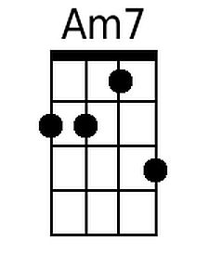
 |  | 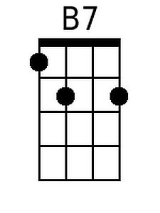 | 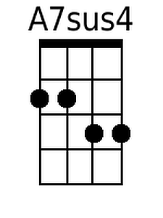
 | 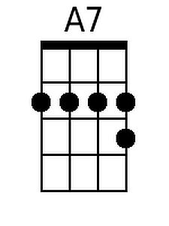
 | 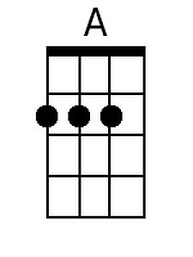 | 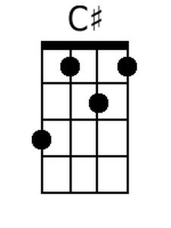 | 