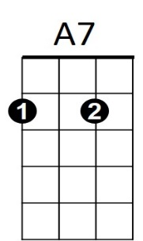**We'll Meet Again (Ross Parker & Hughie Charles, 1939)**

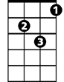

Dm

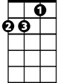

Am

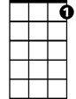

G7

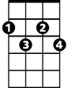

Gdim

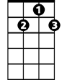

D7



F

C

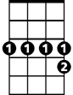

Bb7

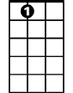

E7

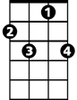

C7

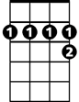

A7

|  |  |
| --- | --- |
| **C E7 Am Bb7 A7**  We'll meet again don't know where, don't know when,  **D7 Dm7 G7**  But I know we'll meet again some sunny day.  **C E7 Am Bb7 A7**  Keep smilin' through just like you always do  **D7 Dm7 G7 C G7 C**  Till the blue skies drive the dark clouds far a-way.  **(Tacet) C7**  So will you please say hello to the folks that I know.  **F**  Tell them I won't be long  **D7**  They'll be happy to know that as you saw me go  **G7 Dm7 G7**  I was singing this song.  **C E7 Am Bb7 A7**  We'll meet again don't know where, don't know when,  **D7 Dm7 G7 C G7**  But I know we'll meet a-gain some sunny day.  **Repeat from top.**  **Outro (retard last line)**  **C E7 Am Bb7 - A7**  We'll meet again don't know where, don't know when,  **D7 Dm7 G7 C F G7 C**  But I know we'll meet again some sunny day. | **D7 var.jpg**  C7  F  Gdim  Dm  G7  A7  Am  C  E7  Bb7 |
| **Bari** | |