**We'll Meet Again (Ross Parker & Hughie Charles, 1939)**

**C E7 Am Bb7 A7**

E7

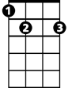

We'll meet again don't know where don't know whe - n

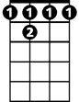

Bb7



C

**D7 Am Dm G7**

But I know we'll meet again some sunny day

**C E7 Am Bb7 A7**

Keep smiling through just like you always do - o

**D7 Dm G7 C**

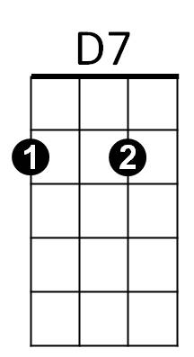Till the blue skies drive the dark clouds far away

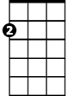

Am

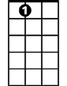

A7

**TACET C7**

So will you please say hello to the folks that I know

**F**

Tell them I won't be long

**D7**

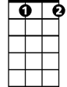

Gdim

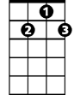

G7

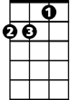

Dm

They'll be happy to know that as you saw me go

**G7 Gdim G7**

I was sing-ing this song

**C E7 Am Bb7 A7**

We'll meet again don't know where don't know whe - n

F

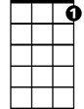

C7

**D7 Am Dm G7 C**

But I know we'll meet a - gain some sunny day

**Repeat from Beginning**

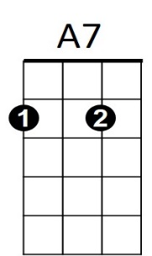

**BARITONE**

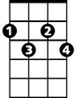

Gdim

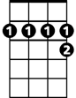

A7

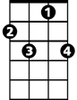

C7



F



G7

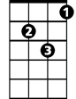

Dm



Am



D7



E7

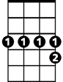

Bb7

C

