What Child Is This? (Am)
Words: William Chatterton Dix, 1865. Waltz - ¾ Time
Music: "Greensleeves," 16th Century English melody arranged by Sir John Stainer

Intro: Strum in on Am.  Am C G Am Dm Em  1. What Child is this who, laid to rest on Mary's lap is sleeping?  Am C G Am  Whom Angels greet with anthems sweet, while shepherds watch are keeping?  Em C G Am Dm Em  This, this is Christ the King, whom shepherds guard and Angels sing;  C G Am Em Am  Haste, haste, to bring Him laud, The Babe, the Son of Mary.  Am C G Am Dm Em  2. Why lies He in such mean estate, Where ox and ass are feeding?  Am C G Am  Good Christians, fear, for sinners here, the silent Word is pleading.  Em C G Am Dm Em  Nails, spear shall pierce Him through, the cross be borne for me, for you.  C G Am Em Am  Hail, hail the Word made flesh, The Babe, the Son of Mary.  Am C G Am Dm Em  3. So bring Him incense, gold and myrrh, Come peasant, king to own Him;  Am C G Am  The King of kings sal-vation brings, Let loving hearts enthrone Him.  Em C G Am Dm Em  Raise, raise a song on high, The virgin sings her lullaby.  C G Am Em Am  Joy, joy for Christ is born, The Babe, the Son of Mary. |  |  |  |  |  |  |  |  | 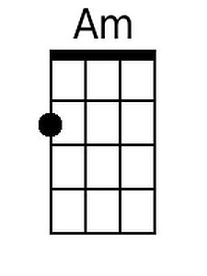
 |  |  |  |  |  |  |  |  | 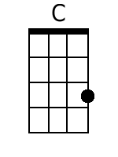
 |  |  |  |  |  |  |  |  | 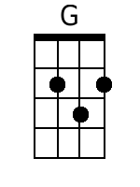
 |  |  |  |  |  |  |  |  | 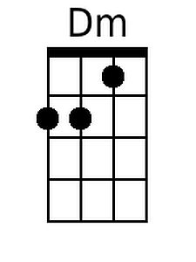
 |  |  |  |  |  |  |  |  | 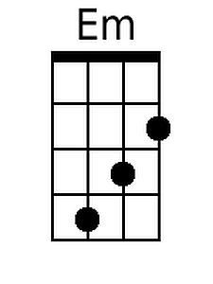
Baritone
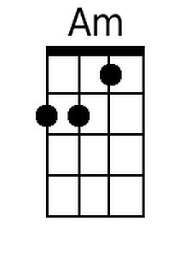 | 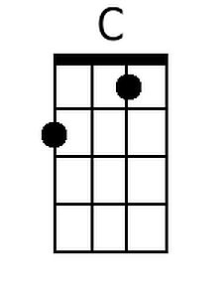 | 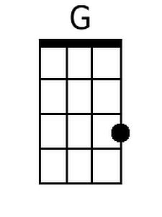 | 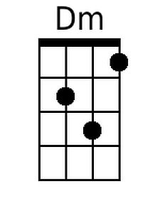 | 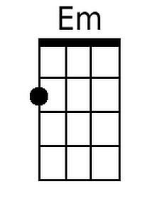

What Child Is This? (Em)
Words: William Chatterton Dix, 1865. Waltz - ¾ Time
Music: "Greensleeves," 16th Century English melody arranged by Sir John Stainer

Intro: Strum in on Em.

Em G D Em Am Bm
1. What Child is this who, laid to rest on Mary's lap is sleeping?
Em G D Em
Whom Angels greet with anthems sweet, while shepherds watch are keeping?
Bm G D Em Am Bm
This, this is Christ the King, whom shepherds guard and Angels sing;
G D Em Bm Em
Haste, haste, to bring Him laud, The Babe, the Son of Mary.

Em G D Em Am Bm
2. Why lies He in such mean estate, Where ox and ass are feeding?
Em G D Em
Good Christians, fear, for sinners here, the silent Word is pleading.
Bm G D Em Am Bm
Nails, spear shall pierce Him through, the cross be borne for me, for you.
G D Em Bm Em
Hail, hail the Word made flesh, The Babe, the Son of Mary.

Em G D Em Am Bm
3. So bring Him incense, gold and myrrh, Come peasant, king to own Him;
Em G D Em
The King of kings sal-vation brings, Let loving hearts enthrone Him.
Bm G D Em Am Bm
Raise, raise a song on high, The virgin sings her lullaby.
G D Em Bm Em
Joy, joy for Christ is born, The Babe, the Son of Mary.

 |  |  |  |  |  |  |  | 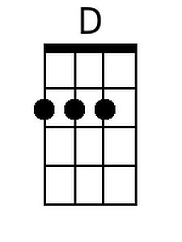
 |  |  |  |  |  |  |  | 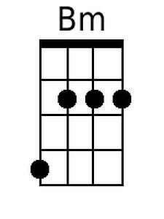
Baritone
 |  | 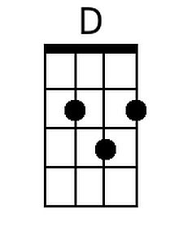 |  | 