**What Kind of Fool Am I (Leslie Bricusse / Anthony Newley)**

**G C**

What kind of fool am I

**Dm G**

Who never fell in love

**C A7**

It seems that I'm the only one

**Dm G**

That I have been thinking of

**C Am**

What kind of man is this?

**D7**

An empty shell

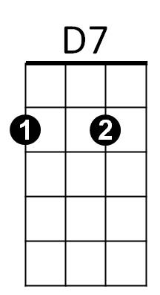 **G Em**

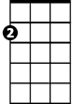

Am

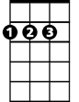

D

Em

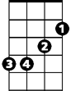

A lonely cell in which

**Am D G**

An empty heart must dwell

**C**

What kind of lips are these

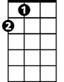

A

F

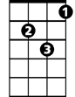

Gm

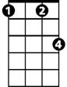

Fm

**Dm G**

That lied with every kiss

**C Gm**

That whispered empty words of love

**A Gm C**

That left me alone like this

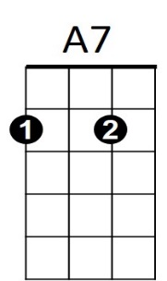

C



Dm

**F Fm**

**BARITONE**



G

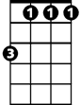

Fm

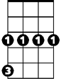

Gm



A

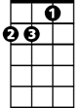

Am

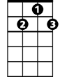

D7



Em



D

Why can't I fall in love

**C D**

Like any other man

**Dm**

And maybe then I'll know

**Fm G C Am F G**

What kind of fool I am.

**G C**

What kind of clown am I?

**Dm G**

What do I know of life?



F

**C Gm A**

Why can't I cast away the mask of play

**Gm C**

And live my life?

**F Fm**

Why can't I fall in love

**C D**

Till I don't give a damn

**Dm**

And maybe then I'll know

**Fm G C Am F G** **Dm C**

What kind of fool I am.



C



Dm



G

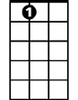

A7