**Somewhere Over the Rainbow / What a Wonderful World (Iz version)**

**(E. Y. Harburg / Harold Arlen / Louis Armstrong)**

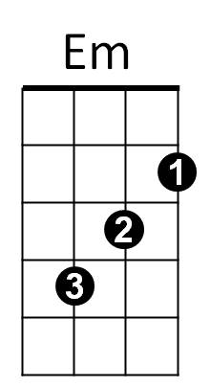**Intro: C Em Am F (2x)**



C

Oooooo-oooooooo-ooooooooo

**C Em F C**

Somewhere over the rainbow, way up high

**F C G Am F**

F

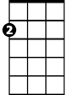

Am

And the dreams that you dreamed of once in a lullaby

**C Em F C**

Somewhere over the rainbow, blue birds fly

**F C**

And the dreams that you dreamed of

**G Am F**



G

Dreams really do come true ooh oh

**C**

Someday I'll wish upon a star

**G Am F**And wake up where the clouds are far behind me

**C**

Where trouble melts like lemon drops

**G Am F**High above the chimney tops, that's where you'll find me



G



Em

C

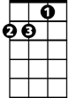

Am



F

**BARITONE**

**C Em F C**

Somewhere over the rainbow, blue birds fly

**F C G Am F**

And the dreams that you dare to, why, oh why can't I?

**C G Am C**

Well, I see trees of green and red roses too

**F C G Am**

I watch them bloom for me and you

**F G Am F**

And I think to myself, what a wonderful world

**C G Am C**

Well, I see skies of blue and I see the clouds of white

**F C G Am**

And the brightness of day, I like the dark

**F G Am F**

And I think to myself, what a wonderful world

**G Am**

The colors of the rainbow, so pretty in the sky

**G Am**

Smiles on the faces of people passing by

**F C F C**

I see friends shaking hands saying, “How do you do?”

**F C F G**

They’re really saying, “I – I love you”

**C G Am C**

I see babies crying, I watch them grow

**F C G Am**

They’ll learn much more than we’ll know

**F G Am F**

And I think to myself, what a wonderful world, world

**C**

Someday I'll wish upon a star

**G Am F**And wake up where the clouds are far behind me

**C**

Where trouble melts like lemon drops

**G Am F**High above the chimney tops, that's where you'll find me

**C Em F C**

Oh, somewhere over the rainbow way up high

**F C G Am F**

And the dreams that you dare to, why, oh why can't I? I?

**End with intro**