**What's New Pussycat? (Burt Bachrach / Hal David)**

**Chorus:**

**C F G**

What's new pussycat? W hoa, whoa, whoa, whoa.



C



G

F

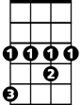

Ab



Bb

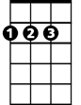

D

**C F G C D**

What's new pussycat? Whoa, whoa, whoa, whoa.

**G D Bb**

Pussycat, Pussycat, I've got flowers,

**Ab**

And lots of hours to spend with you.

**D**

So, go and powder your cute little pussycat nose!

**G Bm C Bm Am C Bm**

Pussycat, Pussycat, I love you. Yes, I do!

**Am D G**

Em

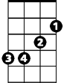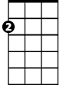

Am

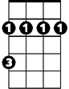

Bm

You and your pussycat nose!

**(CHORUS)**

**G D Bb**

Pussycat, Pussycat, you're so thrilling,

**Ab**

and I'm so willing, to care for you.

**D**

So, go and make up your big little pussycat eyes!

**G Bm C Bm Am C Bm**

Pussycat, Pussycat, I love you. Yes, I do!

**BARITONE**

**Am D G**

C



F



G

You and your pussycat eyes!

**(CHORUS)**

**G D Bb**

Pussycat, Pussycat, you're delicious,

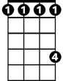

Ab

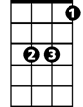

Bb



D

**Ab**

And if my wishes can all come true.

**D**

I'll soon be kissing your sweet little pussycat lips!

**G Bm C Bm Am C Bm**

Pussycat, Pussycat, I love you. Yes, I do!

Bm

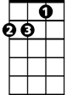

Am



Em

**Am D G Em**

You and your pussycat lips! Whoa, whoa!

**Am D G Em**

You and your pussycat eyes! Whoa, whoa!

**Am D G**

You..and your..pussycat..no..se!