When Irish Eyes Are Smiling (Chauncey Olcott, George Graff, Jr., & Ernest R. Ball, 1912)
Tempo = 159 bpm
C  There's a tear in your eye,  and I'm wondering why  G7  For it never should be there at all  With such power in your smile  C A7  Sure a stone you'd be-guile  D7 G  So there's never a teardrop should fall  C  When your sweet lilting laughter's  like some fairy song  C C7 F  And your eyes twinkle bright as can be  D7  You should laugh all the while  G G7  and all other times smile  D7 G G7  And now smile a smile for me  Chorus:  C G C | C  When Irish eyes are smiling,  F C | C  Sure tis like a morn in spring.  F C A7  In the lilt of Irish laughter  D7 G | G  You can hear the angels sing.  C G C C7  When Irish hearts are happy,  F C | C  All the world seems bright and gay,  F C A7  And when Irish eyes are smil-ing,  D7 G7 C | C  Sure they’ll steal your heart away. |  |  |  | C  For your smile is a part, of the love in your heart  G7  And it makes even sunshine more bright  Like the linnet's sweet song  C A7  Crooning all the day long  D7 G  Comes your laughter so tender and light.  C  For the springtime of life, is the sweetest of all  C C7 F  And there is ne'er a real care or re-gret  D7  And while springtime is ours  G G7  Throughout all of youth's hours  D7 G G7  Let us smile each chance we get.  [Chorus] (2x)  Outro Retard  F C A7  And when Irish eyes are smil-ing  D7 G7 C_ C C C  Sure they’ll steal your heart a-way. [Hold]
 |  |  |  | 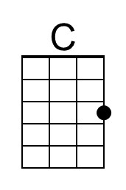 | 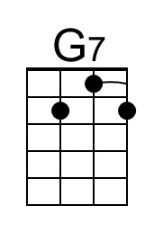 | 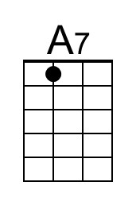 | 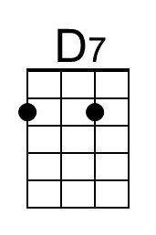
 |  |  |  | 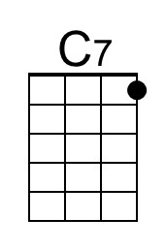 | 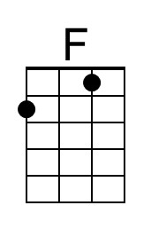 | 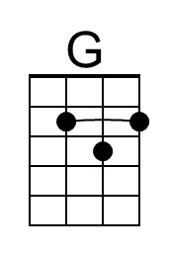
Bari | 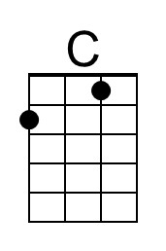 | 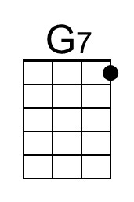 | 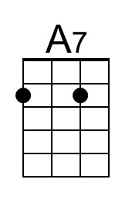 | 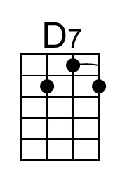 | 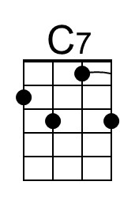 | 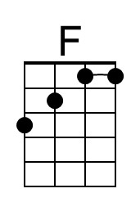 | 