**When Irish Eyes Are Smiling (Chauncey Olcott, George Graff Jr)**

**C**

There's a tear in your eye, and I'm wondering why

**G7**

For it never should be there at all

With such power in your smile

**C A7**

Sure a stone you'd bequile

**D7 G**

So there's never a teardrop should fall

**G7**

When your sweet lilting laughter's like some fairy song

**C C7 F**

And your eyes twinkle bright as can be

**D7 G**

You should laugh all the while and all other times



C

**G7**

smile

**D7 G G7**

And now smile a smile for me

**Chorus:**

**C G C**

When Irish eyes are smiling,

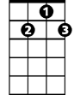

G7

**F C**

Sure tis like a morn in spring

**F C A7**

In the lilt of Irish laughter

**D7 G**

You can hear the angels sing

**C G C C7**

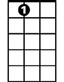

A7

When Irish hearts are happy

**F C**

All the world seems bright and gay

**F C A7**

And when Irish eyes are smil-ing

**D7 G7 C**

Sure they’ll steal your heart away

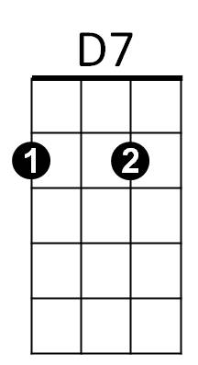

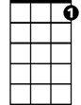

C7

F



G

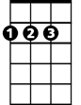

D

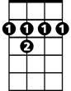

B7

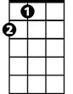

A

E7

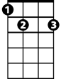

**C**

For your smile is a part, of the love in your heart

**G7**

And it makes even sunshine more bright

Like the linnet's sweet song

**C A7**

Crooning all the day long

**D7 G**

Comes your laughter and light

**G7**

For the springtime of life, is the sweetest of all

**C C7 F**

And there is ne'er a real care or regret

**D7**

And while springtime is ours

**BARITONE**

**G G7**

Throughout all of youth's hours

C



**D7 G G7**

Let us smile each chance we get

**[Chorus]**

**A7 D A D**

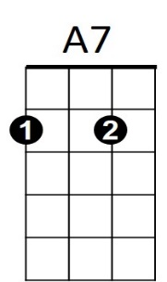 When Irish eyes are smiling,

**G D**

Sure 'tis like a morn in spring

**G D B7**

In the lilt of Irish laughter

**E7 A**

You can hear the angels sing

**D A D D7**

When Irish hearts are happy



G7

**G D**

All the world seems bright and gay

**(2X)**

**G D B7**

And when Irish eyes are smil-ing

**E7 A7 D**

Sure they’ll steal your heart away



A

B7



E7



D



G



F

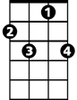

C7



D7