When Will I Be Loved (Phil Everly, 1960) (C)
When Will I Be Loved by Linda Ronstadt

C C  __ I've been cheated. __ Been mistreated  C F G C  When will I be loved?  C F G C F G  I've been put down, I've been pushed a-round  C F G C  When will I be loved?  Bridge  F G F C  When I find a new man, that I want for mine  F G Am7 G  He always breaks my heart in two, it happens every time  C F G C F G  I've been made blue, I've been lied to  C F G C  When will I be loved?  Instrumental Verse  Repeat Bridge  C F G C F G  I've been chea-ted, Been mis-trea-ted  C F G C C F G C  When will I be loved? When will I be loved?  C F G F C  Tell me, when will I be lo-o-o-ved? |  |  |  |  |  |  | 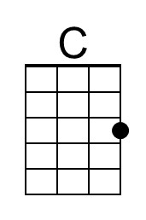
 |  |  |  |  |  |  | 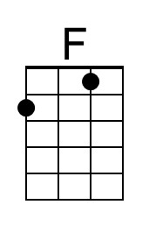
 |  |  |  |  |  |  | 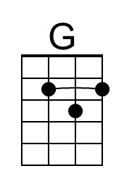
 |  |  |  |  |  |  | 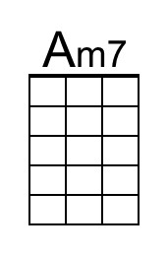
 |  |  | Bari | 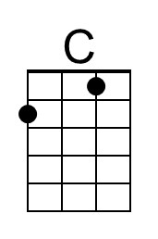 | 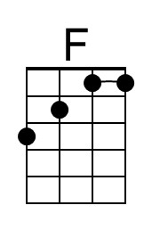 | 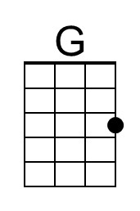 | 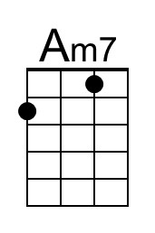

When Will I Be Loved (Phil Everly, 1960) (G)
When Will I Be Loved by Linda Ronstadt

G G
__ I've been cheated. __ Been mistreated
G C D G
When will I be loved?

G C D G C D
I've been put down, I've been pushed a-round
G C D G
When will I be loved?

Bridge
C D C G
When I find a new man, that I want for mine
C D Em7 D
He always breaks my heart in two, it happens every time

G C D G C D
I've been made blue, I've been lied to
G C D G
When will I be loved?

Instrumental Verse

Repeat Bridge

G C D G C D
I've been chea-ted, Been mis-trea-ted
G C D G G C D G
When will I be loved? When will I be loved?
G C D C G
Tell me, when will I be lo-o-o-ved?

 |  |  |  |  |  |  | 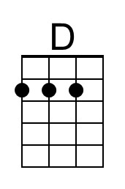
 |  |  |  |  |  |  | 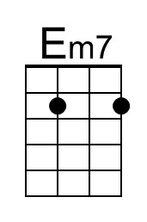
 |  |  | Bari |  |  | 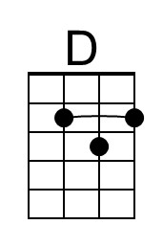 | 