**When Will I Be Loved (Phil Everly) (Linda Ronstadt arrangement) Key C**

**C F G**

I've been cheat-ed,

**C F G**

Been mis-treat-ed

**C F G C F G**

When will I – I be loved?

**C F G**

I've been pushed down

**C F G**

I've been pushed 'round

**C F G C F G**

When will I – I be loved?

**Chorus:**

**F G**

When I find a new man,

**F C**

That I want for mine

**F G**

He always breaks my heart in two,

**C G G7**

It happens every time

**C F G**

I've been made blue

**C F G**

I've been lied to

**C F G C F G**

When will I – I be loved?

**(Chorus)**

**C F G**

I've been cheat-ed

**C F G**

Been mis-treat-ed

**C F G C F G**

When will I – I be loved?

**C F G C**

When will I – I be loved?

**F G C F G F C**

Tell me, when will I ~ be ~ lo - o - oved?

**BARITONE**

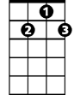

G7



G

F



G



C

C



F

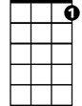

G7

**When Will I Be Loved (Phil Everly) (Linda Ronstadt arrangement) Key F**

**F Bb C**

I've been cheat-ed,

**F Bb C**

Been mis-treat-ed

**F Bb C F Bb C**

When will I – I be loved?

**F Bb C**

I've been pushed down

**F Bb C**

I've been pushed 'round

**F Bb C F Bb C**

When will I – I be loved?

**Chorus:**

**Bb C**

When I find a new man,

**Bb F**

That I want for mine

**Bb C**

He always breaks my heart in two,

**F C C7**

It happens every time

**BARITONE**

F



**F Bb C**

I've been made blue

**F Bb C**

I've been lied to

**F Bb C F Bb C**

When will I – I be loved?

**(Chorus)**



F

**F Bb C**

I've been cheat-ed

**F Bb C**

Been mis-treat-ed

**F Bb C F Bb C**

When will I – I be loved?

**F Bb C F**

When will I – I be loved?

**Bb C F Bb C Bb F**

Tell me, when will I ~ be ~ lo – o - oved?



C



Bb



C7

C

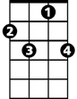

C7

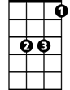

Bb

C



F7

**When Will I Be Loved (Phil Everly) (Linda Ronstadt arrangement) Key G**

**G C D**

I've been cheat-ed,

**G C D**

Been mis-treat-ed

**G C D G C D**

When will I – I be loved?

**G C D**

I've been pushed down

**G C D**

I've been pushed 'round

**G C D G C D**

When will I – I be loved?

**Chorus:**

**C D**

When I find a new man,

**C G**

That I want for mine

**C D**

He always breaks my heart in two,

**G D D7**

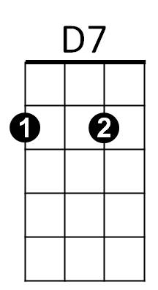It happens every time

**BARITONE**



C



G

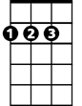

D



D

C



G



D7

**G C D**

I've been made blue

**G C D**

I've been lied to

**G C D G C D**

When will I – I be loved?

**(Chorus)**

**G C D**

I've been cheat-ed

**G C D**

Been mis-treat-ed

**G C D G C D**

When will I – I be loved?

**G C D G**

When will I – I be loved?

**C D G C D C G**

Tell me, when will I ~ be ~ lo – o - oved?