Where Have All the Flowers Gone (A)
(Pete Seeger, 1955; added verses by Joe Hickerson, May 1960)
Where Have All the Flowers Gone by the Kingston Trio (Bb) (131 BPM)
Where Have All the Flowers Gone by Peter, Paul and Mary (Bb) (118 BPM)
Where Have All the Flowers Gone by Pete Seeger (Bb) (134 BPM)

Intro A F#m D E  A F#m D E  Where have all the flowers gone, long time passing?  A F#m Bm E  Where have all the flowers gone, long time ago?  A F#m D E  Where have all the flowers gone? Young girls picked them everyone.  Chorus  D A  When will they ever learn?  D E7 A | E7  When will they ever learn?  A F#m D E  Where have all the young girls gone, long time passing?  A F#m Bm E  Where have all the young girls gone, long time ago?  A F#m D E  Where have all the young girls gone? Gone for husbands everyone. Chorus  A F#m D E  Where have all the husbands gone, long time passing?  A F#m Bm E  Where have all the husbands gone, long time ago?  A F#m D E  Where have all the husbands gone? Gone for soldiers everyone. Chorus  A F#m D E  Where have all the soldiers gone, long time passing?  A F#m Bm E  Where have all the soldiers gone, long time ago?  A F#m D E  Where have all the soldiers gone? Gone to graveyards everyone. Chorus  A F#m D E  Where have all the graveyards gone, long time passing?  A F#m Bm E  Where have all the graveyards gone, long time ago?  A F#m D E  Where have all the graveyards gone? Gone to flowers everyone. Chorus  Repeat Verse 1 End on A | 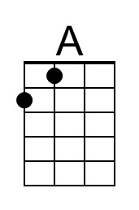 | 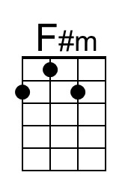
 | 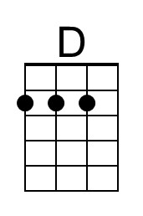 | 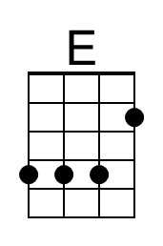
 | 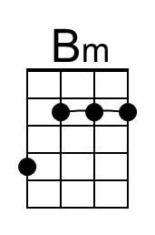 | 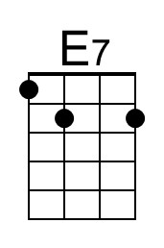
 | Bari
 | 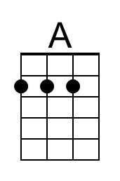 | 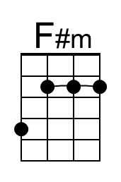
 | 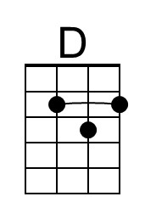 | 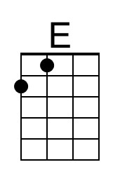
 | 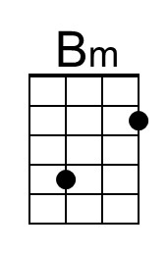 | 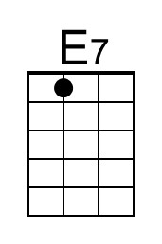

Where Have All the Flowers Gone (Bb)
(Pete Seeger, 1955; added verses by Joe Hickerson, May 1960)
Where Have All the Flowers Gone by the Kingston Trio (Bb) (131 BPM)
Where Have All the Flowers Gone by Peter, Paul and Mary (Bb) (118 BPM)
Where Have All the Flowers Gone by Pete Seeger (Bb) (134 BPM)

Intro Bb Gm Eb F  Bb Gm Eb F  Where have all the flowers gone, long time passing?  Bb Gm Cm F  Where have all the flowers gone, long time ago?  Bb Gm Eb F  Where have all the flowers gone? Young girls picked them everyone.  Chorus  Eb Bb  When will they ever learn?  Eb F7 Bb | F7  When will they ever learn?  Bb Gm Eb F  Where have all the young girls gone, long time passing?  Bb Gm Cm F  Where have all the young girls gone, long time ago?  Bb Gm Eb F  Where have all the young girls gone? Gone for husbands everyone. Chorus  Bb Gm Eb F  Where have all the husbands gone, long time passing?  Bb Gm Cm F  Where have all the husbands gone, long time ago?  Bb Gm Eb F  Where have all the husbands gone? Gone for soldiers everyone. Chorus  Bb Gm Eb F  Where have all the soldiers gone, long time passing?  Bb Gm Cm F  Where have all the soldiers gone, long time ago?  Bb Gm Eb F  Where have all the soldiers gone? Gone to graveyards everyone. Chorus  Bb Gm Eb F  Where have all the graveyards gone, long time passing?  Bb Gm Cm F  Where have all the graveyards gone, long time ago?  Bb Gm Eb F  Where have all the graveyards gone? Gone to flowers everyone. Chorus  Repeat Verse 1 End on Bb | 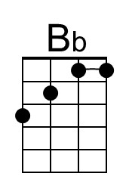 | 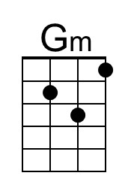
 | 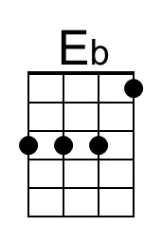 | 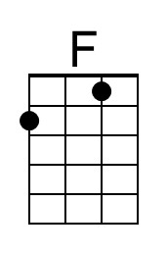
 | 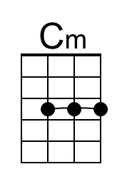 | 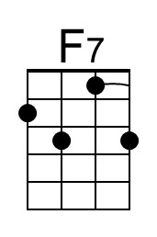
 | Bari
 | 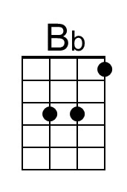 | 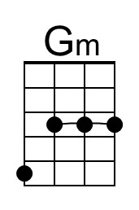
 | 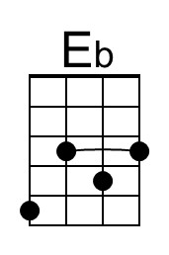 | 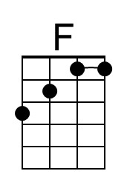
 | 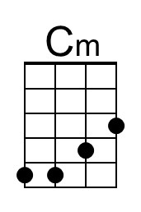 | 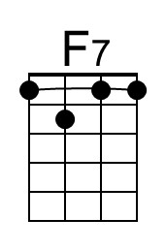

Where Have All the Flowers Gone (C)
(Pete Seeger, 1955; added verses by Joe Hickerson, May 1960)
Where Have All the Flowers Gone by the Kingston Trio (Bb) (131 BPM)
Where Have All the Flowers Gone by Peter, Paul and Mary (Bb) (118 BPM)
Where Have All the Flowers Gone by Pete Seeger (Bb) (134 BPM)

Intro C | Am | F | G |  C Am F G  Where have all the flowers gone, long time passing?  C Am Dm G  Where have all the flowers gone, long time ago?  C Am F G  Where have all the flowers gone? Young girls picked them everyone.  Chorus  F C  When will they ever learn?  F G7 C | G7  When will they ever learn?  C Am F G  Where have all the young girls gone, long time passing?  C Am Dm G  Where have all the young girls gone, long time ago?  C Am F G  Where have all the young girls gone? Gone for husbands everyone. Chorus  C Am F G  Where have all the husbands gone, long time passing?  C Am Dm G  Where have all the husbands gone, long time ago?  C Am F G  Where have all the husbands gone? Gone for soldiers everyone. Chorus  C Am F G  Where have all the soldiers gone, long time passing?  C Am Dm G  Where have all the soldiers gone, long time ago?  C Am F G  Where have all the soldiers gone? Gone to graveyards everyone. Chorus  C Am F G  Where have all the graveyards gone, long time passing?  C Am Dm G  Where have all the graveyards gone, long time ago?  C Am F G  Where have all the graveyards gone? Gone to flowers everyone. Chorus  Repeat Verse 1 End on C | 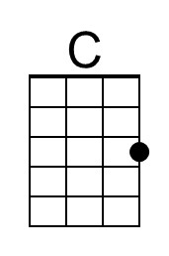 | 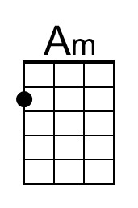
 |  | 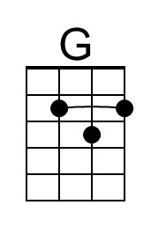
 | 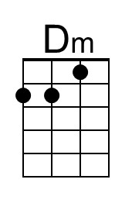 | 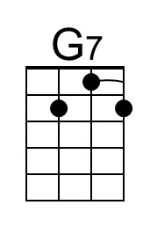
 | Bari
 | 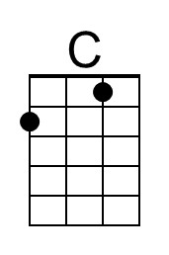 | 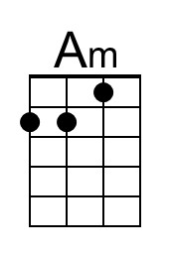
 |  | 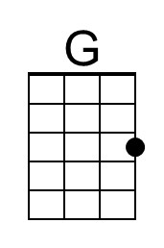
 | 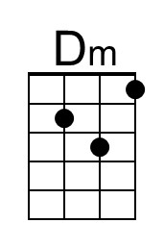 | 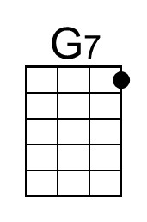

Where Have All the Flowers Gone (G)
(Pete Seeger, 1955; added verses by Joe Hickerson, May 1960)
Where Have All the Flowers Gone by the Kingston Trio (Bb) (131 BPM)
Where Have All the Flowers Gone by Peter, Paul and Mary (Bb) (118 BPM)
Where Have All the Flowers Gone by Pete Seeger (Bb) (134 BPM)

Intro G | Em | C | D |  G Em C D  Where have all the flowers gone, long time passing?  G Em Am D  Where have all the flowers gone, long time ago?  G Em C D  Where have all the flowers gone? Young girls picked them everyone.  Chorus  C G  When will they ever learn?  C D7 G | D7  When will they ever learn?  G Em C D  Where have all the young girls gone, long time passing?  G Em Am D  Where have all the young girls gone, long time ago?  G Em C D  Where have all the young girls gone? Gone for husbands everyone. Chorus  G Em C D  Where have all the husbands gone, long time passing?  G Em Am D  Where have all the husbands gone, long time ago?  G Em C D  Where have all the husbands gone? Gone for soldiers everyone. Chorus  G Em C D  Where have all the soldiers gone, long time passing?  G Em Am D  Where have all the soldiers gone, long time ago?  G Em C D  Where have all the soldiers gone? Gone to graveyards everyone. Chorus  G Em C D  Where have all the graveyards gone, long time passing?  G Em Am D  Where have all the graveyards gone, long time ago?  G Em C D  Where have all the graveyards gone? Gone to flowers everyone. Chorus  Repeat Verse 1 End on G |  | 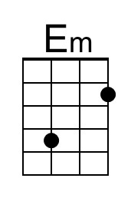
 |  | 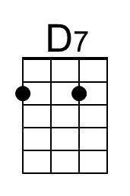
 | Bari
 |  | 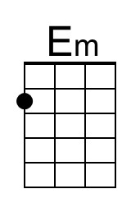
 |  | 