While My Guitar Gently Weeps (George Harrison, 1968)
While My Guitar Gently Weeps byThe Beatles – Key of Am – GCEA

Am C6 Am6 Fmaj7  I look at you all see the love there that's sleeping  Am G D - E7  __While my gui-tar gently weeps  Am C6 Am6 Fmaj7  I look at the floor and I see it needs sweeping  Am G C - E7  __Still my gui-tar gently weeps  A C#m7 F#m C#m  _ I don't know why ___ nobody told you,  Bm E  __ how to un-fold your love.  A C#m7 F#m C#m A  __I don't know how ___ someone con-trolled you,  Bm E  __ They bought and sold you  Am C6 Am6 Fmaj7  I look at the world and I notice it's turning  Am G D - E7  __ While my gui-tar gently weeps  Am C6 Am6 Fmaj7  With every mis-take we must surely be learning  Am G C - E7  __ Still my gui-tar gently weeps  A C#m7 F#m C#m  _ I don't know how ___ you were di-verted.  Bm E  ___ You were perverted too  A Amaj7 F#m C#m  I don't know how ___ you were in-verted.  Bm E  __ No one alerted you.  Am C6 Am6 Fmaj7  I look at you all, see the love there that's sleeping  Am G D - E7  __ While my gui-tar gently weeps  Am C6 | Am6 | Fmaj7 |  I look at you all...  Am G7 C - F6 C  __ Still my gui-tar gently weeps. | 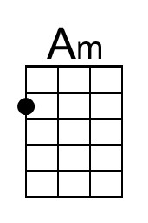 | 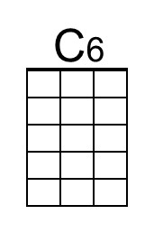 | 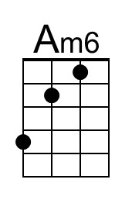
 | 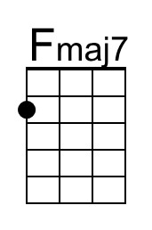 | 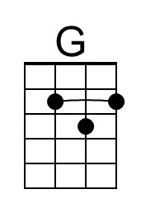 | 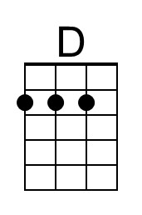
 | 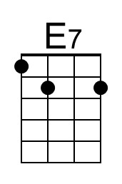 | 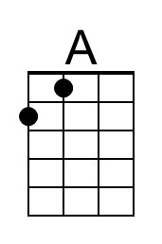 | 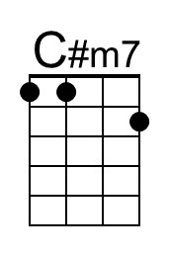
 | 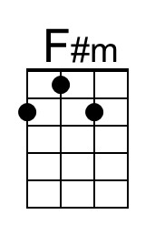 | 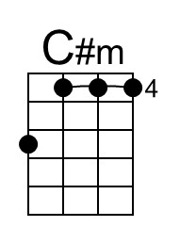 | 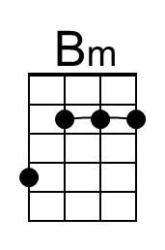
 | 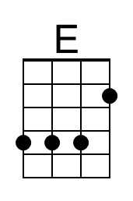 | 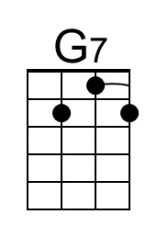 | 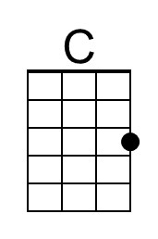
 | 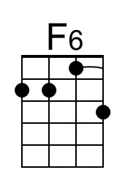

While My Guitar Gently Weeps (George Harrison, 1968)
While My Guitar Gently Weeps byThe Beatles – Key of Am – DGBE

Am C6 Am6 Fmaj7  I look at you all see the love there that's sleeping  Am G D - E7  __While my gui-tar gently weeps  Am C6 Am6 Fmaj7  I look at the floor and I see it needs sweeping  Am G C - E7  __Still my gui-tar gently weeps  A C#m7 F#m C#m  _ I don't know why ___ nobody told you,  Bm E  __ how to un-fold your love.  A C#m7 F#m C#m A  __I don't know how ___ someone con-trolled you,  Bm E  __ They bought and sold you  Am C6 Am6 Fmaj7  I look at the world and I notice it's turning  Am G D - E7  __ While my gui-tar gently weeps  Am C6 Am6 Fmaj7  With every mis-take we must surely be learning  Am G C - E7  __ Still my gui-tar gently weeps  A C#m7 F#m C#m  _ I don't know how ___ you were di-verted.  Bm E  ___ You were perverted too  A Amaj7 F#m C#m  I don't know how ___ you were in-verted.  Bm E  __ No one alerted you.  Am C6 Am6 Fmaj7  I look at you all, see the love there that's sleeping  Am G D - E7  __ While my gui-tar gently weeps  Am C6 | Am6 | Fmaj7 |  I look at you all...  Am G7 C - F6 C  __ Still my gui-tar gently weeps. | 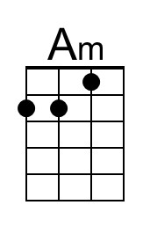 | 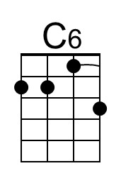
 | 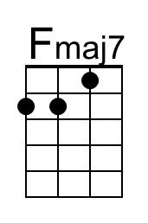 | 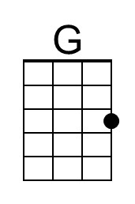 | 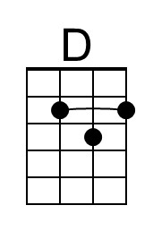
 | 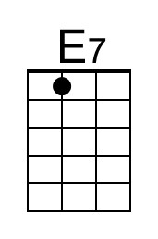 | 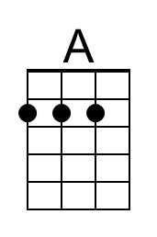 | 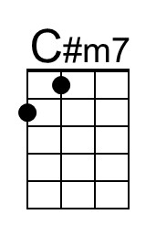
 | 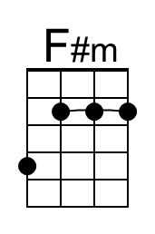 | 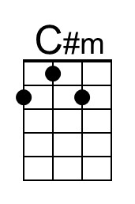 | 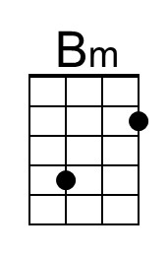
 | 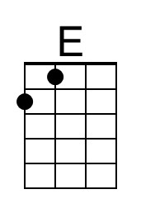 | 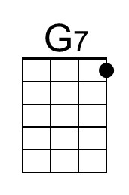 | 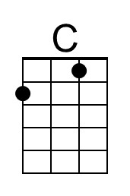
 | 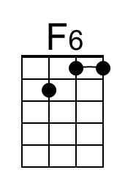

While My Guitar Gently Weeps (George Harrison, 1968)
While My Guitar Gently Weeps byThe Beatles – Key of Dm – GCEA

Dm F6 Dm6 Bbmaj7  I look at you all see the love there that's sleeping  Dm C G - A7  __While my gui-tar gently weeps  Dm F6 Dm6 Bbmaj7  I look at the floor and I see it needs sweeping  Dm C F - A7  __Still my gui-tar gently weeps  D F#m7 Bm F#m  _ I don't know why ___ nobody told you,  Em A  __ how to un-fold your love.  D F#m7 Bm F#m D  __I don't know how ___ someone con-trolled you,  Em A  __ They bought and sold you  Dm F6 Dm6 Bbmaj7  I look at the world and I notice it's turning  Dm C G - A7  __ While my gui-tar gently weeps  Dm F6 Dm6 Bbmaj7  With every mis-take we must surely be learning  Dm C F - A7  __ Still my gui-tar gently weeps  D F#m7 Bm F#m  _ I don't know how ___ you were di-verted.  Em A  ___ You were perverted too  D Dmaj7 Bm F#m  I don't know how ___ you were in-verted.  Em A  __ No one alerted you.  Dm F6 Dm6 Bbmaj7  I look at you all, see the love there that's sleeping  Dm C G - A7  __ While my gui-tar gently weeps  Dm F6 | Dm6 | Bbmaj7 |  I look at you all...  Dm C7 F - Bb6 F  __ Still my gui-tar gently weeps. | 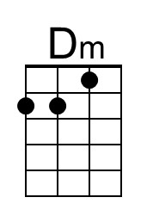 |  | 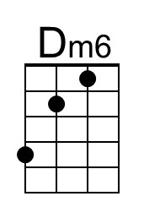
 | 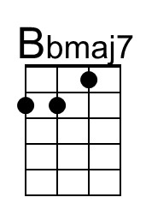
 | 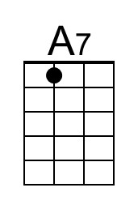 | 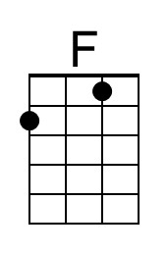
 | 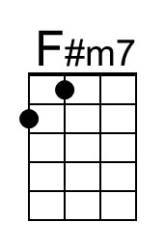
 | 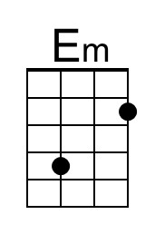 |  | 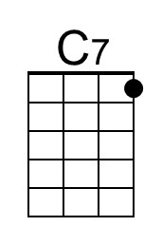
 | 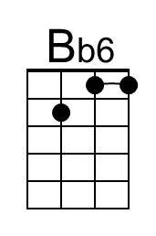

While My Guitar Gently Weeps (George Harrison, 1968)
While My Guitar Gently Weeps byThe Beatles – Key of Dm – DGBE

Dm F6 Dm6 Bbmaj7  I look at you all see the love there that's sleeping  Dm C G - A7  __While my gui-tar gently weeps  Dm F6 Dm6 Bbmaj7  I look at the floor and I see it needs sweeping  Dm C F - A7  __Still my gui-tar gently weeps  D F#m7 Bm F#m  _ I don't know why ___ nobody told you,  Em A  __ how to un-fold your love.  D F#m7 Bm F#m D  __I don't know how ___ someone con-trolled you,  Em A  __ They bought and sold you  Dm F6 Dm6 Bbmaj7  I look at the world and I notice it's turning  Dm C G - A7  __ While my gui-tar gently weeps  Dm F6 Dm6 Bbmaj7  With every mis-take we must surely be learning  Dm C F - A7  __ Still my gui-tar gently weeps  D F#m7 Bm F#m  _ I don't know how ___ you were di-verted.  Em A  ___ You were perverted too  D Dmaj7 Bm F#m  I don't know how ___ you were in-verted.  Em A  __ No one alerted you.  Dm F6 Dm6 Bbmaj7  I look at you all, see the love there that's sleeping  Dm C G - A7  __ While my gui-tar gently weeps  Dm F6 | Dm6 | Bbmaj7 |  I look at you all...  Dm C7 F - Bb6 F  __ Still my gui-tar gently weeps. | 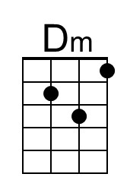 |  | 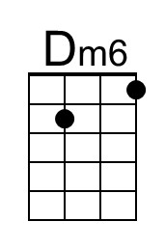
 | 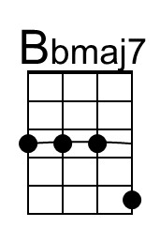
 | 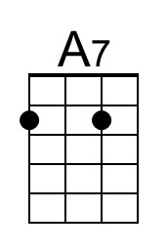 | 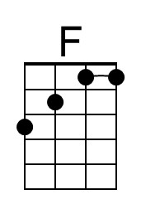
 | 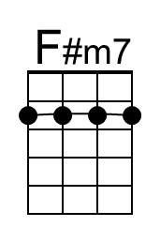
 | 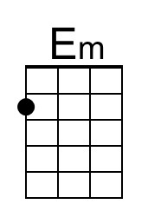 |  | 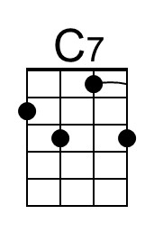
 | 