**White Christmas (Irving Berlin, 1940)**

**Intro: (Last two lines of song)**

**C Dm G**

I`m dreaming of a white Christmas,



C

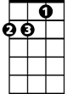

Dm

**F G C**

Just like the ones I used to know,

**C7 F Fm**

Where the tree tops glisten and children listen,

**C Am Dm G**



G

F



To hear sleigh bells in the snow.

*Alternate Walkdown*: **G F# F**

**C Dm G**

I`m dreaming of a white Christmas,

**F G C**

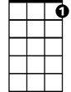

C7

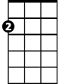

Am

With every Christmas card I write.

**C7 F Fm**

May your days be merry and bright -

**C Dm G C (G7 – Rollover)**

And may all your Christmases be white.

**End on C**

**Repeat entire song**

**BARITONE**



Am

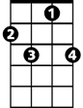

C7

C

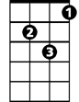

Dm



F



G