**White Rabbit (Gracie Slick) Key B**

**Intro: B**

**B**

One pill makes you larger,

**C**

and one pill makes you small

**B**

And the ones that mother gives you,

**C**

Don’t do anything at all

**D F D**

Go ask Alice, when she's ten feet tall

**B**

And if you go chasing rabbits,

**C**

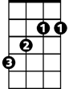

B

F

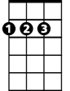

D



C

And you know you're going to fall

**B**

Tell 'em a hookah-smoking caterpillar

**C**

Has given you the call



C

**3**

**D F D**

And call Alice, when she was just small

**A**

When the men on the chessboard

**D**

Get up and tell you where to go

B

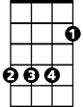

A

C



D



F

**A**

**BARITONE**

And you've just had some kind of mushroom,

**D**

And your mind is moving low

**B**

Go ask Alice, I think she'll know

**B**

When logic and proportion

**C**

Have fallen sloppy dead

**B**

And the white knight is talking backwards

**C**

And the red queen's off with her head

**D F D**

Remember what the door mouse said

**A D A D**

Feed your head, feed your head



F

**8**



D

**5**

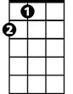

A