Who Put the Bomp (Barry Mann & Gerry Goffin, 1961) (C)
Who Put the Bomp by Barry Mann (C) – Who Put the Bomp by The Viscounts (1961)
4/4 | Tempo = 175
Intro (Single C Strum)  C E7 Am  I'd like to thank the guy, who wrote the song  F G7 | C |  That made my baby fall in love with me ....  Chorus  C Am  Who but the bomp in the bomp a bomp a bomp?  F G7  Who put the ram in the rama lama ding dong?  C Am  Who put the bop in the bop shoo bop shoo bop?  F G7  Who put the dip in the dip de dip de dip?  C E7 Am F  Who was that man? I'd like to shake his hand!  C F G7 C - G7  He made my baby fall in love with me..(yeah)  C Am F G7  When my baby heard “Bomp ba ba-bomp a bompa bomp bomp,”  C Am F - G7 C E7  Every word went right into her heart. And when she heard them singing  Am F  “Rama lama rama, lama lama ding dong”  C F G7 C - G7  She said we'd never have to part. So, Chorus  C Am  Each time that we're a-lone  F G7  Boogety boogety boogety boogety boogety boogety shoop  C Am F - G7 C E7  Sets my baby's heart all a glow. And every time we dance to  Am F  Dip de dip de dip dip de dip de dip.  C F G7 C - G7  She always says she loves me so. So, Chorus  Lyrics spoken; chords repeated. End on C  C Am F G7  Darling, bomp ba ba bomp ba-bomp a bomp bomp  And my honey, ramalama ding dong forever  And when I say dip de dip de dip de dip  You know I mean it from the bottom of my  boogety boogety boogety shoop. | 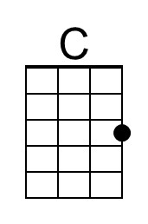 | 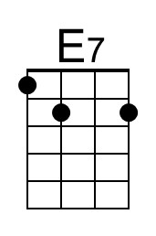
 | 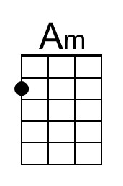 | 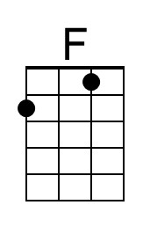
 | 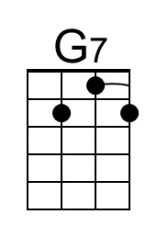
 | Bari
 | 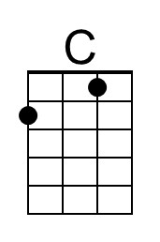 | 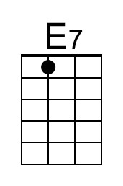
 | 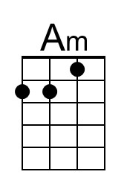 | 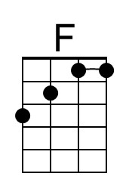
 | 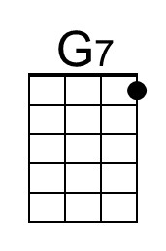

Who Put the Bomp (Barry Mann & Gerry Goffin, 1961) (G)
Who Put the Bomp by Barry Mann (C) – Who Put the Bomp by The Viscounts (1961)
4/4 | Tempo = 175
Intro (Single G Strum)  G B7 Em  I'd like to thank the guy, who wrote the song  C D7 | G |  That made my baby fall in love with me ....  Chorus  G Em  Who but the bomp in the bomp a bomp a bomp?  C D7  Who put the ram in the rama lama ding dong?  G Em  Who put the bop in the bop shoo bop shoo bop?  C D7  Who put the dip in the dip de dip de dip?  G B7 Em C  Who was that man? I'd like to shake his hand!  G C D7 G - D7  He made my baby fall in love with me..(yeah)  G Em C D7  When my baby heard “Bomp ba ba-bomp a bompa bomp bomp,”  G Em C - D7 G B7  Every word went right into her heart. And when she heard them singing  Em C  “Rama lama rama, lama lama ding dong”  G C D7 G - D7  She said we'd never have to part. So, Chorus  G Em  Each time that we're a-lone  C D7  Boogety boogety boogety boogety boogety boogety shoop  G Em C - D7 G B7  Sets my baby's heart all a glow. And every time we dance to  Em C  Dip de dip de dip dip de dip de dip.  G C D7 G - D7  She always says she loves me so. So, Chorus  Lyrics spoken; chords repeated. End on G  G Em C D7  Darling, bomp ba ba bomp ba-bomp a bomp bomp  And my honey, ramalama ding dong forever  And when I say dip de dip de dip de dip  You know I mean it from the bottom of my  boogety boogety boogety shoop. | 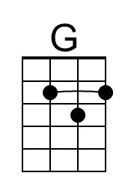 | 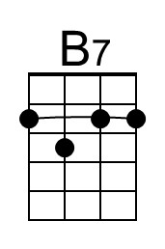
 | 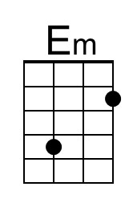
 | 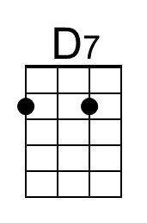
 | Bari
 | 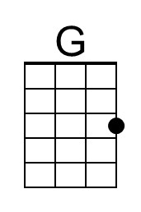 | 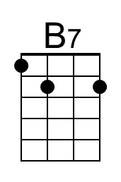
 | 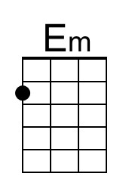
 | 