**Who Threw the Overalls in Mrs. Murphy’s Chowder? (George L. Giefer / Mat Ray) Key C**

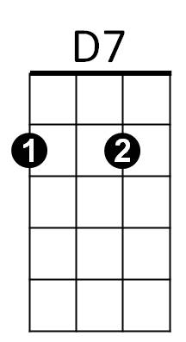**C**

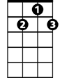

G7

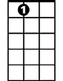

A7



C

The Murphy's gave a party

Just about a week ago

**Am**

Everything was plentiful,

**D7 G7**

The Murphy's they're not slow

**C**

They treated us like gentlemen,

We tried to act the same

**D7**

But only for what happened,

**G D7 G**

Well, it was an awful shame

**F G7**

When Mrs. Murphy dished the chowder out

F



G

**C**

She fainted on the spot

**F G7**

She found a pair of overalls

**C**

In the bottom of the pot

Tim Nolan he got rippin' mad

E7

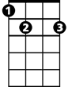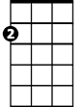

Am

His eyes were bulgin' out

**D7**

He jumped up on the PI-A-NO

**G D7 G**

And loudly he did shout -

**Chorus:**

**C**

Oh, who threw the overalls

**BARITONE**

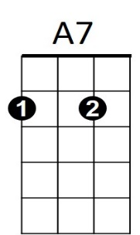In Mrs. Murphy's chowder?



D7

C



G

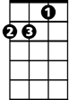

Am



F

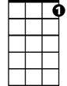

G7



E7

**D7 G7**

Nobody spoke, so he shouted all the louder

**C E7 Am**

It's an Irish trick that's true

**F C**

I can lick the cur that threw

**D7 G7 C**

The overalls in Mrs Murphy's chow - der

**C**

We dragged the pants from out the soup

And laid them on the floor

**Am**

Each man swore upon his life

**D7 G7**

He’d ne'er seen them before

**C**

They were plastered up with mortar

And were worn out at the knee

**D7**

They'd had their many ups and downs

**G D7 G**

As we could plainly see

**F G7**

When Mrs. Murphy she came to

**C**

She began to cry and pout

**F G7**

She'd had them in the wash that day

**C**

And forgot to take them out

Tim Nolan he excused himself

For what he'd said that night

**D7**

So we put music to the words

**G D7 G**

And sang with all our might

**(Chorus)**

**Who Threw the Overalls in Mrs. Murphy’s Chowder? (George L. Giefer / Mat Ray) Key G**

**G**



G



A7

E7



The Murphy's gave a party

Just about a week ago

Everything was plentiful,

**A7 D7**

The Murphy's they're not slow

 **G**

They treated us like gentlemen,

We tried to act the same

**A7**

But only for what happened,

**D A7 D**

Well, it was an awful shame

**C D7**

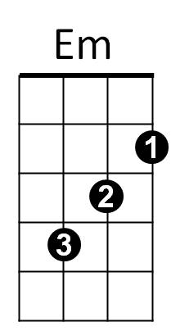When Mrs. Murphy dished the chowder out

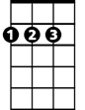

D



C

**G**

She fainted on the spot

**C D7**

She found a pair of overalls

**G**

In the bottom of the pot

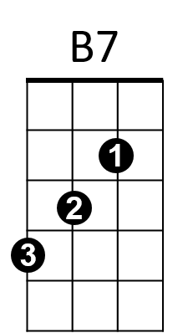Tim Nolan he got rippin' mad

His eyes were bulgin' out

**A7**

He jumped up on the PI-A-NO

**D A7 D**

And loudly he did shout -

**Chorus:**

**G**

Oh, who threw the overalls

**BARITONE**

In Mrs Murphy's chowder?

**A7 D7**

Nobody spoke, so he shouted all the louder

**G B7 Em**

It's an Irish trick that's true

**C G**

I can lick the cur that threw

**A7 D7 G**

The overalls in Mrs Murphy's chow - der

**G**

We dragged the pants from out the soup

And laid them on the floor

Each man swore upon his life

**A7 D7**

He’d ne'er seen them before

**G**

They were plastered up with mortar

And were worn out at the knee

**A7**

They'd had their many ups and downs

**D A7 D**

As we could plainly see

**C D7**

When Mrs Murphy she came to

**G**

She began to cry and pout

**C D7**

She'd had them in the wash that day

**G**

And forgot to take them out

Tim Nolan he excused himself

For what he'd said that night

**A7**

So we put music to the words

**D A7 D**

And sang with all our might

**(Chorus)**





D



E7



G



D7

C



Em

B7



**Who Threw the Overalls in Mrs. Murphy’s Chowder? (George L. Giefer / Mat Ray) Key D**





D

**D**

The Murphy's gave a party j

Just about a week ago

Everything was plentiful,

**E7 A7**

The Murphy's they're not slow

**D**



A7

E7



They treated us like gentlemen,

We tried to act the same

**E7**

But only for what happened,

**A E7 A**

Well, it was an awful shame

**G A7**

When Mrs. Murphy dished the chowder out

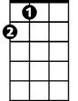

A



G

**D**

She fainted on the spot

**G A7**

She found a pair of overalls

**D**

In the bottom of the pot

Tim Nolan he got rippin' mad

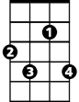

F#7

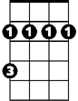

Bm

His eyes were bulgin' out

**E7**

He jumped up on the PI-A-NO

**A E7 A**

And loudly he did shout -

**Chorus:**

**D**

Oh, who threw the overalls

**BARITONE**

In Mrs Murphy's chowder?



D

**E7 A7**

Nobody spoke, so he shouted all the louder

**D F#7 Bm**

It's an Irish trick that's true

**G D**

I can lick the mick that threw



A

**E7 A7 D**

The overalls in Mrs Murphy's chow - der

**D**

We dragged the pants from out the soup

And laid them on the floor

Each man swore upon his life

**E7 A7**

He’d ne'er seen them before

**D**

They were plastered up with mortar

And were worn out at the knee

**E7**

They'd had their many ups and downs

**A E7 A**

As we could plainly see

**G A7**

When Mrs Murphy she came to

**D**

She began to cry and pout

**G A7**

She'd had them in the wash that day

**D**

And forgot to take them out

Tim Nolan he excused himself

For what he'd said that night

**E7**

So we put music to the words

**A E7 A**

And sang with all our might

**(Chorus)**





E7

B7

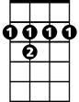

F#7

Bm

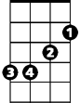

G