Who’s Sorry Now? (Ted Snyder, Bert Kalmer, Harry Ruby) (C)
Who’s Sorry Now? by Connie Francis
Who’s Sorry Now? By Harry Ruby

C E7  Who’s sorry now? Who’s sorry now?  A7 D7  Whose heart is aching for breaking each vow?  G7 C A7  Who’s sad and blue? Who’s crying too?  D7 G7 G7#5  Just like I cried over you  C E7  Right to the end, Just like a friend  A7 Dm  I tried to warn you some - how  F Fm6 C A7  You had your way, Now you must pay  D7 G7 C  I’m glad that you’re sorry now.  Repeat from beginning. |  |  |  |  |  |  | 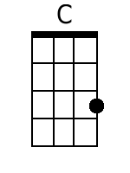 | 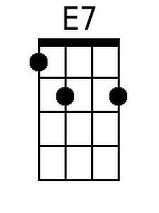
 |  |  |  |  |  |  | 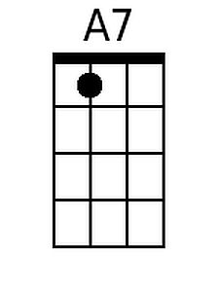 | 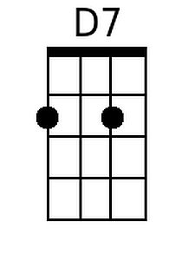
 |  |  |  |  |  |  | 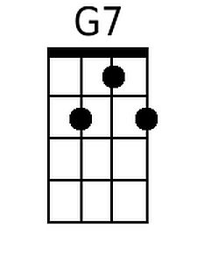 | 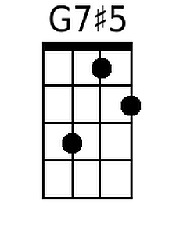
 |  |  |  |  |  |  | 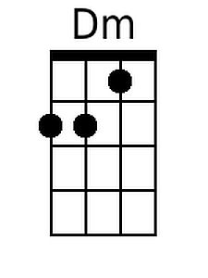 | 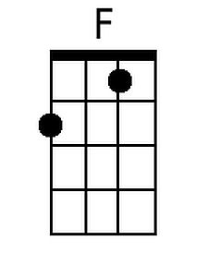
 |  |  |  |  |  |  | 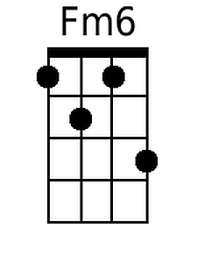
Baritone
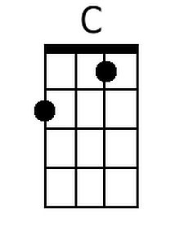 | 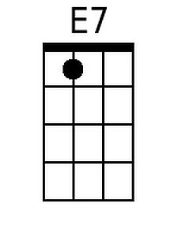 | 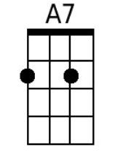 | 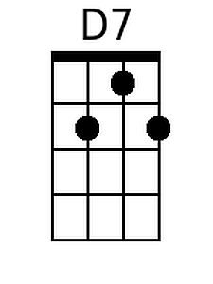 | 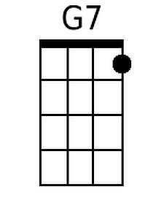
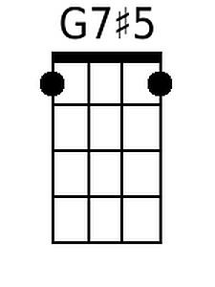 | 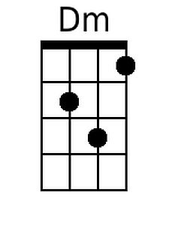 | 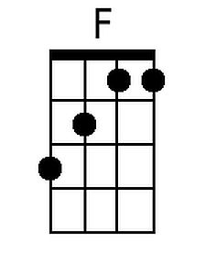 | 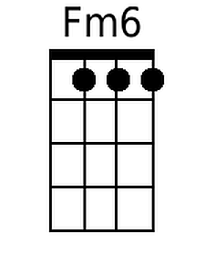

Who’s Sorry Now? (Ted Snyder, Bert Kalmer, Harry Ruby) (G)
Who’s Sorry Now? by Connie Francis
Who’s Sorry Now? By Harry Ruby

G B7  Who's sorry now? Who's sorry now?  E7 A7  Whose heart is aching for breaking each vow?  D7 G E7  Who's sad and blue? Who's crying too?  A7 D7 D7#5  Just like I cried over you  G B7  Right to the end, Just like a friend  E7 Am  I tried to warn you some - how  C Cm6 G E7  You had your way, Now you must pay  A7 D7 G  I'm glad that you're sorry now.  Repeat from beginning. |  |  |  |  |  |  | 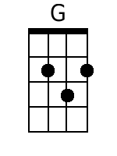 | 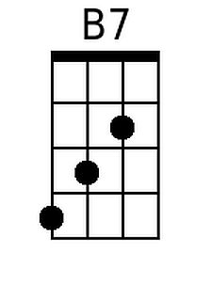
 |  |  |  |  |  |  |  | 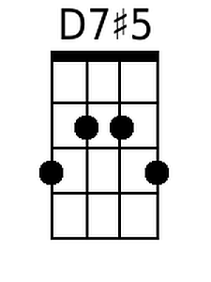
 |  |  |  |  |  |  | 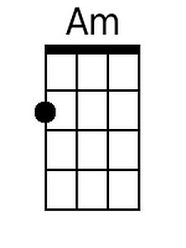
 |  |  |  |  |  |  | 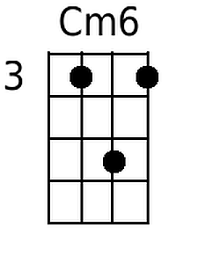
Baritone
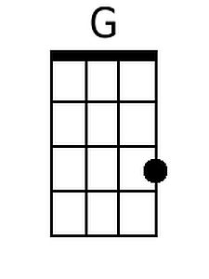 | 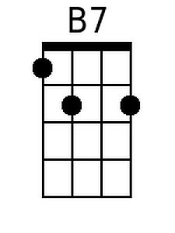
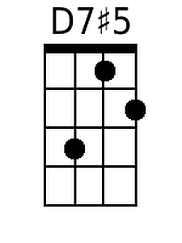 | 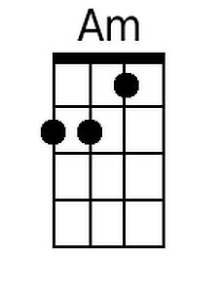 |  | 