Why Do Fools Fall In Love (C)
(Frankie Lymon, Herman Santiago, Jimmy Merchant, 1955-56)
Why Do Fools Fall In Love by Frankie Lymon & The Teenagers (1956) (C# - 174 BPM)

Intro  C Am Dm G7 C Am Dm G7 C Am Dm G7  Oh wah, Oh wah, Oh wah, Oh wah, Oh wah, Oh wah,  C  Why Tacet do fools fall in love?  C Am Dm G7 C - Am Dm G7 C Am  Why do birds sing, so gay? And lovers a-wait the break of day,  Dm G7 C - Am | Dm G |  Why do they fall in love?  C - Am Dm G7 C Am Dm G7 C Am  Why.... does the rain fall from up a-bove? Why do fools, fall in love?  Dm G7 C F C  Why do they fall in love?  Bridge  F C C7  Love is a losing game, love can be a shame.  D7 G7  I know of a fool you see; for - that - fool is me.  C - Am | Dm G C - Am | Dm  Tell me why, Whyy-y?  G C - Am Dm G C Am | Dm G  Tell me why, Why do they fall in love?  Repeat Intro  Instrumental Verse  C Am | Dm G | C Am | Dm G | C Am | Dm G | C F C  Repeat Bridge  Outro  F G C  Why - do - fools - fall in love?  C Am Dm G7 C Am Dm G7 C Am Dm G7  Oh wah, Oh wah, Oh wah, Oh wah, Oh wah, Oh wah,  C | C ↓  Why Tacet do fools fall in love? |  |  |  |  |  |  |  |  | 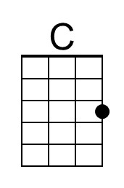
 |  |  |  |  |  |  |  |  | 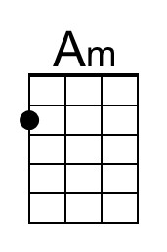
 |  |  |  |  |  |  |  |  | 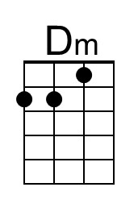
 |  |  |  |  |  |  |  |  | 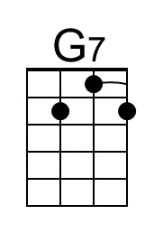
 |  |  |  |  |  |  |  |  | 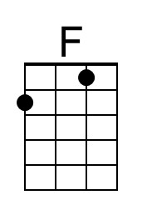
 |  |  |  |  |  |  |  |  | 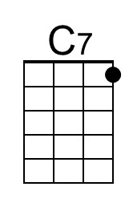
 |  |  |  |  |  |  |  |  | 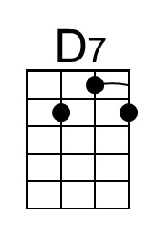
Bari | 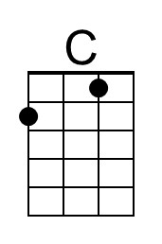 | 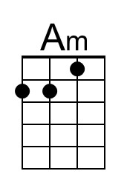 | 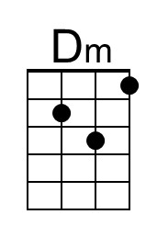 | 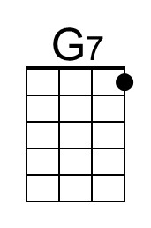 | 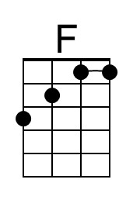 | 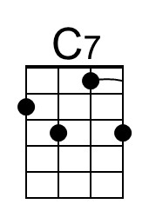

Why Do Fools Fall In Love (G)
(Frankie Lymon, Herman Santiago, Jimmy Merchant, 1955-56)
Why Do Fools Fall In Love by Frankie Lymon & The Teenagers (1956) (C# - 174 BPM)

Intro  G Em Am D7 G Em Am D7 G Em Am D7  Oh wah, Oh wah, Oh wah, Oh wah, Oh wah, Oh wah,  G Tacet  Why do fools fall in love?  G Em Am D7 G - Em Am D7 G Em  Why do birds sing, so gay? And lovers a-wait the break of day,  Am D7 G - Em | Am D |  Why do they fall in love?  G - Em Am D7 G Em Am D7 G Em  Why.... does the rain fall from up a-bove? Why do fools, fall in love?  Am D7 G C G  Why do they fall in love?  Bridge  C G G7  Love is a losing game, love can be a shame.  A7 D7  I know of a fool you see; for - that - fool is me.  G - Em | Am D G - Em | Am  Tell me why, Whyy-y?  D G - Em Am D G Em | Am D  Tell me why, Why do they fall in love?  Repeat Intro  Instrumental Verse  G Em | Am D | G Em | Am D | G Em | Am D | G C G  Repeat Bridge  C D G  Why - do - fools - fall in love?  Outro  G Em Am D7 G Em Am D7 G Em Am D7  Oh wah, Oh wah, Oh wah, Oh wah, Oh wah, Oh wah,  G | G ↓  Why Tacet do fools fall in love? |  |  |  |  |  |  |  |  | 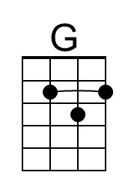
 |  |  |  |  |  |  |  |  | 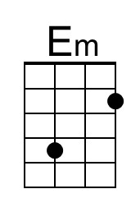
 |  |  |  |  |  |  |  |  | 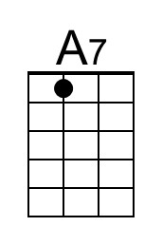
Bari | 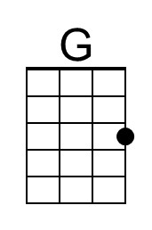 | 