**Wichita Lineman (Jimmy Webb)**

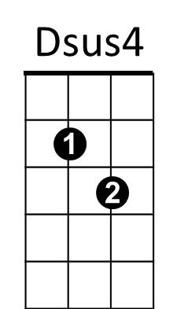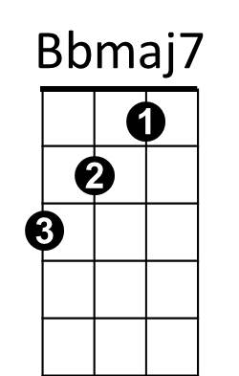**Intro: F Gm7 F**

F

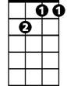

Gm7

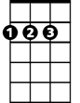

D



G

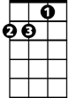

Dm



Bb

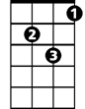

Gm

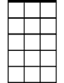

Am7

**Gm7 Bbmaj7**

I am a lineman for the county

**F Gm7**

And I drive the main road

**Dm Am7 G D Dsus4 D**

Searchin' in the sun for another overload.

**Am7**

I hear you s ingin' in the wires,

**G**  **Gm**

I can hear you through the whine

**D Am7 Bb**

And the Wichita Lineman is still on the line.

**Bb Am7 / Bb Gm7**

**Gm7 Bbmaj7**

I know I need a small vacation,

**BARITONE**

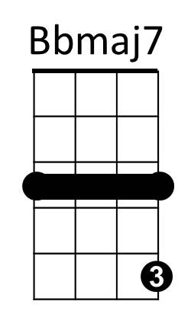 **F Gm7**



F



Dm

But it don't look like rain.

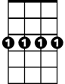

Gm7

**Dm Am7**

And if it snows that stretch down south

**G D Dsus4 D**

Won’t ever stand the strain.



D



G

**Am7**

And I need you more than want you,

**G** **Gm**

And I want you for all time.

**D Am7 Bb Am7 Bb Gm7**

And the Wichita Lineman is still on the line.

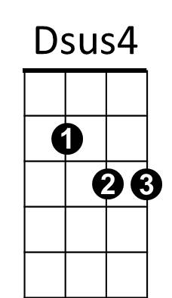

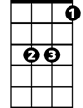

Bb

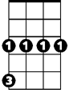

Gm

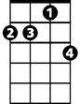

Am7

**(Instrumental verse)**

**Am7**

And I need you more than want you,

**G** **Gm**

And I want you for all time.

**D Am7 Bb Am7**

And the Wichita Lineman is still on the line.

**Bb Am7 (Repeat to fade)**