
Will The Circle Be Unbroken (Habershon & Gabriel, 1907) (C)
Recast by A.P. Carter and recorded by the Carter Family as
Can The Circle Be Unbroken (1927)
Will The Circle Be Unbroken by The Nitty Gritty Dirt Band with Johnny Cash, Ricky Skaggs
Will the Circle Be Unbroken by June & Johnny Cash and Others

Intro: Chords for chorus  C C7 F C  I was standing by my window, on a cold and cloudy day.  C Am C G C | C  When I saw that hearse come rollin’ for to carry my mother a-way.  Chorus  C C7 F C  Will the circle be un-broken, by and by, Lord, by and by?  C Am C G C | C  There's a better home a-waiting, in the sky, Lord, in the sky.  C C7 F C  I said to that, under-taker, “Under-taker please drive slow.  C Am C G C | C  For this lady you are carrying, Lord I hate to see her go”. Chorus  C C7 F C  Oh, I followed close be-hind her, tried to hold up and be brave.  C Am C G C | C  But I could not hide my sorrow when they laid her in the grave. Chorus  C C7 F C  I went back home, my home was lonesome, miss my mother she was gone.  C Am C G C | C  All my brothers, and sisters crying, what a home so sad and a-lone. Chorus  C C7 F C  We sang the songs of our childhood, hymns of faith that made us strong.  C Am C G C | C  Ones that Mother Maybelle taught us and the angels sang a-long. Chorus (2x) |  |  |  |  |  |  | 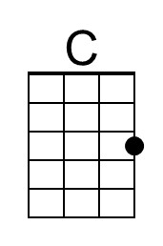
 |  |  |  |  |  |  | 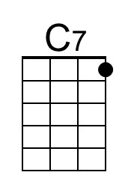
 |  |  |  |  |  |  | 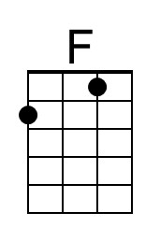
 |  |  |  |  |  |  | 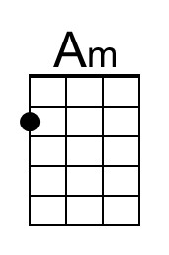
 |  |  |  |  |  |  | 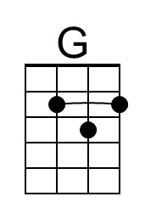
 |  | Bari | 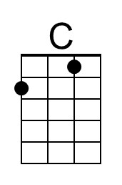 | 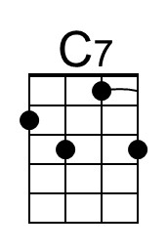 | 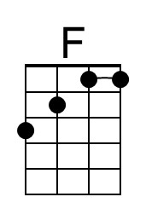 | 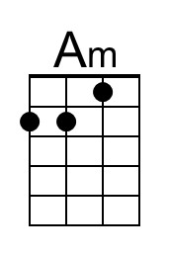 | 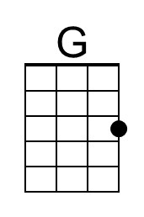

Will The Circle Be Unbroken (Habershon & Gabriel, 1907) (G)
Recast by A.P. Carter and recorded by the Carter Family as
Can The Circle Be Unbroken (1927)
Will The Circle Be Unbroken by The Nitty Gritty Dirt Band with Johnny Cash, Ricky Skaggs
Will the Circle Be Unbroken by June & Johnny Cash and Others

Intro: Chords for chorus

G G7 C G
I was standing by my window, on a cold and cloudy day.
G Em G D G | G
When I saw that hearse come rollin’ for to carry my mother a-way.

Chorus
G G7 C G
Will the circle be un-broken, by and by, Lord, by and by?
G Em G D G | G
There's a better home a-waiting, in the sky, Lord, in the sky.

G G7 C G
I said to that, under-taker, “Under-taker please drive slow.
G Em G D G | G
For this lady you are carrying, Lord I hate to see her go”. Chorus

G G7 C G
Oh, I followed close be-hind her, tried to hold up and be brave.
G Em G D G | G
But I could not hide my sorrow when they laid her in the grave. Chorus

G G7 C G
I went back home, my home was lonesome, miss my mother she was gone.
G Em G D G | G
All my brothers, and sisters crying, what a home so sad and a-lone. Chorus

G G7 C G
We sang the songs of our childhood, hymns of faith that made us strong.
G Em G D G | G
Ones that Mother Maybelle taught us and the angels sang a-long. Chorus (2x)

 |  |  |  |  |  |  | 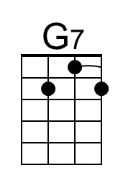
 |  |  |  |  |  |  | 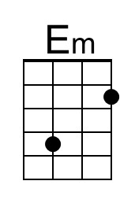
 |  |  |  |  |  |  | 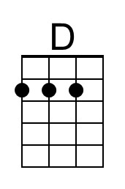
 |  | Bari |  | 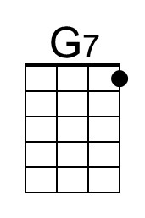 |  | 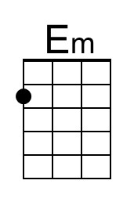 | 