Willie Nice Christmas (Kacey Musgraves) GCEA
Intro: C G7 C B slide to C

C Em7 G7
I'm gonna wrap my presents up in red bandanas
C
And leave some special cookies out for Santa
C7
Throw my troubles to the wind,
F Fm
'til we're back on the road again
C G7 C
Here's to finding your own little peace on Earth

C G7 C
And - I - hope you have a really, a really, really,
G7
Willie nice Christmas
C
If you’re in Luckenbach or Waikiki
I hope you have a really, a really, really,
C7 F Dm
Willie nice Christmas
C G7 C
And may your heart be lighter than the angel on
C
top of the tree *

C Em7 G7
Don't get caught up in the hustle and the bustle
C
This time of year ain't supposed to be so stressful
C7
Here's to easy silent nights
F Fm
And finding your own paradise
C G7 C
With whatever family, you might call your own

C G7 C
And - I - hope you have a really, a really, really,
G7
Willie nice Christmas
C
And may it be a lot more green than blue

Yeah, I hope you have a really, really, really,
C7 F Dm
Willie nice Christmas
C G7 C
And, a Willie, Happy New Year, too
[Instrumental verse]

Bridge: (slower, thumb strum)
F Em
Have a Willie happy Hanukkah, Feliz Navidad - ukkah
Dm C Dm Em7
A Willie happy Kwanzaa 'cause it's all the same
F Em
A Mele Kalikimaka, hey - Whatever way you wanna say
Dm Em7 G7
Just ….have – your-- self - a
C
Really, really, really, a really, really,
G7
Willie nice Christmas
C
Whether you’re in Luckenbach or Waikiki

I hope you have a really, a really, really,
C7 F Dm
Willie nice Christmas
C G7 C
And may your spirits be brighter than the lights on
C
your Christmas tree *
C G7
And may your heart be lighter than the angel on
C
top of the tree
C G7 C B ----- C
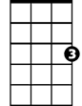
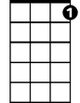
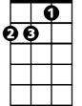
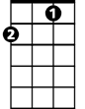
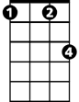
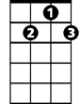
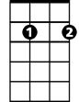
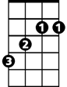
Happy Holidays, Willie and me
C
C7
Dm
F
Fm
G7
Em7
B

Willie Nice Christmas (Kacey Musgraves) DGBE (BARITONE)
Intro: C G7 C B slide to C

C Em7 G7
I'm gonna wrap my presents up in red bandanas
C
And leave some special cookies out for Santa
C7
Throw my troubles to the wind,
F Fm
'til we're back on the road again
C G7 C
Here's to finding your own little peace on Earth

C G7 C
And - I - hope you have a really, a really, really,
G7
Willie nice Christmas
C
If you’re in Luckenbach or Waikiki

I hope you have a really, a really, really,
C7 F Dm
Willie nice Christmas
C G7 C
And may your heart be lighter than the angel on
C
top of the tree *

C Em7 G7
Don't get caught up in the hustle and the bustle
C
This time of year ain't supposed to be so stressful
C7
Here's to easy silent nights
F Fm
And finding your own paradise
C G7 C
With whatever family, you might call your own

C G7 C
And - I - hope you have a really, a really, really,
G7
Willie nice Christmas
C
And may it be a lot more green than blue

Yeah, I hope you have a really, really, really,
C7 F Dm
Willie nice Christmas
C G7 C
And, a Willie, Happy New Year, too
[Instrumental verse]

Bridge: (slower, thumb strum)
F Em
Have a Willie happy Hanukkah, Feliz Navidad - ukkah
Dm C Dm Em7
A Willie happy Kwanzaa 'cause it's all the same
F Em
A Mele Kalikimaka, hey - Whatever way you wanna say
Dm Em7 G7
Just ….have – your-- self - a
C
Really, really, really, a really, really,
G7
Willie nice Christmas
C
Whether you’re in Luckenbach or Waikiki

I hope you have a really, a really, really,
C7 F Dm
Willie nice Christmas
C G7 C
And may your spirits be brighter than the lights on
C
your Christmas tree *
C G7
And may your heart be lighter than the angel on
C
top of the tree
C G7 C B ----- C
Happy Holidays, Willie and me
BARITONE
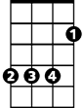
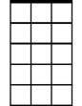
G7
C
B
Em7

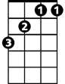
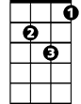
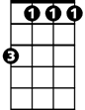
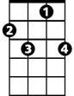
F
Dm
Fm
C7

