Winchester Cathedral (Geoff Stephens, 1966) (C)
Winchester Cathedral by The New Vaudeville Band (C)
4/4 Time – Tempo 128 bpm

Intro (Instrumental for first 2 lines)
C Am G G6
Oh-bo-de-o-do, oh-bo-de-o-do,
G7 G6 C G7
Oh-bo-de-o-do de-do-duh.

C Am G G6
Oh-bo-de-o-do, oh-bo-de-o-do,
G7 G6 C ↓ G7 ↓
Oh-bo-de-o-do de-do-duh.

C G
__ Winchester Cathedral, __ you're bringing me down.
G7 C
__ You stood and you watched as, __ my baby left town.
C G
__ You could have done something, __ but you didn't try.
G7 C
__ You didn't do nothing; __ you let her walk by.

Bridge
C C7 F
__ Now everyone knows just how much I needed that gal,
D D7
__ She wouldn't have gone far a-way.
G D7 G7
If only you'd started ringing your bell.

 | 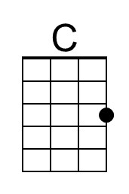 | 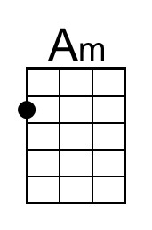 | 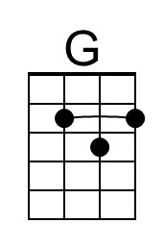 | 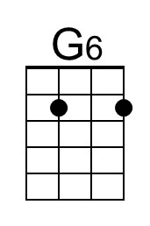 | 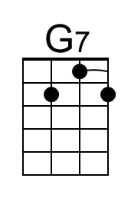
 | 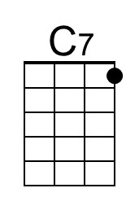 | 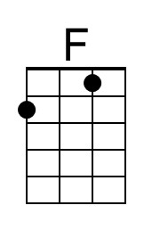 | 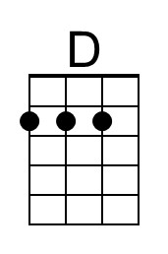 | 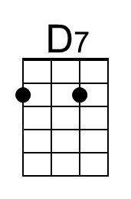 | 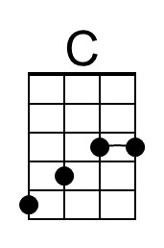

Winchester Cathedral (C) – Page 2

C G
__ Winchester Cathedral, __ you're bringing me down.
G7 C
__ You stood and you watched as, __ my baby left town.

(Instrumental / Kazoo)
C G
__ Winchester Cathedral, __ you're bringing me down.
G7 C
__ You stood and you watched as, __ my baby left town.

Bridge
C C7 F
__ Now everyone knows just how much I needed that gal,
D D7
__ She wouldn't have gone far a-way.
G D7 G7
If only you'd started ringing your bell.

C G
__ Winchester Cathedral, __ you're bringing me down.
G7 C
__ You stood and you watched as, __ my baby left town.

Outro
C Am G G6
Oh-bo-de-o-do, oh-bo-de-o-do,
G7 G6 C ↓ C ↓ [Hold]
Oh-bo-de-o-do de-do-duh. [High C]

 |  | Bari | 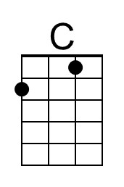 | 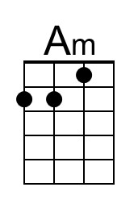 | 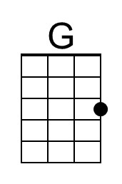 | 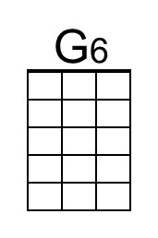 | 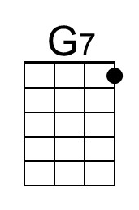
 |  |  | 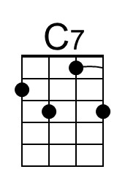 | 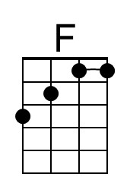 | 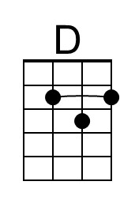 | 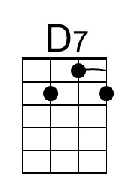 | 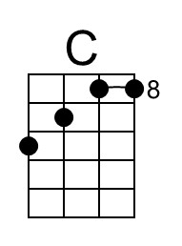

Winchester Cathedral (Geoff Stephens, 1966) (G)
Winchester Cathedral by The New Vaudeville Band (C)
4/4 Time – Tempo 128 bpm

Intro (Instrumental for first 2 lines)
G Em D D6
Oh-bo-de-o-do, oh-bo-de-o-do,
D7 D6 G D7
Oh-bo-de-o-do de-do-duh.

G Em D D6
Oh-bo-de-o-do, oh-bo-de-o-do,
D7 D6 G ↓ D7 ↓
Oh-bo-de-o-do de-do-duh.

G D
__ Winchester Cathedral, __ you're bringing me down.
D7 G
__ You stood and you watched as, __ my baby left town.
G D
__ You could have done something, __ but you didn't try.
D7 G
__ You didn't do nothing; __ you let her walk by.

Bridge
G G7 C
__ Now everyone knows just how much I needed that gal,
A A7
__ She wouldn't have gone far a-way.
D A7 D7
If only you'd started ringing your bell.

 |  | 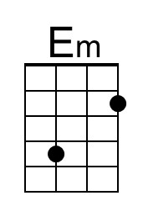 |  | 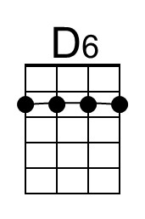
 |  |  | 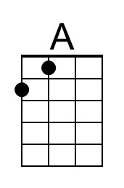 | 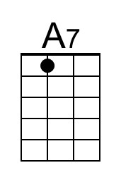 | 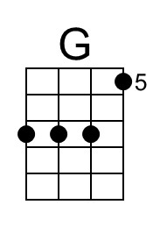

Winchester Cathedral (G) – Page 2

G D
__ Winchester Cathedral, __ you're bringing me down.
D7 G
__ You stood and you watched as, __ my baby left town.

(Instrumental / Kazoo)
G D
__ Winchester Cathedral, __ you're bringing me down.
D7 G
__ You stood and you watched as, __ my baby left town.

Bridge
G G7 C
__ Now everyone knows just how much I needed that gal,
A A7
__ She wouldn't have gone far a-way.
D A7 D7
If only you'd started ringing your bell.

G D
__ Winchester Cathedral, __ you're bringing me down.
D7 G
__ You stood and you watched as, __ my baby left town.

Outro
G Em D D6
Oh-bo-de-o-do, oh-bo-de-o-do,
D7 D6 G ↓ G ↓ [Hold]
Oh-bo-de-o-do de-do-duh. [High C]

 |  | Bari |  | 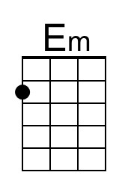 |  | 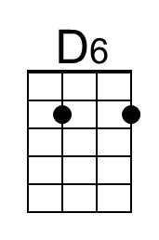
 |  |  |  |  | 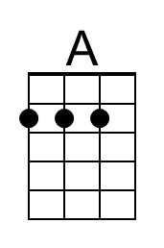 | 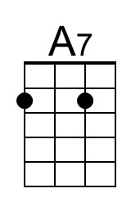 | 