
Winchester Cathedral (Geoff Stephens, 1966) (C)
Winchester Cathedral by The New Vaudeville Band

Intro (4 measures) C | G | G7 | C |  C G  __ Winchester Cathedral, __ you're bringing me down.  G7 C  __ You stood and you watched as, __ my baby left town.  C G  __ You could have done something, __ but you didn't try.  G7 C  __ You didn't do nothing; __ you let her walk by.  Bridge  C C7 F  __ Now everyone knows just how much I needed that gal,  D D7  __ She wouldn't have gone far a-way.  G D7 G7  If only you'd started ringing your bell.  C G  __ Winchester Cathedral, __ you're bringing me down.  G7 C  __ You stood and you watched as, __ my baby left town.  (Instrumental Verse) (kazoos?)  Bridge. Last Verse.  Outro |  |  | 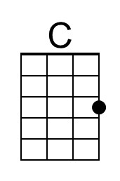 | 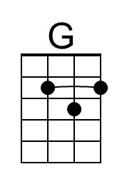
 |  |  | 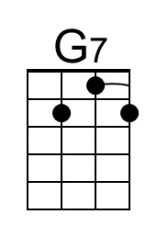 | 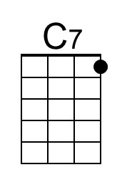
 |  |  | 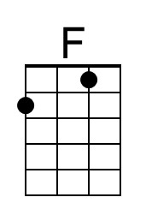 | 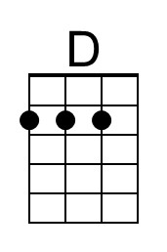
 |  |  |  | 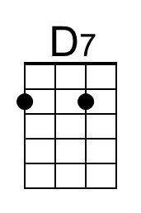
C G  Oh-bo-de-o-do, oh-bo-de-o-do,  G7 C | C [Hold]  Oh-bo-de-o-do de-do-duh. | 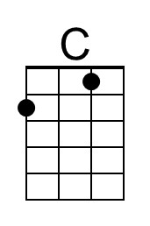 | 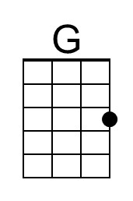 | 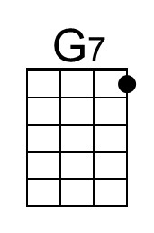 | 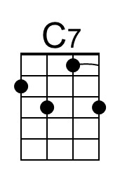
 | 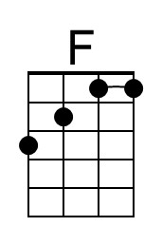 | 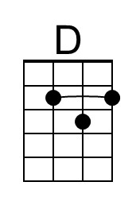 | 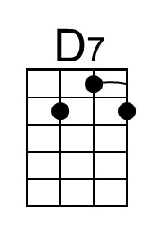

Winchester Cathedral (Geoff Stephens, 1966) (G)
Winchester Cathedral by The New Vaudeville Band

Intro (4 measures) G | D | D7 | G |

G D
__ Winchester Cathedral, __ you're bringing me down.
D7 G
__ You stood and you watched as, __ my baby left town.
G D
__ You could have done something, __ but you didn't try.
D7 G
__ You didn't do nothing; __ you let her walk by.

Bridge
G G7 C
__ Now everyone knows just how much I needed that gal,
A A7
__ She wouldn't have gone far a-way.
D A7 D7
If only you'd started ringing your bell.

G D
__ Winchester Cathedral, __ you're bringing me down.
D7 G
__ You stood and you watched as, __ my baby left town.

(Instrumental Verse) (kazoos?)

Bridge. Last Verse.

Outro
 |  |  |  | 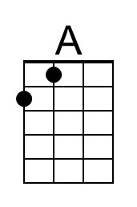
 |  |  |  | 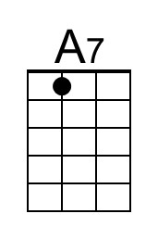
G D
Oh-bo-de-o-do, oh-bo-de-o-do,
D7 G | G [Hold]
Oh-bo-de-o-do de-do-duh.
 |  | 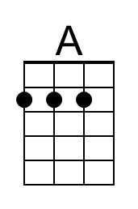 | 