
Winchester Cathedral (Geoff Stephens, 1966) (C)
Winchester Cathedral by The New Vaudeville Band
Tempo = 124 bpm
Intro (4 measures)  C Am G G6  Oh-bo-de-o-do, oh-bo-de-o-do,  G7 G6 C ↓ G7 ↓  Oh-bo-de-o-do de-do-duh.  C G  __ Winchester Cathedral, __ you're bringing me down.  G7 C  __ You stood and you watched as, __ my baby left town.  C G  __ You could have done something, __ but you didn't try.  G7 C  __ You didn't do nothing; __ you let her walk by.  Bridge  C C7 F  __ Now everyone knows just how much I needed that gal,  D D7  __ She wouldn't have gone far a-way.  G D7 G7  If only you'd started ringing your bell.  C G  __ Winchester Cathedral, __ you're bringing me down.  G7 C  __ You stood and you watched as, __ my baby left town. |  |  | 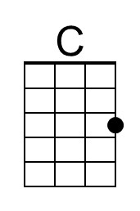 | 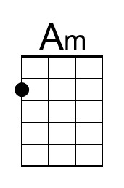
 |  |  | 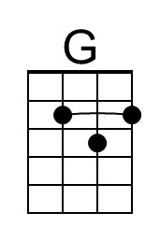 | 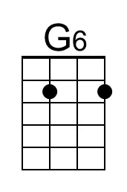
 |  |  | 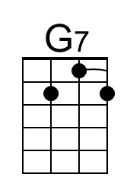 | 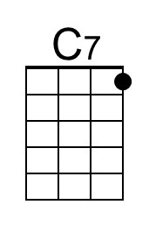
 |  |  | 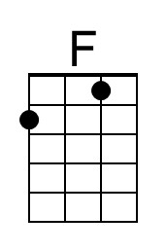 | 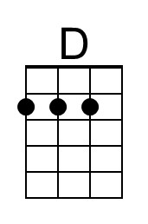
 |  |  | 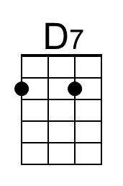 | 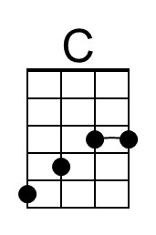
(Instrumental Verse) (kazoos?)  Bridge. Last Verse.  Outro  C Am G G6  Oh-bo-de-o-do, oh-bo-de-o-do,  G7 G6 C ↓ C ↓ [Hold]  Oh-bo-de-o-do de-do-duh. [High C] | 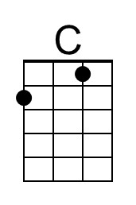 | 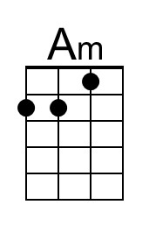 | 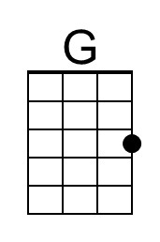 | 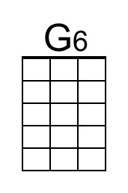
 | 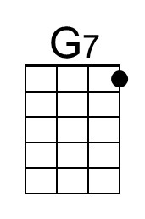 | 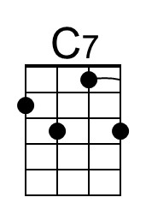 | 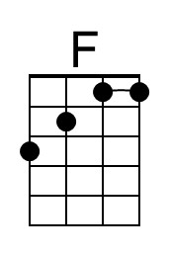 | 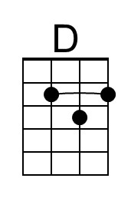
 | 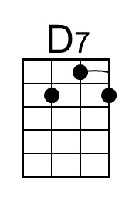 | 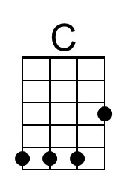

Winchester Cathedral (Geoff Stephens, 1966) (G)
Winchester Cathedral by The New Vaudeville Band
Tempo = 124 bpm
Intro (4 measures)  G Em D D6  Oh-bo-de-o-do, oh-bo-de-o-do,  D7 D6 G ↓ D7 ↓ [Hold]  Oh-bo-de-o-do de-do-duh.  G D  __ Winchester Cathedral, __ you're bringing me down.  D7 G  __ You stood and you watched as, __ my baby left town.  G D  __ You could have done something, __ but you didn't try.  D7 G  __ You didn't do nothing; __ you let her walk by.  Bridge  G G7 C  __ Now everyone knows just how much I needed that gal,  A A7  __ She wouldn't have gone far a-way.  D A7 D7  If only you'd started ringing your bell.  G D  __ Winchester Cathedral, __ you're bringing me down.  D7 G  __ You stood and you watched as, __ my baby left town. |  |  |  | 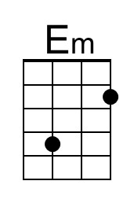
 |  |  |  | 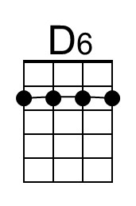
 |  |  |  | 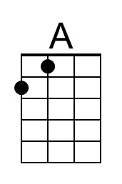
 |  |  | 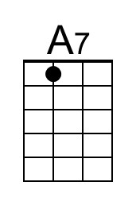 | 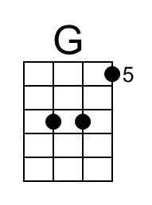
(Instrumental Verse) (kazoos?)  Bridge. Last Verse.  Outro  G Em D D6  Oh-bo-de-o-do, oh-bo-de-o-do,  D7 D6 G ↓ G ↓ [Hold]  Oh-bo-de-o-do de-do-duh. [High G] |  | 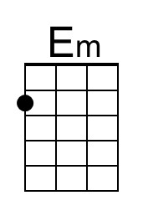 |  | 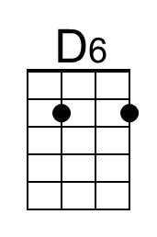
 |  |  |  | 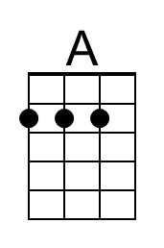
 | 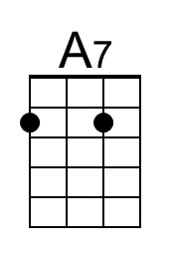 | 