Winchester Cathedral (Geoff Stephens) (G)

Intro: G D D7 G  G D  Winchester Cathedral, you're bringing me down.  D7 G  You stood and you watched as, my baby left town.  G D  You could have done something, but you didn't try.  D7 G  You didn't do nothing; you let her walk by.  Bridge:  G G7 C  Now everyone knows just how much I needed that gal,  A A7  She wouldn't have gone far a-way.  D A7 D7  If only you'd started ringing your bell.  G D  Winchester Cathedral, you're bringing me down.  D7 G  You stood and you watched as, my baby left town.  (Instrumental Verse)  Outro:  G D  Oh-bo-de-o-do, oh-bo-de-o-do,  D7 G  Oh-bo-de-o-do de-do-duh. |  |  |  |  |  |  | 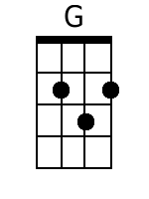 |  | 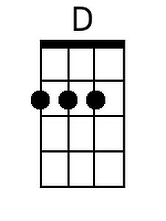
 |  |  |  |  |  |  | 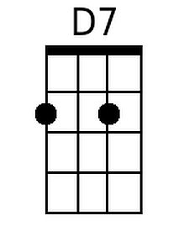 |  | 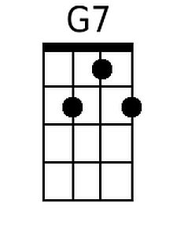
 |  |  |  |  |  |  | 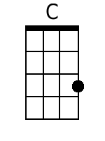 |  | 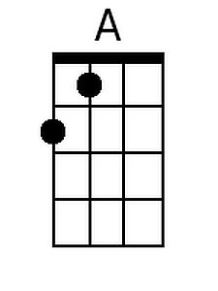
 |  |  |  |  |  |  | 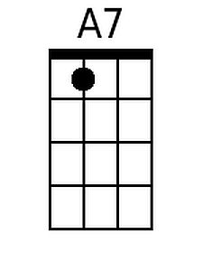
Bari
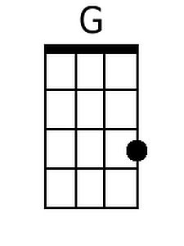 | 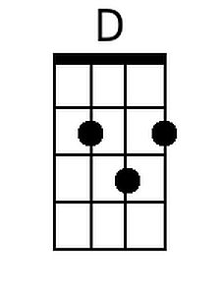 | 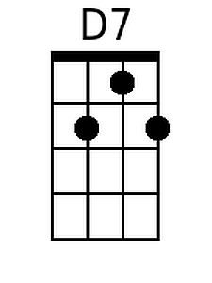 | 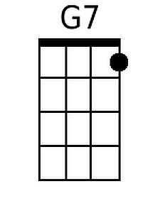 | 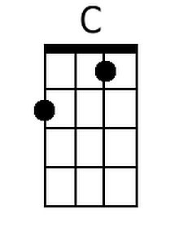 | 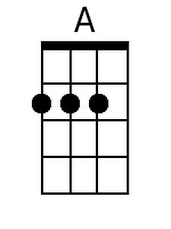 | 