**Winchester Cathedral (Geoff Stephens)**

**Intro: C G G7 C**

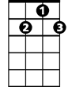

G7



C



G

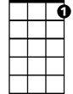

C7

F



**C G**

Winchester Cathedral, you're bringing me down.

**G7 C**

You stood and you watched as, my baby left town.

**C G**

You could have done something, but you didn't try.

**G7 C**

You didn't do nothing; you let her walk by.

**Bridge:**

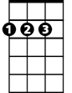

D

**C C7 F**

Now everyone knows just how much I needed that gal,

**D D7**

She wouldn't have gone far a-way.

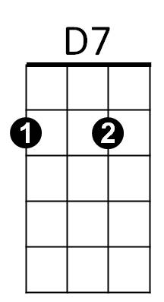 **G D7 G7**

If only you'd started ringing your bell.

**C G**

Winchester Cathedral, you're bringing me down.

**G7 C**

You stood and you watched as, my baby left town.

**(Instrumental Verse) (kazoos?)**



F



G

**BARITONE**

C



G7

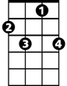

C7



D



D7

**Outro:**

**C G**

Oh-bo-de-o-do, oh-bo-de-o-do,

**G7 C**

Oh-bo-de-o-do de-do-duh.