Windmills of Your Mind (Bergman / Legrand / Bergman) (Am)
GCEA – Soprano, Concert, Tenor

Intro: Am E7 Am  Am  Round, like a circle in a spiral,  E7  Like a wheel within a wheel  Never ending or beginning  Am  On an ever spinning reel  A7  Like a snowball down a mountain,  Dm7  Or a carnival balloon  G7  Like a carousel that's turning,  Cmaj7  Running rings around the moon  Chorus:  Fmaj7  Like a clock whose hands are sweeping  Dm  Past the minutes of its face  E7  And the world is like an apple  Am  Whirling silently in space  Ebdim E7  Like the circles that you find  Am  In the windmills of your mind!  Am  Like a tunnel that you follow  E7  To a tunnel of its own  Down a hollow to a cavern  Am  Where the sun has never shone  A7  Like a door that keeps revolving  Dm7  In a half forgotten dream  G7  Or the ripples from a pebble  Cmaj7  Someone tosses in a stream. Chorus | Am  Keys that jingle in your pocket,  Dm7  Words that jangle in your head  G7  Why did summer go so quickly,  Cmaj7  Was it something that you said?  C7  Lovers walking along a shore  Fmaj7  And leave their footprints in the sand  B7  Is the sound of distant drumming  Em  Just the fingers of your hand?  A7  Pictures hanging in a hallway  Dm  And the fragment of a song  G7  Half remembered names and faces,  Cmaj7  But to whom do they belong?  Fmaj7  When you knew that it was over  Dm  You were suddenly aware  E7  That the autumn leaves were turning  Am  To the color of her hair!  Am  Like a circle in a spiral,  E7  Like a wheel within a wheel  Never ending or beginning  D#dim  On an ever spinning reel  Am  As the images unwind,  E7  Like the circles that you find  Am  In the windmills of your mind! | 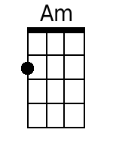  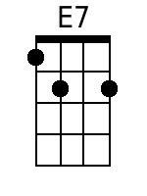  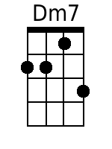  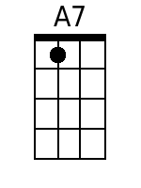  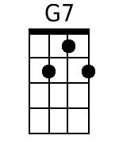  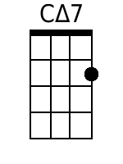  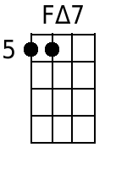  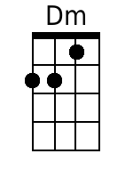  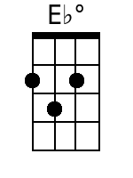  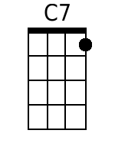  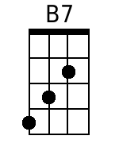  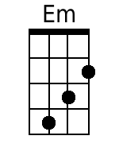

Windmills of Your Mind (Bergman / Legrand / Bergman) (Am)
DGBE - Baritone

Intro: Am E7 Am  Am  Round, like a circle in a spiral,  E7  Like a wheel within a wheel  Never ending or beginning  Am  On an ever spinning reel  A7  Like a snowball down a mountain,  Dm7  Or a carnival balloon  G7  Like a carousel that's turning,  Cmaj7  Running rings around the moon  Chorus:  Fmaj7  Like a clock whose hands are sweeping  Dm  Past the minutes of its face  E7  And the world is like an apple  Am  Whirling silently in space  Ebdim E7  Like the circles that you find  Am  In the windmills of your mind!  Am  Like a tunnel that you follow  E7  To a tunnel of its own  Down a hollow to a cavern  Am  Where the sun has never shone  A7  Like a door that keeps revolving  Dm7  In a half forgotten dream  G7  Or the ripples from a pebble  Cmaj7  Someone tosses in a stream. Chorus | Am  Keys that jingle in your pocket,  Dm7  Words that jangle in your head  G7  Why did summer go so quickly,  Cmaj7  Was it something that you said?  C7  Lovers walking along a shore  Fmaj7  And leave their footprints in the sand  B7  Is the sound of distant drumming  Em  Just the fingers of your hand?  A7  Pictures hanging in a hallway  Dm  And the fragment of a song  G7  Half remembered names and faces,  Cmaj7  But to whom do they belong?  Fmaj7  When you knew that it was over  Dm  You were suddenly aware  E7  That the autumn leaves were turning  Am  To the color of her hair!  Am  Like a circle in a spiral,  E7  Like a wheel within a wheel  Never ending or beginning  D#dim  On an ever spinning reel  Am  As the images unwind,  E7  Like the circles that you find  Am  In the windmills of your mind! | 