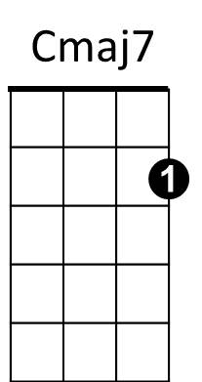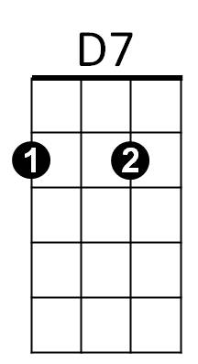**Windmills of Your Mind (Marilyn Bergman / Michel Legrand / Alan Bergman) Key Em**

**Intro: Em B7 Em GCEA**

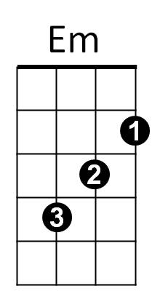

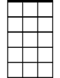

Am7

E7

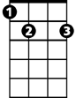

**Em**

Round, like a circle in a spiral,

**B7**

Like a wheel within a wheel

Never ending or beginning

**Em**

On an ever spinning reel

**E7**

Like a snowball down a mountain,

**Am7**

Or a carnival balloon

**D7**

Like a carousel that's turning,

**Gmaj7**

Running rings around the moon

**Chorus:**

**Cmaj7**

Like a clock whose hands are sweeping

**Am**

Past the minutes of its face

**B7**

And the world is like an apple

**Em**

Whirling silently in space

**Bbdim**  **B7**

Like the circles that you find

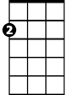

Am

**Em**

In the windmills of your mind!

**Em**

Like a tunnel that you follow

**B7**

To a tunnel of its own

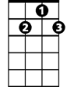

G7

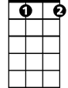

Bbdim

Down a hollow to a cavern

**Em**

Where the sun has never shone

**E7**

Like a door that keeps revolving

**Am7**

In a half forgotten dream

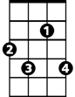

F#7

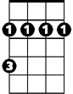

Bm

**D7**

Or the ripples from a pebble

**Gmaj7**

Someone tosses in a stream

**(Chorus)**

**Em**

Keys that jingle in your pocket,

**Am7**

Words that jangle in your head

**D7**

Why did summer go so quickly,

**Gmaj7**

Was it something that you said?

**G7**

Lovers walking along a shore

**Cmaj7**

And leave their footprints in the sand

**F#7**

Is the sound of distant drumming

**Bm**

Just the fingers of your hand?

**E7**

Pictures hanging in a hallway

**Am**

And the fragment of a song

**D7**

Half remembered names and faces,

**Gmaj7**

But to whom do they belong?

**Cmaj7**

When you knew that it was over

**Am**

You were suddenly aware

**B7**

That the autumn leaves were turning

**Em**

To the color of her hair!

**Em**

Like a circle in a spiral,

**B7**

Like a wheel within a wheel

Never ending or beginning

**Bbdim**

On an ever spinning reel

**Em**

As the images unwind,

**B7**

Like the circles that you find

**Em**

In the windmills of your mind!

**Windmills of Your Mind (Marilyn Bergman / Michel Legrand / Alan Bergman) Key Em DGBE**

**BARITONE**

**Intro: Em B7 Em**



Em

B7



**Em**

Round, like a circle in a spiral,

**B7**

Like a wheel within a wheel

Never ending or beginning

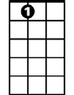

E7

**Em**

On an ever spinning reel

**E7**

Like a snowball down a mountain,

**Am7**

Or a carnival balloon

**D7**

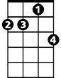

Am7

Like a carousel that's turning,

**Gmaj7**

Running rings around the moon

**Chorus:**

**Cmaj7**

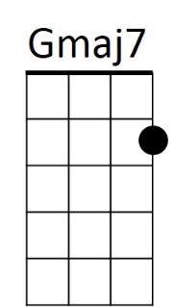Like a clock whose hands are sweeping



D7

**Am**

Past the minutes of its face

**B7**

And the world is like an apple

**Em**

Whirling silently in space

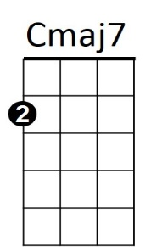**Bbdim**  **B7**

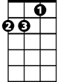

Am

Like the circles that you find

**Em**

In the windmills of your mind!

**Em**

Like a tunnel that you follow

**B7**

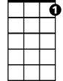

G7

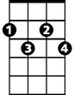

Bbdim

To a tunnel of its own

Down a hollow to a cavern

**Em**

Where the sun has never shone

**E7**

Like a door that keeps revolving

**Am7**

Bm

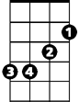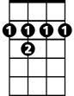

F#7

In a half forgotten dream

**D7**

Or the ripples from a pebble

**Gmaj7**

Someone tosses in a stream

**(Chorus)**

**Em**

Keys that jingle in your pocket,

**Am7**

Words that jangle in your head

**D7**

Why did summer go so quickly,

**Gmaj7**

Was it something that you said?

**G7**

Lovers walking along a shore

**Cmaj7**

And leave their footprints in the sand

**F#7**

Is the sound of distant drumming

**Bm**

Just the fingers of your hand?

**E7**

Pictures hanging in a hallway

**Am**

And the fragment of a song

**D7**

Half remembered names and faces,

**Gmaj7**

But to whom do they belong?

**Cmaj7**

When you knew that it was over

**Am**

You were suddenly aware

**B7**

That the autumn leaves were turning

**Em**

To the color of her hair!

**Em**

Like a circle in a spiral,

**B7**

Like a wheel within a wheel

Never ending or beginning

**Bbdim**

On an ever spinning reel

**Em**

As the images unwind,

**B7**

Like the circles that you find

**Em**

In the windmills of your mind!