**Wind Beneath My Wings (Jeff Silbar / Larry Henley) Key C**

**C F**

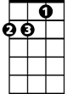

Dm



G



C

F



It must have been cold there in my shadow,

**C F**

To never have sunlight on your face.

**Dm G**

You were content to let me shine; that's your way.

**Dm G**

E7

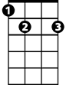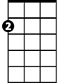

Am

You always walked a step behind.

**C F**

So I was the one with all the glory,

**C F**

While you were the one wi th all the strain.

**Dm G**

A beautiful face without a name; for so long.

**Dm G E7**

A beautiful smile to hide the pain.

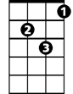

Dm

C



F

**BARITONE**

**Chorus:**

**Am F C**

Did you ever know that you're my hero,

**Am F C G**



Am

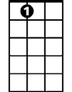

E7

And everything I would like to be?



G

**Am F C G**

I can fly higher than an ea-gle

**F G C**

For you are the wind beneath my wings.

**C F**

It might have appeared to go unnoticed,

**C F**

But I've got it all here in my heart.

**Dm G**

I want you to know I know the truth, of course I know it.

**Dm G E7**

I would be nothing without you.

**(Chorus) 2x**

**Wind Beneath My Wings (Jeff Silbar / Larry Henley) Key G**

**G C**



Am



C



G

It must have been cold there in my shadow,

**G C**

To never have sunlight on your face.

**Am D**

You were content to let me shine; that's your way.

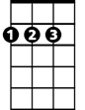

D

**Am D**

Em

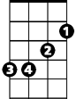

You always walked a step behind.

**G C**

So I was the one with all the glory,

**G C**

While you were the one with all the strain.

**Am D**

A beautiful face without a name; for so long.

**Am D B7**

A beautiful smile to hide the pain.



Am



G

C



**BARITONE**

**Chorus:**

**Em C G**

Did you ever know that you're my hero,

**Em C G D**

And everything I would like to be?



D



Em

B7



**Em C G D**

I can fly higher than an ea-gle

**C D G**

For you are the wind beneath my wings.

**G C**

It might have appeared to go unnoticed,

**G C**

But I've got it all here in my heart.

**Am D**

I want you to know I know the truth, of course I know it.

**Am D B7**

I would be nothing without you.

**(Chorus) 2x**