Winter Wonderland
C88a C
(Felix Bernard & Richard Bernhard Smith, 1934; “Children’s Version,” 1947)
Winter Wonderland by Perry Como (1946)

Intro: (Last two lines of verse) G7 Dm7 G7 Dm7 D7 G7 C  G7 C G7  Sleigh bells ring, are you list'nin', in the lane snow is glist'nin'  G7 Dm7 G7 Dm7  A beautiful sight, we're happy to-night  D7 G7 C  Walking in a winter wonder-land.  G7 C G7  Gone a-way is the blue-bird, here to stay is a new bird  G7 Dm7 G7 Dm7  He sings a love song as we go a-long  D7 G7 C  Walking in a winter wonder-land.  E B7 E  In the meadow we can build a snowman  E B7 E  Then pretend that he is Parson Brown  G D7 G  He'll say, "Are you married?" We'll say, "No man"  A7 D7 G - G7  But you can do the job when you're in town.  C G7  Later on we'll conspire as we dream by the fire  G7 Dm7 G7 Dm7  To face una-fraid, the plans that we've made  D7 G7 C  Walking in a winter wonder-land.  D7 G7 C D7 | G7 C |  Walking ... in a winter ... wonder-land. |  |  |  |  |  |  | 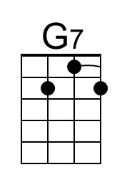 | 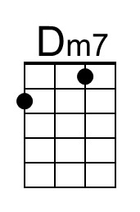
 |  |  |  |  |  |  | 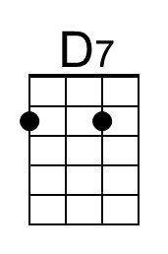 | 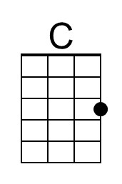
 |  |  |  |  |  |  | 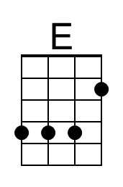 | 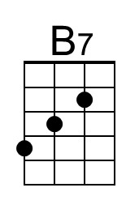
 |  |  |  |  |  |  | 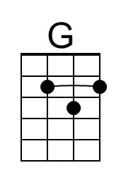 | 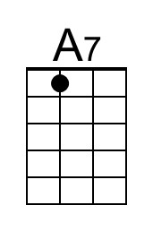
Baritone
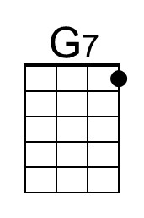 | 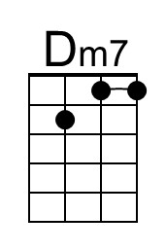 | 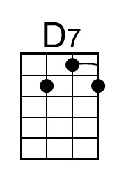 | 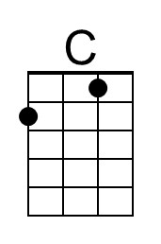 | 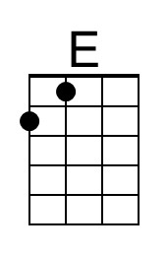 | 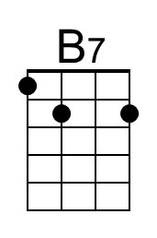 | 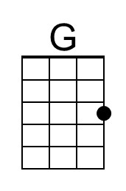 | 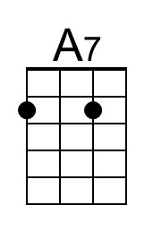

Winter Wonderland
C88a F
(Felix Bernard & Richard Bernhard Smith, 1934; “Children’s Version,” 1947)
Winter Wonderland by Perry Como (1946)

Intro: (Last two lines of verse) C7 Gm7 C7 Gm7 G7 C7 F  C7 F C7  Sleigh bells ring, are you list'nin', in the lane snow is glist'nin'  C7 Gm7 C7 Gm7  A beautiful sight, we're happy to-night  G7 C7 F  Walking in a winter wonder-land.  C7 F C7  Gone a-way is the blue-bird, here to stay is a new bird  C7 Gm7 C7 Gm7  He sings a love song as we go a-long  G7 C7 F  Walking in a winter wonder-land.  A E7 A  In the meadow we can build a snowman  A E7 A  Then pretend that he is Parson Brown  C G7 C  He'll say, "Are you married?" We'll say, "No man"  D7 G7 C - C7  But you can do the job when you're in town.  F C7  Later on we'll conspire as we dream by the fire  C7 Gm7 C7 Gm7  To face una-fraid, the plans that we've made  G7 C7 F  Walking in a winter wonder-land.  G7 C7 F G7 | C7 F |  Walking ... in a winter ... wonder-land. |  |  |  |  |  |  | 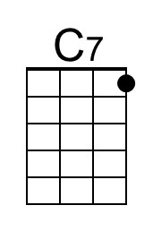 | 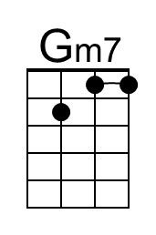
 |  |  |  |  |  |  |  | 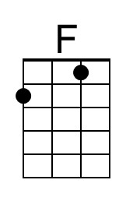
 |  |  |  |  |  |  | 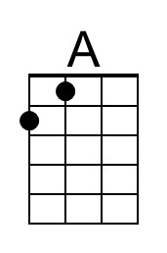 | 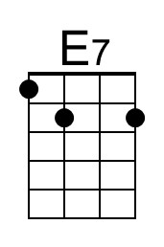
Baritone
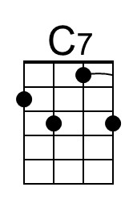 | 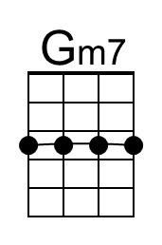 |  | 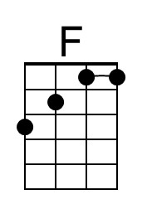 | 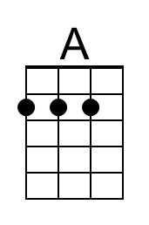 | 