Winter Wonderland
C88 C
(Felix Bernard & Richard Bernhard Smith, 1934)
Additional lyrics added in 1947.

Intro (Last two lines of verse) G7 Dm7 G7 Dm7 D7 G7 C  G7 C G7  Sleigh bells ring, are you list'nin', in the lane snow is glist'nin'  G7 Dm7 G7 Dm7  A beautiful sight, we're happy to-night  D7 G7 C  Walking in a winter wonder-land.  G7 C G7  Gone a-way is the blue-bird, here to stay is a new bird  G7 Dm7 G7 Dm7  He sings a love song as we go a-long  D7 G7 C  Walking in a winter wonder-land.  E7 B7 E7  In the meadow we can build a snowman  E7 B7 E7  Then pretend that he is Parson Brown  G D7 G  He'll say, "Are you married?" We'll say, "No man"  A7 D7 G7  But you can do the job when you're in town.  C G7  Later on we'll conspire as we dream by the fire  G7 Dm7 G7 Dm7  To face una-fraid, the plans that we've made  D7 G7 C  Walking in a winter wonder-land. |  |  |  |  |  |  | 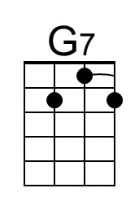 | 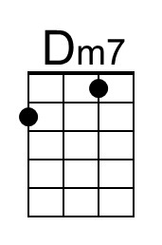
 |  |  |  |  |  |  | 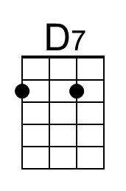 | 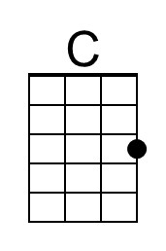
 |  |  |  |  |  |  | 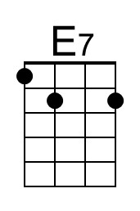 | 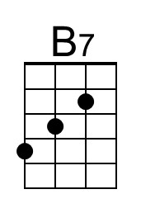
 |  |  |  |  |  |  | 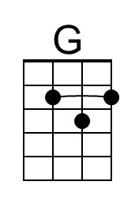 | 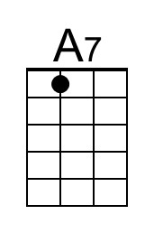
Baritone
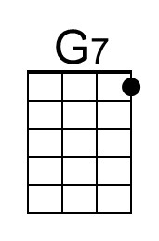 | 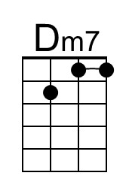 | 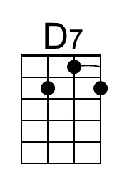 | 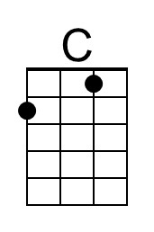 | 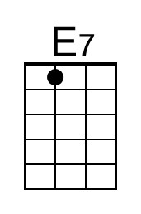 | 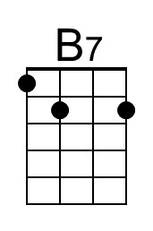 | 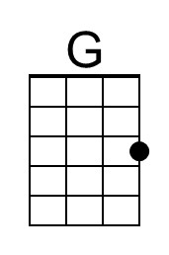 | 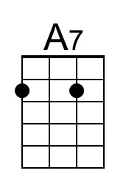

Winter Wonderland (C) - Page 2

G7 C G7
Sleigh bells ring, are you list'nin', in the lane snow is glist'nin'
G7 Dm7 G7 Dm7
A beautiful sight, we're happy to-night
D7 G7 C
Walking in a winter wonder-land.

G7 C G7
Gone a-way is the blue-bird, here to stay is a new bird
G7 Dm7 G7 Dm7
He’s singing song as we go a-long
D7 G7 C
Walking in a winter wonder-land.

E7 B7 E7
In the meadow we can build a snowman
E7 B7 E7
And pretend that he's a circus clown
G D7 G
We'll have lots of fun with Mister Snowman
A7 D7 G7
Un-til the other kiddies knock him down.

C G7
When it snows ain't it thrillin’, Though your nose gets a chillin’?
G7 Dm7 G7 Dm7
We'll frolic and play the Eskimo way
D7 G7 C
Walking in a winter wonder-land.
D7 G7 C
Walking in a winter wonder-land.
D7 G7 C D7 | G7 C |
Walking ... in a winter ... wonder-land.

Winter Wonderland
C88 F
(Felix Bernard & Richard Bernhard Smith, 1934)
Additional lyrics added in 1947.

Intro (Last two lines of verse) C7 Gm7 C7 Gm7 G7 C7 F  C7 F C7  Sleigh bells ring, are you list'nin', in the lane snow is glist'nin'  C7 Gm7 C7 Gm7  A beautiful sight, we're happy to-night  G7 C7 F  Walking in a winter wonder-land.  C7 F C7  Gone a-way is the blue-bird, here to stay is a new bird  C7 Gm7 C7 Gm7  He sings a love song as we go a-long  G7 C7 F  Walking in a winter wonder-land.  A E7 A  In the meadow we can build a snowman  A E7 A  Then pretend that he is Parson Brown  C G7 C  He'll say, "Are you married?" We'll say, "No man"  D7 G7 C7  But you can do the job when you're in town.  F C7  Later on we'll conspire as we dream by the fire  C7 Gm7 C7 Gm7  To face una-fraid, the plans that we've made  G7 C7 F  Walking in a winter wonder-land. |  |  |  |  |  |  | 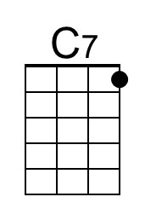 | 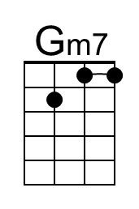
 |  |  |  |  |  |  |  | 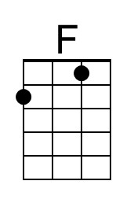
 |  |  |  |  |  |  | 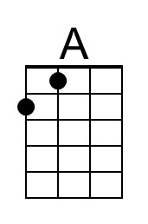
Baritone
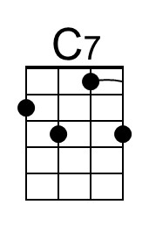 | 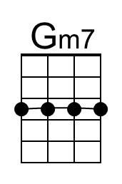 |  | 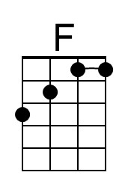 | 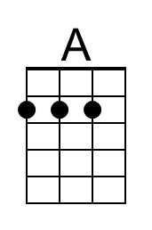

Winter Wonderland (F) - Page 2
C7 F C7
Sleigh bells ring, are you list'nin', in the lane snow is glist'nin'
C7 Gm7 C7 Gm7
A beautiful sight, we're happy to-night
G7 C7 F
Walking in a winter wonder-land.

C7 F C7
Gone a-way is the blue-bird, here to stay is a new bird
C7 Gm7 C7 Gm7
He's singing song as we go a-long
G7 C7 F
Walking in a winter wonder-land.

A E7 A
In the meadow we can build a snowman
A E7 A
And pretend that he's a circus clown
C G7 C
We'll have lots of fun with Mister Snowman
D7 G7 C7
Un-til the other kiddies knock him down.

F C7
When it snows ain't it thrillin', though your nose gets a chillin'?
C7 Gm7 C7 Gm7
We'll frolic and play the Eskimo way
G7 C7 F
Walking in a winter wonder-land.
G7 C7 F
Walking in a winter wonder-land.
G7 C7 F G7 | C7 F |
Walking ... in a winter ... wonder-land.

