Witch Doctor (David Seville, 1958) (C)

Gv Cv  I told the witchdoctor, I was in love with you  Gv Cv  I told the witchdoctor, I was in love with you  Gv Cv Cv  And then the witchdoctor, he told me what to do, he said that  Chorus  C F C G  Ooh eeh ooh ahah ting tang walla walla bing bang  C F G C  Ooh eeh ooh ahah, ting tang walla walla bing bang  C F C G  Ooh eeh ooh ahah ting tang walla walla bing bang  C F G Cv  Ooh eeh ooh ahah, ting tang walla walla bing bang  Gv Cv  I told the witchdoctor, you didn't love me true  Gv Cv  I told the witchdoctor, you didn't love me nice  Gv Cv Cv  And then the witchdoctor, he gave me this advice, he said that, Chorus.  Bridge  F C  You’ve been keeping love from me, just like you were a miser  F C C  And I'll admit I wasn't very smart  F C  So I went out to find myself a guy that's so much wiser  D7 G  And he taught me the way to win your heart  Gv Cv  My friend the witchdoctor, he taught me what to say  Gv Cv  My friend the witchdoctor, he taught me what to do  Gv Cv Cv  I know that you'll be mine when I say this to you, Chorus.  Repeat From Bridge. Last time: Chorus (2x) |  |  |  |  |  |  | 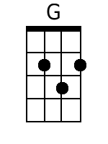
 |  |  |  |  |  |  | 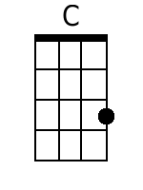
 |  |  |  |  |  |  | 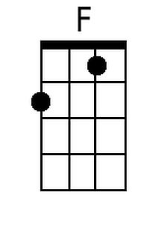
 |  |  |  |  |  |  | 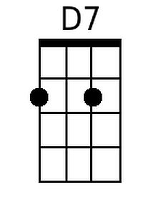
Baritone
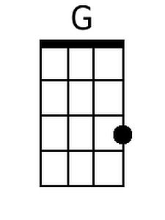 | 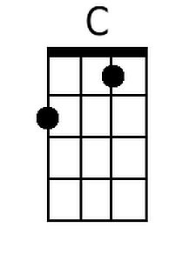 | 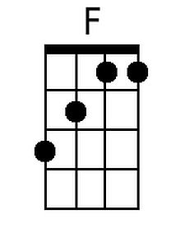 | 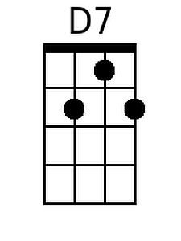

Witch Doctor (David Seville, 1958) (G)

Dv Gv  I told the witchdoctor, I was in love with you  Dv Gv  I told the witchdoctor, I was in love with you  Dv Gv Gv  And then the witchdoctor, he told me what to do, he said that  Chorus  G C G D  Ooh eeh ooh ahah ting tang walla walla bing bang  G C D G  Ooh eeh ooh ahah, ting tang walla walla bing bang  G C G D  Ooh eeh ooh ahah ting tang walla walla bing bang  G C D Gv  Ooh eeh ooh ahah, ting tang walla walla bing bang  Dv Gv  I told the witchdoctor, you didn't love me true  Dv Gv  I told the witchdoctor, you didn't love me nice  Dv Gv Gv  And then the witchdoctor, he gave me this advice, he said that, Chorus.  Bridge  C G  You've been keeping love from me, just like you were a miser  C G G  And I'll admit I wasn't very smart  C G  So I went out to find myself a guy that's so much wiser  A7 D  And he taught me the way to win your heart  Dv Gv  My friend the witchdoctor, he taught me what to say  Dv Gv  My friend the witchdoctor, he taught me what to do  Dv Gv Gv  I know that you'll be mine when I say this to you, Chorus.  Repeat From Bridge. Last time: Chorus (2x) |  |  |  |  |  |  | 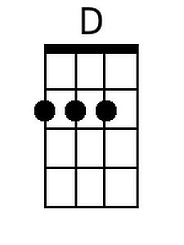
 |  |  |  |  |  |  | 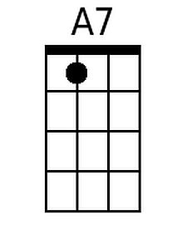
Baritone
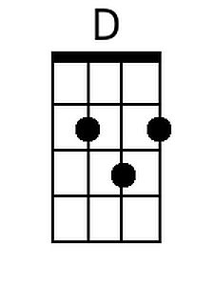 |  |  | 