Witch Doctor (David Seville, 1958) (C)

G↓ C↓  I told the witchdoctor, I was in love with you  G↓ C↓  I told the witchdoctor, I was in love with you  C↓ G↓ C↓  And then the witchdoctor, he told me what to do, he said that  Chorus  C F C G  Ooh eeh ooh ahah ting tang walla walla bing bang  C F G C  Ooh eeh ooh ahah, ting tang walla walla bing bang  C F C G  Ooh eeh ooh ahah ting tang walla walla bing bang  C F G C↓  Ooh eeh ooh ahah, ting tang walla walla bing bang  G↓ C↓  I told the witchdoctor, you didn't love me true  G↓ C↓  I told the witchdoctor, you didn't love me nice  C↓ G↓ C↓  And then the witchdoctor, he gave me this advice, he said that, Chorus.  Bridge  F C  You’ve been keeping love from me, just like you were a miser  F C - C  And I'll admit I wasn't very smart  F C  So I went out to find myself a guy that's so much wiser  D7 G  And he taught me the way to win your heart  G↓ C↓  My friend the witchdoctor, he taught me what to say  G↓ C↓  My friend the witchdoctor, he taught me what to do  C↓ G↓ C↓  I know that you'll be mine when I say this to you, Chorus.  Repeat From Bridge. Last time: Chorus (2x) |  |  |  |  |  |  | 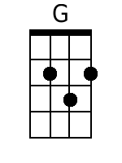
 |  |  |  |  |  |  | 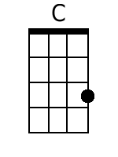
 |  |  |  |  |  |  | 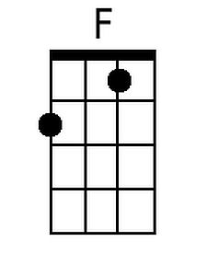
 |  |  |  |  |  |  | 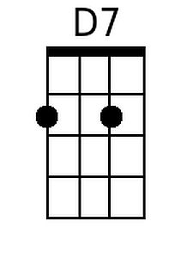
Baritone
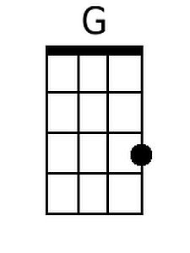 | 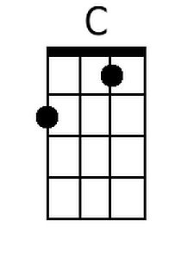 | 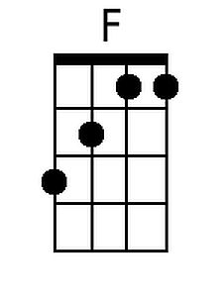 | 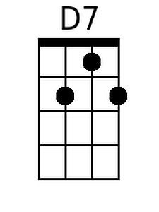

Witch Doctor (David Seville, 1958) (G)

D↓ G↓  I told the witchdoctor, I was in love with you  D↓ G↓  I told the witchdoctor, I was in love with you  G↓ D↓ G↓  And then the witchdoctor, he told me what to do, he said that  Chorus  G C G D  Ooh eeh ooh ahah ting tang walla walla bing bang  G C D G  Ooh eeh ooh ahah, ting tang walla walla bing bang  G C G D  Ooh eeh ooh ahah ting tang walla walla bing bang  G C D G↓  Ooh eeh ooh ahah, ting tang walla walla bing bang  D↓ G↓  I told the witchdoctor, you didn't love me true  D↓ G↓  I told the witchdoctor, you didn't love me nice  G↓ D↓ G↓  And then the witchdoctor, he gave me this advice, he said that, Chorus.  Bridge  C G  You've been keeping love from me, just like you were a miser  C G - G  And I'll admit I wasn't very smart  C G  So I went out to find myself a guy that's so much wiser  A7 D  And he taught me the way to win your heart  D↓ G↓  My friend the witchdoctor, he taught me what to say  D↓ G↓  My friend the witchdoctor, he taught me what to do  G↓ D↓ G↓  I know that you'll be mine when I say this to you, Chorus.  Repeat From Bridge. Last time: Chorus (2x) |  |  |  |  |  |  | 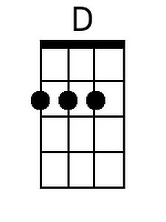
 |  |  |  |  |  |  | 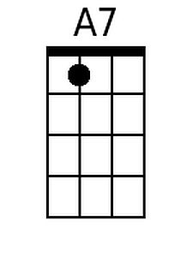
Baritone
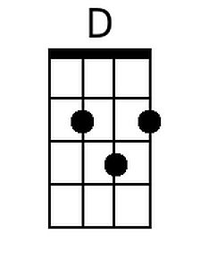 |  |  | 