Witchcraft (Cy Coleman & Carolyn Leigh, 1957) (C)
Witchcraft by Frank Sinatra (1957) (C @ 116)

Intro (Chords for first verse)

C Ebdim7
Those fingers in my hair, that sly, come hither stare
Dm7 G7 C9
That strips my conscience bare - it's witchcraft.

F Fm
And I've got no defense for it - the heat is too intense for it-
Cm D7#5 Gm7
What good would common sense for it do?

G7 C9 C6 C G7sus4 G7
'Cause it's witchcraft, wicked witchcraft, ______ __
C9 C6 C9 C6
And although I know it's strictly taboo,__
Em7
When you arouse a need in me, my heart says, "Yes, indeed!" to me -
Dm Bb Dm7 G7
Proceed with what you're leading me to.

C6 Ebdim7
It's such an ancient pitch, but one I wouldn't switch,
Dm7 G7sus4 G7 C Bbdim7 A7
'Cause there's no nicer witch than you. ____ __
Dm7 G7sus4 G7 C Fdim7 C
'Cause there's no nicer witch than you. ____ __

 | 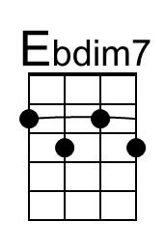 | 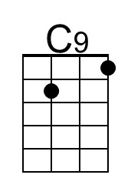 | 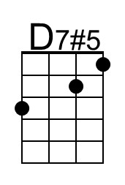 | 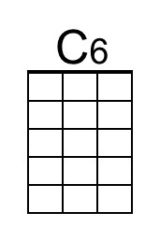 | 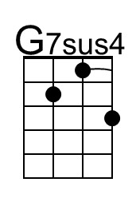 | 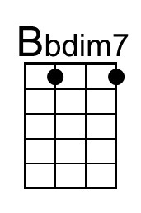 | 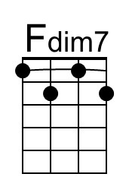
Bari | 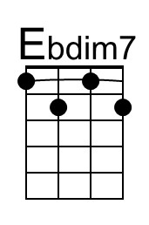 | 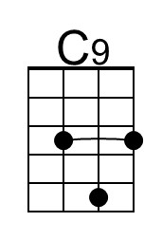 | 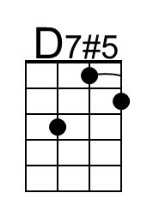 | 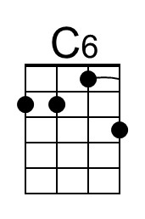 | 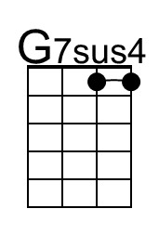 | 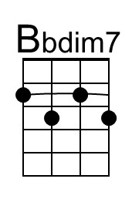 | 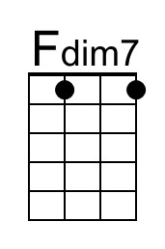

Witchcraft (Cy Coleman & Carolyn Leigh, 1957) (G)
Witchcraft by Frank Sinatra (1957) (C @ 116)

Intro (Chords for first verse)

G Bbdim7
Those fingers in my hair, that sly, come hither stare
Am7 D7 G9
That strips my conscience bare - it's witchcraft.

C Cm
And I've got no defense for it - the heat is too intense for it-
Gm A7#5 Dm7
What good would common sense for it do?

D7 G9 G6 G D7sus4 D7
'Cause it's witchcraft, wicked witchcraft, ______ __
G9 G6 G9 G6
And although I know it's strictly taboo,__
Bm7
When you arouse a need in me, my heart says, "Yes, indeed!" to me -
Am F Am7 D7
Proceed with what you're leading me to.

G6 Bbdim7
It's such an ancient pitch, but one I wouldn't switch,
Am7 D7sus4 D7 G Fdim7 D7
'Cause there's no nicer witch than you. _____ ___
Am7 D7sus4 D7 G Cdim7 G
'Cause there's no nicer witch than you. _____ __

 |  | 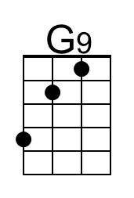 | 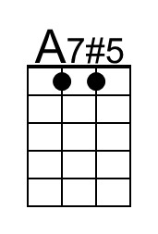 | 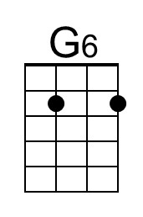 | 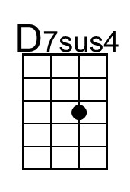 |  | 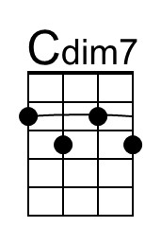
Bari |  | 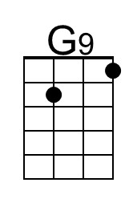 | 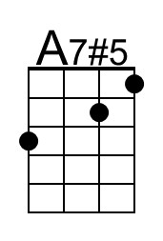 | 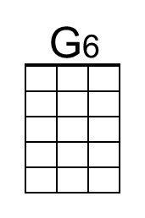 | 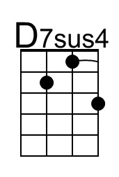 |  | 