**Witchy Woman (Eagles) UBA**

**Intro: Dm / Dm/ C/Am/Am/ C/A7/ A7/ C / Dm/ Dm/**



C

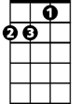

Dm

**Dm A7 Dm**

Raven hair and ruby lips, Sparks fly from her finger tips,

**A7 Dm**

Echoed voices in the night, She's a restless spirit on and endless flight

**Chorus:**

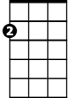

Am

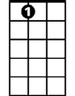

A7

**Dm A7 Dm**

Woohoo witchy woman, See how high she fli-ies

**Dm A7 Dm**

Woohoo witchy woman, She got the moon in her eye-es

**(Intro)**

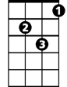

Gm

**Dm A7 Dm**

She had me spellbound in the night. Dancing shadows in the fire light

**A7**

Crazy laughter in another room,

**Dm**

And she drove herself to madness with a silver spoon.

**(Chorus)**

**Dm / Dm/ C/Am/Am/ C/A7/A7/ C/Dm/Dm/ Dm/ Dm/ C/Am /Am/ C/A7/A7/ C/ Dm/Dm/**

Ah - ah – ah ah ah – Ah - ah – ah ah ah

**Dm Am A7 Dm Dm Am A7 Dm Dm Dm/ Dm/ C/Am/Am/ C/A7/A7/ C/Dm/Dm/**

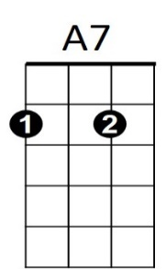**Dm**



Am

**BARITONE**

C



Dm

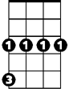

Gm

I know you want to love her, but let me tell you brother,

**Gm A7 Dm**

She's been sleepin’ in the devil's bed.

**Dm**

There's some rumors goin round, someone's underground,

**Gm A7 Dm**

She can rock you in the night until your skin turns red

**(Chorus)**

**Intro 2x (slowing at end)**