With Her Head Tucked Underneath Her Arm
Lyrics by R. P. Weston and Bert Lee; Music by Harris Weston (1934)
As performed by the Kingston Trio, With Her Head Tucked Underneath Her Arm

Intro: Am - C - F - E (2x)  Am Dm - E  1. In the Tower of London, large as life,  E Am  the ghost of Anne Boleyn walks, they de-clare.  Am Dm - E  Poor Anne Boleyn was once King Henry's wife,  E Am  un-til he made the headsman bob her hair.  Dm E  Ah, yes, he did her wrong long years a-go,  F E  and she comes up at night to tell him so,  Chorus  Am E Am E  With her head tucked under-neath her arm  F - G E  she walks the bloody tower,  F Am  with her head tucked underneath her arm  Dm E  at the midnight hour.  Am G F E  2. She comes to haunt King Henry, she means giving him what for.  Am G F E  Gad-zooks, she's going to tell him off, she's feeling very sore,  F Dm Am F  and just in case the headsman wants to give her an en-core,  Am E Am - C - F - E  she's has her head tucked underneath her arm. Chorus  Am G F E  3. The sentries think that it's a football that she carries in,  Am G F E  and when they've had a few they shout 'Is Army going to win?  F Dm Am F  They think that it's Red Grange instead of poor old Ann Bo-leyn,  Am E Am - C - F - E  with her head tucked underneath her arm. |  |  |  |  |  |  | 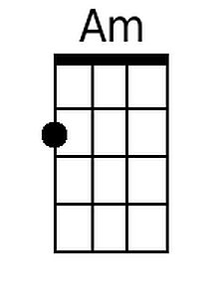  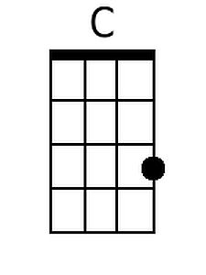  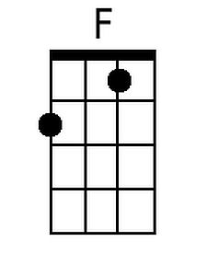  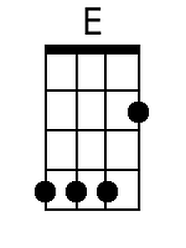  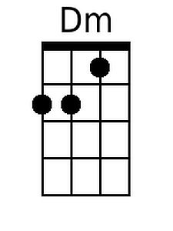  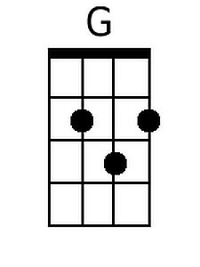
Bari
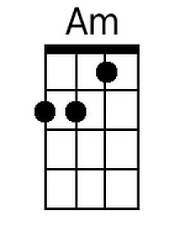 | 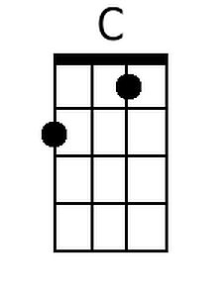 | 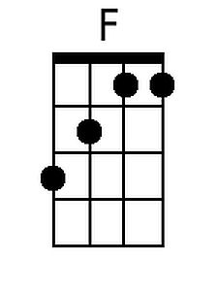 | 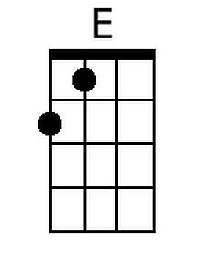 | 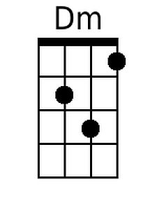 | 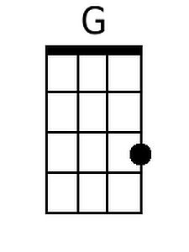

Am Dm - E
4. Some-times gay King Henry gives a spread,
E Am
for all his pals and gals and ghostly crew,
Am Dm - E
her headsman carves the joint and cuts the bread,
E Am
then in comes Anne Boleyn to queer the do.
Dm E
She holds her head up with a wild war whoop,
F E
and Henry cries, "Don't drop it in the soup!" Chorus

Am G F E
5. One night she caught King Henry, he was in the canteen bar.
Am G F E
Said he, "Are you Jane Seymour, Anne Bo-leyn, or Katherine Parr?
F Dm Am F
Oh, how the sweet San Perry-Ann do I know who you are,
Am E Am↓ Am↓ Am↓
with your head tucked under-neath your arm?"

