**Woman (Paul McCartney)**

**C F**

**C F Em**

Woman, do you love me? Woman, if you need me

**Am D G G7 C C7**

Then believe me, I need you to be my woman.

**C F Em**

Woman, do you love me? Woman, if you need me

Em

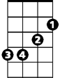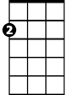

Am

F



C

**Am D G G7 C C7**

Then believe me, I need you to be my woman.

**C F**

And should you ask me how I'm doing,

**G C Em Am**

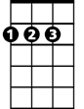

D

What shall I say? Things are OK.



Bb

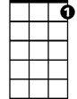

C7

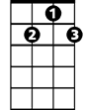

G7

**D**

But I know that they're not,

**Bb G**

And I still may have lost you.

**C F Em**

Woman, do you love me? Woman, if you need me

**Am D G G7 C C7**

Then believe me, I need you to be my woman.

**BARITONE**

**C F**



D

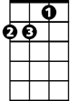

Am

C



F



Em

I hope you'll take your time and tell me,

**G C Em Am**

When we're alone, love will come home.

**D Bb G**

I would give up my world, if you'll say that my girl Is my -

**C F Em**

Woman, *do you love me? Woman, if you need me*

**Am D G G7 C C7**

*Then believe me, I need you to be my woman.*

**C Am F G**

I've got plenty of time, I’ve got plenty of time just to get through it

**C Am F G**

Once again you'll be mine, I still think we can do it,



G7

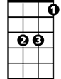

Bb

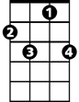

C7

**Am Dm G**

and you know how much I love you.

**C F Em**

Woman, don't forsake me, woman, if you take me

**Am D G G7 C F G7 C**

Then believe me I'll take you to be my woman.