Won't You Be My Neighbor (Fred Rogers, 1967) (C)

Intro: C A7 Dm G7 F// G7// C// G7 /

C A7 Dm G7
It’s a beautiful day in this neighborhood, A beautiful day for a neighbor,
C A7 Dm - G7
Would you be mine? __ Could you be mine?
C A7 Dm G7
It’s a neighborly day in this beauty-wood, a neighborly day for a beauty,
Dm G7 C Gm7 C7
Would you be mine? __ Could you be mine?

F A7 Dm C#º7
I have always wanted to have a neighbor just like you,
C F D7 G7 G7#5
I’ve always wanted to live in a neighbor-hood with you.

C A7 Dm G7
,So let’s make the most of this beautiful day, since we’re together, we might as well say
C A7 F Dm G7 C
Would you be mine? __ Could you be mine? Won’t you be my neighbor?

F G6 Dm A7 F G7 C
Won’t you please, won’ t you please, please won’t you be --- my neighbor?

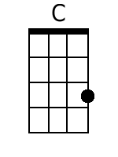 |  | 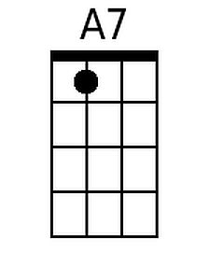 |  | 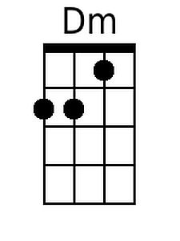 |  | 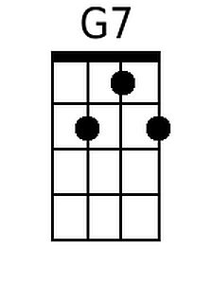 |  | 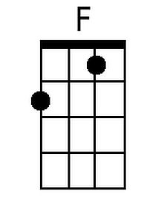
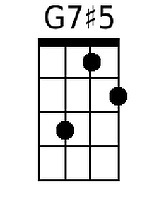 |  | 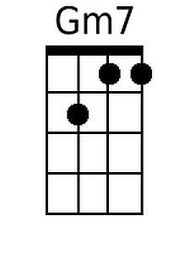 |  | 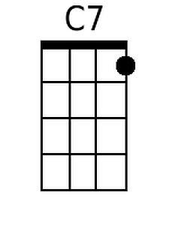 |  | 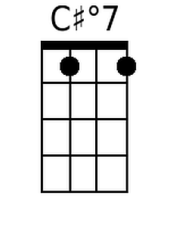 |  | 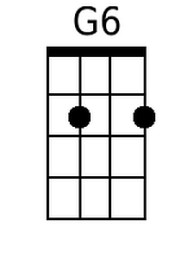
Bari
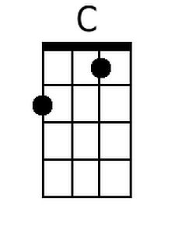 | 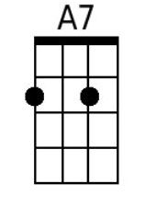 |  | 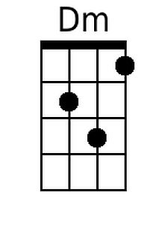 |  | 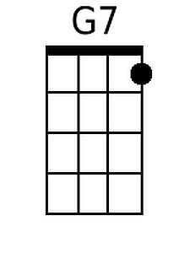 |  | 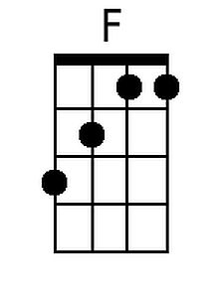 |  | 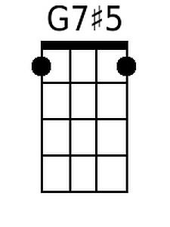 |  | 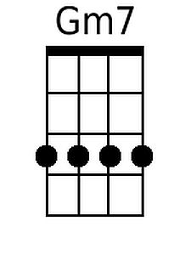 |  | 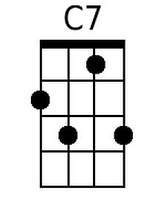 |  | 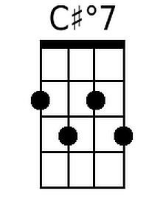 |  | 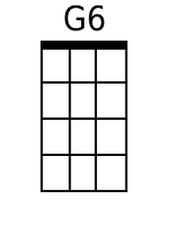

Won't You Be My Neighbor (Fred Rogers, 1967) (G)

Intro: G E7 Am D7 C// D7// G// D7 /

G E7 Am D7
It's a beautiful day in this neighborhood, A beautiful day for a neighbor,
G E7 Am - D7
Would you be mine? __ Could you be mine?
G E7 Am D7
It's a neighborly day in this beauty-wood, a neighborly day for a beauty,
Am D7 G Dm7 G7
Would you be mine? __ Could you be mine?

C E7 Am Abº7
I have always wanted to have a neighbor just like you,
G C A7 D7 D7#5
I've always wanted to live in a neighbor-hood with you.

G E7 Am D7
So let's make the most of this beautiful day, since we're together, we might as well say
G E7 C Am D7 G
Would you be mine? __ Could you be mine? Won't you be my neighbor?

C D6 Am E7 C D7 G
Won't you please, won' t you please, please won't you be --- my neighbor?

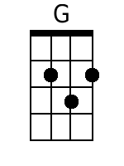 |  | 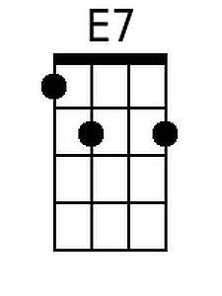 |  | 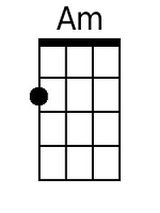 |  | 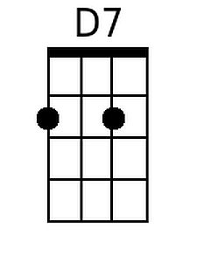
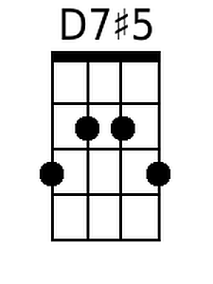 |  | 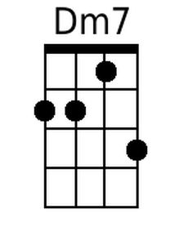 |  |  |  | 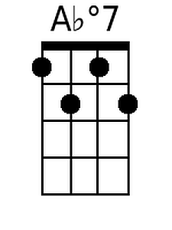 |  | 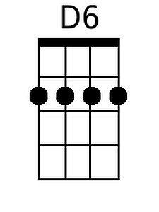
Bari
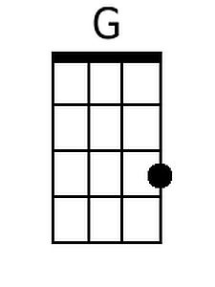 | 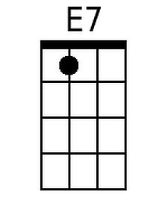 |  | 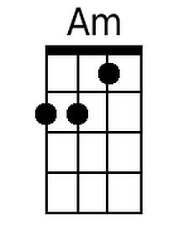 |  | 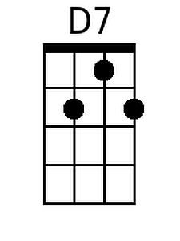 |  |  |  | 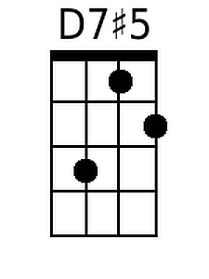 |  | 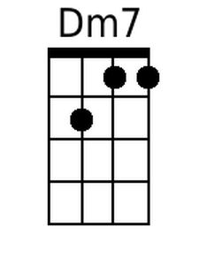 |  |  |  | 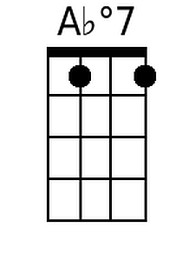 |  | 